

FlightDynamics

UnitI- CruisingFlightPerformance

  - TheSourceofAerodynamicForce
The aerodynamic force exerted on a body immersed in an airflow is due to the two handsof nature which are in direct contact with the surface of the body; these two hands of nature arethepressureandshearstressdistributionsactingallovertheexposedsurfaceofthebody.Thepressureandshearstressdistributionsexertedonthesurfaceofanaerofoilduetotheairflowover the body are sketched qualitatively in Fig 1, pressure acts locally perpendicular to thesurfaceandshearstress actslocallyparalleltothesurface.
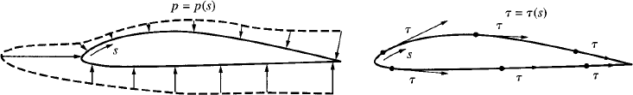
Fig.1.PressureandShearstressdistribution.
The net aerodynamic force on the body is due to the pressure and shear stressdistributionsintegratedoverthetotalexposedsurfacearea.

AerodynamicLift,Drag,andMoments
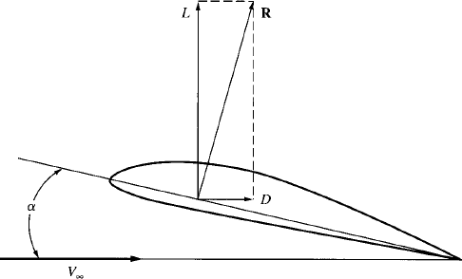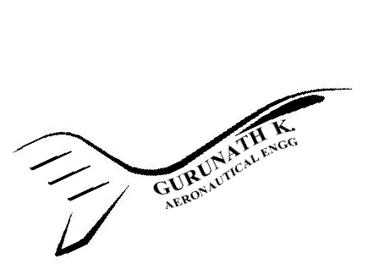ConsiderthebodysketchedinFig.2,orientedatanangleofattackatothefreestreamdirection.Thefree-streamvelocityisdenotedbyV,andisfrequentlycalledtherelativewind.TheresultantaerodynamicforceRisinclinedrearwardfromthevertical.(Notethat,ingeneral,R is not perpendicular to the chord line.) By definition, the component of R perpendicular tothe free-stream velocity is the lift L, and the component of R parallel to the free-stream directionisthedrag,D.

Fig.2.Lift,drag,andresultantaerodynamicforce.
ForthebodyshowninFig.2,imaginethatyouplaceanaxisperpendiculartothepageatanyarbitrarypointonthebody.

Justforthesakeofdiscussion,wechoosethepointone-quarterofthedistancebehindthe leading edge, measured along the chord line, as shown in Fig. 3a. This point is called thequarter-chordpoint;thereisnothinginherentlymagicaboutthischoice-wecouldjustaswellchoose any other point on the body. Now imagine that the axis perpendicular to the page throughthe point is rigidly attached to the body, and that you suspend the body in an airstream, holdingtheaxiswithyourhand.Duetothepressureandshearstressdistributedalloverthesurfaceofthe body, there will be a tendency for the axis to twist in your hand; that is, there will be ingeneral amomentabouttheaxis.
SrinivasanEngineeringCollege,Perambalur–621212. AUCR2013
Inthiscase,sincetheaxisislocatedatthequarter-chordpoint,wecallsuchamomentthe moment about the quarter chord, Mc/4. If we had chosen instead to put the axis at the leadingedge,asshowninFig.3b,thenwewouldstillfeelatwistingaction,butitwouldbeadifferentmagnitudefromabove.
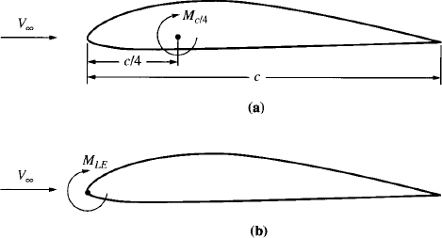
Fig.3.(a)Momentaboutthequarter-chordpoint;(b)Momentabouttheleadingedge.
Inthiscase,wewouldexperiencethemomentabouttheleadingedgeMLEeventhoughthe surface pressure and shear stress distributions are the same for parts (a) and (b) in Fig. 3,MLE is different from Mc/4 simply because we have chosen a different point about which to takethemoments.

TypesofDrag

Skin-frictiondrag:
Dragduetofrictionalshearstressintegratedoverthesurface.

Pressuredragduetoflowseparation(Formdrag):
Thedragduetothepressureimbalanceinthedragdirectioncausedbyseparatedflow.

Profiledrag(Sectiondrag):
Thesumofskinfrictiondragandformdrag.

Interferencedrag:
Anadditionalpressuredragcausedbythemutualinteractionoftheflowfieldsaroundeach component of the airplane. The total drag of the combined body is usually greater thanthatofthesumofitsindividualparts;thedifferenceistheinterferencedrag.
GurunathK.–AE6501FlightDynamics|2

Parasitedrag:
SrinivasanEngineeringCollege,Perambalur–621212. AUCR2013
Thetermusedfortheprofiledragforacompleteairplane.Itisthatportionofthetotaldragassociatedwithskinfrictionandpressuredragduetoflowseparation,integratedoverthecompleteairplanesurface.Itincludesinterferencedrag.

Induceddrag:
A pressure drag due to the pressure imbalance in the drag direction caused by theinducedflow(downwash)associatedwiththevorticescreatedatthetipsoffinitewings.

Zero-liftdrag:
Theparasitedragthatexistswhentheairplaneisatitszero-liftangleofattack,thatis,whentheliftoftheairplaneiszero.

Dragduetolift:
Thatportionofthetotalairplanedragmeasuredabovethezero-liftdrag.Itconsistsofthe change in parasite drag when the airplane is at an angle of attack different from thezero-lift angle, plus the induced drag from the wings and other lifting components of theairplane.

Externalstoredrag:
Anincreaseinparasitedragduetoexternalfueltanks,bombs,rockets,etc.,carriedaspayloadbytheairplane,butmountedexternallyfromtheairframe.

Landinggeardrag:
Anincreaseinparasitedragwhenthelandinggearisdeployed.

Protuberancedrag:
An increase in parasite drag due to "aerodynamic blemishes" on the external surface,suchasantennas,lights,protrudingrivets,androughormisalignedskinpanels.

Leakagedrag:
An increase in parasite drag due to air leaking into and out of holes and gaps in thesurface.Airtendstoleakinwheretheexternalpressuredistributionishighestandtoleakoutwheretheexternalpressuredistributionislowest.

Enginecoolingdrag:
An increase in parasite drag due to airflow through the internal cooling passages forreciprocatingengines.

Flapdrag:
An increase in both parasite drag and induced drag due to the deflection of flaps forhigh-liftpurposes.

Trimdrag:
The induced drag of the tail caused by the tail lift necessary to balance the pitchingmomentsabouttheairplane'scentreofgravity.Inaconventionalrear-mountedtail,theliftofthe tail is frequently downward to achieve this balance. When this is the tax, the wing mustproduce extra lift to counter the downward lift on the tail; the resulting increase in the winginduceddragisthenincludedinthetrimdrag.

TheDragPolar
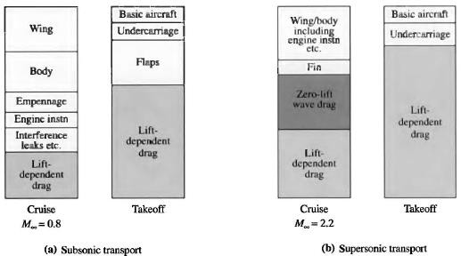
Drag is such a dominant consideration in airplane aerodynamics, it is interesting tocomparetherelativepercentagesforthevariouscomponentsofdragfortypicalsubsonicandsupersonicairplanes.

Fig.1.1.Comparisonofcruiseandtake-offdragbreakdowns
Thesebarchartsillustraterelativepercentages;theydonotgivetheactualmagnitudes.AgenericsubsonicjettransportistreatedinFig.1.1.(a);bothcruiseatMach0.8andtake-offconditionsareshown.Similarly,agenericslender,delta-wing,supersonictransportistreatedinFig.1.1.(b);bothcruiseatMach2.2andtake-offconditionsareshown.
For the subsonic transport, the elements labelled wing, body, empennage, engineinstallations, interference, leaks, undercarriage, and flaps are the contributors to the zero-liftparasite drag; that is, they stem from friction drag and pressure drag. The element labelledlift-dependent drag stems from the increment of parasite drag associated with the change inangle of attack from the zero-lift valve, and the induced drag. Note that most of the drag atcruise is parasite drag, whereas most of the drag at take-off is lift-dependent drag, which in thiscaseismostlyinduceddragassociatedwiththehighliftcoefficientattake-off.

For the supersonic transport more than two-thirds of the cruise drag is wave drag-acombinationofzero-liftwavedragandthelift-dependentdrag.Thisdominanceofwavedragis the major aerodynamic characteristic of supersonic airplanes. At take-off, the drag of thesupersonic transport is much like that of the subsonic transport, except that the supersonictransport experiences more lift-dependent drag. This is because the low-aspect-ratio delta wingincreases the induced drag, and the higher angle of attack required for the delta wing attake-offincreasestheincrementinparasitedragduetolift.
SrinivasanEngineeringCollege,Perambalur–621212. AUCR2013
Elaborating on the breakdown of subsonic cruise drag that, the total parasite drag atcruise, about two-thirds is usually due to skin friction, and the rest is form drag and interferencedrag. Since friction drag is a function of the total wetted surface area of the airplane, an estimateof the parasite drag of the whole airplane should involve the wetted surface area. The wettedsurface area 𝑆_{𝑤𝑒𝑡}can be anywhere between 2 and 8 times the reference planform area of thewing 𝑆. In turn, the zero-lift parasite drag 𝐷₀can be expressed in terms of an equivalent skinfrictioncoefficient 𝐶_{𝑓𝑒},and𝑆_{𝑤𝑒𝑡},asfollows:
𝐷0=𝑞∞𝑆𝑤𝑒𝑡𝐶𝑓𝑒
where,𝐶_{𝑓𝑒}isafunctionofReynoldsnumberbasedonmeanchordlength.
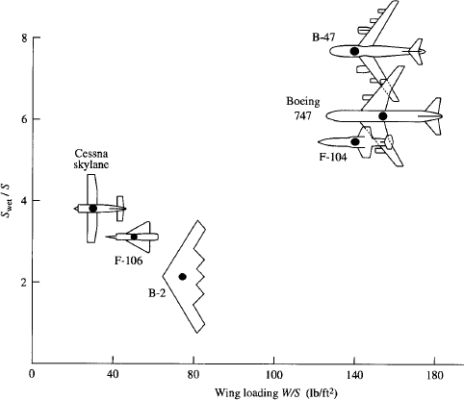
Fig.1.2.Ratioofwettedsurfaceareatoreferenceareaforanumberofdifferentairplaneconfigurations.
The equivalent skin-friction coefficient includes form drag and interference drag as wellasfrictiondrag.Themoreconventionalzero-liftdragcoefficient𝐶_{𝐷,0}isdefinedintermsoftheplanfotmarea 𝑆.

𝐷₀
𝐶_{𝐷,0}=𝑞 𝑆=
∞
𝑞∞𝑆𝑤𝑒𝑡𝐶𝑓𝑒
=
𝑞∞𝑆
𝑆𝑤𝑒𝑡
𝐶𝑓𝑒
𝑆

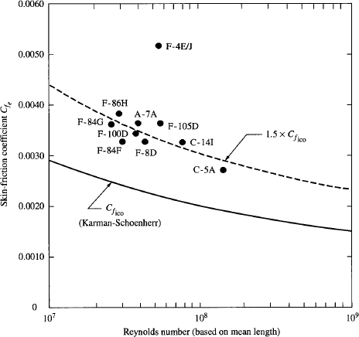

Fig.1.3.Equivalentskin-frictiondragforavarietyofairplanes.

Theabovecanbeusedto obtainan estimatefor𝐶_{𝐷,0}
byfinding^{𝑆𝑤𝑒𝑡}fromtheFig.1.2
𝑆

and𝐶_{𝑓𝑒}fromtheFig.1.3.Foreveryaerodynamicbody,thereisarelationbetween𝐶_{𝐷}and𝐶_{𝐿}thatcanbeexpressedasanequationorplottedonagraph.Boththeequationandthegrapharecalledthedragpolar.Virtuallyalltheaerodynamicinformationaboutanairplanenecessaryforaperformanceanalysisiswrappedupinthedragpolar.Thetotaldragforanairplaneis,
𝑇𝑜𝑡𝑎𝑙𝑑𝑟𝑎𝑔=𝑃𝑎𝑟𝑎𝑠𝑖𝑡𝑒𝑑𝑟𝑎𝑔+𝑊𝑎𝑣𝑒𝑑𝑟𝑎𝑔+𝐼𝑛𝑑𝑢𝑐𝑒𝑑𝑑𝑟𝑎𝑔
Incoefficientform,

𝐶_{𝐷}

=𝐶𝐷,𝑒

+𝐶𝐷,𝑤
𝐶2
+
𝐿
𝜋𝑒𝐴𝑅

where𝑒isthespanefficiencyfactor,givenby;and𝛿iscalculatedfromliftinglinetheory.
1

𝑒=

1+𝛿

Theparasitedragcoefficient𝐶_{𝐷,𝑒}canbetreatedasthesumofitsvalueatzerolift𝐶_{𝐷,𝑒,0}andtheincrementinparasitedrag∆𝐶_{𝐷,𝑒}duetolift.Anotherwaytolookatthesourceof∆𝐶_{𝐷,𝑒}is to realize that lift is a function of angle of attack 𝛼 and that ∆𝐶_{𝐷,𝑒}is due to the change inorientationoftheairplane,thatis,thechangein𝛼requiredtoproducethenecessarylift.Thatis,theskin-frictiondrag(toalesserextent)andthepressuredragduetoflowseparation(toagreaterextent)changewhen𝛼changes;thesumofthesechangescreates∆𝐶_{𝐷,𝑒}.

Thesourceof𝐶_{𝐷}isfrictiondragandpressuredragduetoflowseparation.Thisphysicalphenomenonisexactlythesamesourceof𝐶_{𝐷,𝑒}.Since∆𝐶_{𝐷,𝑒}variesapproximatelyas𝐶²,indeed.
SrinivasanEngineeringCollege,Perambalur–621212. AUCR2013
𝐿
𝐶𝐷,𝑒=𝐶𝐷,𝑒,0+∆𝐶𝐷,𝑒=𝐶𝐷,𝑒,0+𝑘1𝐶2
𝐿
where𝑘₁,isasuitableproportionalityconstant.Next,wecandissectthewavedragcoefficient
𝐶_{𝐷,𝑤}inasimilarfashion;thatis,𝐶_{𝐷,𝑤}isthesumofthezero-liftwavedragcoefficient𝐶_{𝐷,𝑤,0}
andthechange∆𝐶_{𝐷,𝑤}dueto1ift.So,
𝐶𝐷,𝑤=𝐶𝐷,𝑤,0+∆𝐶𝐷,𝑤=𝐶𝐷,𝑤,0+𝑘2𝐶2
𝐿
where𝑘₂,isasuitableproportionalityconstant.And,
𝐶2

𝐶 =𝐶
+𝐶
+𝑘𝐶²+𝑘
𝐶2+ 𝐿

𝐷 𝐷,𝑒,0
𝐷,𝑤,0
1 𝐿
2 𝐿
𝜋𝑒𝐴𝑅

𝐶𝐷=𝐶𝐷,𝑒,0+𝐶𝐷,𝑤,0+(𝑘1+𝑘2+𝑘3)𝐶2
𝐿

where𝑘 ≡1 ,also𝑘
+𝑘 +𝑘 ≡𝐾.Then,

3 𝜋𝑒𝐴𝑅
1 2 3

𝐶𝐷=𝐶𝐷,𝑒,0+𝐶𝐷,𝑤,0+𝐾𝐶2
𝐿

Thesumofthefirsttwotermsissimplythezero-liftdragcoefficient𝐶_{𝐷,0},
𝐶_{𝐷}=𝐶_{𝐷,0}+𝐾𝐶²
𝐿
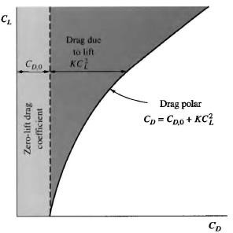
Theaboveisthedragpolarfortheairplane.The𝐶_{𝐷}isthetotaldragcoefficient,𝐶_{𝐷,0}isthezero-liftparasitedragcoefficient,and𝐾𝐶²isthedragduetolift.Thisequationisvalidforbothsubsonicandsupersonicflight.Atsupersonicspeeds,𝐶_{𝐷,0}containsthewavedragatzerolift,alongwiththefrictionandformdrags,andtheeffectofwavedragduetoliftiscontainedinthevalueusedfor𝐾.
𝐿
Fig.1.4.Schematicofthecomponentsofthedragpolar.
A graph of 𝐶_{𝐿}versus 𝐶_{𝐷}is sketched in Fig. 1.4. This is simply a plot of above equation,hencethecurveitselfis alsocalledthedragpolar.

TheFourForcesofFlight
The four forces of flight – lift, drag, weight,andthrust,denotedby𝐿,𝐷,𝑊,and𝑇,respectively
– are sketched in Fig. 1.5 for an airplane in levelflight.Thefree-streamvelocity𝑉∞isalwaysinthedirectionofthelocalflightof the airplane; inFig. 1.5 the flight path is horizontal, and hence 𝑉∞isalsoalongthehorizontal.Theairplaneismovingfromlefttoright,hence𝑉∞isdrawnpointingtowardthe left since it is a flow velocity relative to theairplane. By definition, the airplane’s lift and dragare perpendicular and parallel, respectively, to 𝑉∞asshowninFig.1.5.

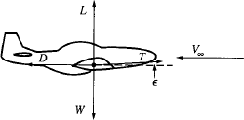

Fig. 1.5. Four forces of flight for the case of ahorizontal flight path. Note: For ordinary flight,lift and weight are much larger than thrust anddrag;thatis,fortypicalairplanes,L/D=10to15.

Lift and drag are aerodynamic forces; in Fig. 1.5, 𝐿 and 𝐷 represent the lift and drag,respectively, of the complete airplane, including the wing, tail, fuselage, etc. The weight alwaysacts toward the centre of the earth; for the level-flight case shown in Fig. 1.5, 𝑊 is perpendicularto 𝑉∞. The thrust is produced by whatever flight propulsion device is powering the airplane. Ingeneral, 𝑇 is not necessarily in the free-stream direction; this is shown in Fig. 1.5 where 𝑇 isdrawn at an angle 𝜖 relative to the flight path. For the level-flight case shown in Fig. 1.5, allfour forces are in the same plane. This is also the longitudinal plane of symmetry for theairplane;theplaneofsymmetrysplitstheairplaneintotwosymmetrichalves.
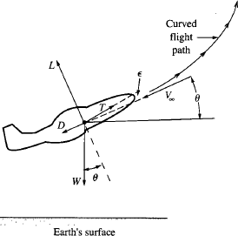
Consider next the case of the airplaneclimbing or descending along a flight path that isangledtothehorizontal,asshowninFig.1.6.Ingeneral, the flight path is curved, as shown. Letus consider the case where the curve of the flightpath lies entirely in the plane of the page, that is,in the vertical plane perpendicular to the earth'ssurface. At any given instant as the airplanemoves along this path, the local, instantaneousangle of the flight path, relative to the horizontal,is 𝜃. Hence 𝑉∞is inclined at angle 𝜃, which iscalled the local climb angle of the airplane. Asbefore,𝐿and𝐷areperpendicularandparallelto
𝑉∞.Weight𝑊,actstowardthecentreofthe

earth,andhenceisperpendiculartotheearth'ssurface.
Fig.1.6.Climbingflight.

Fortheairplaneinclimbingflight,thedirectionof𝑊isinclinedattheangle𝜃relativetothelift,asshowninFig.1.6.Theverticalplaneisstilltheplaneofsymmetryfortheairplane.
urunathK.–AE6501FlightDynamics|
G
Starting with the airplane in the orientation shown in Fig. 1.6, we now rotate it aboutthelongitudinalaxis –theaxisalongthefuselagefromthenosetothetail.Thatis,letusroll(orbank)theairplanethroughtherollangle ∅showninFig.1.7.

GurunathK.–AE6501FlightDynamics|

This figure shows a more general orientation of the airplane in three-dimensional space,at an instantaneous climb angle of 𝜃 and an instantaneous roll angle ∅. Examine Fig. 1.7 closely.Thesideviewshows,inperspective,theairplanerolledtowardyou.Theplaneofsymmetryisasshowninthehead-onfrontviewattherightinFig.1.7.ThisfrontviewisaprojectionoftheairplaneandtheforcesonplaneAAtakenperpendiculartothelocalfree-streamvelocity𝑉∞.In this head-on front view, the plane of symmetry of the airplane is inclined to the local verticalthroughthe rollangle∅.
ngCollege,Pe
SrinivasanEngineeri rambalur–621212. AUCR2013
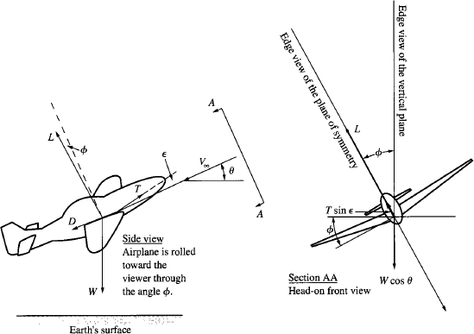
Fig.1.7.Airplaneinclimbingflightandrolledthroughangle∅.
Now consider the four forces of flight as they appear in Fig. 1.7. In the side view, theliftisshown,inperspective,rotatedawayfromthelocalverticalthroughtheangle∅;thatis,theliftisinclinedtothepageattherollangle∅.Inthehead-onfrontview,theliftLisclearlyshown inclined to the vertical at angle ∅. The thrust 𝑇, which is inclined to the flight pathdirectionthroughtheanglet,isalsorotatedoutoftheplaneofthepageinthesideview.Inthehead-onfrontview,TprojectsasthecomponentTsinc;thiscomponentisalsorotatedawayfrom the vertical through angle 𝜖. The weight 𝑊 is always directed downward in the localverticaldirection.Hence,inthesideview, 𝑊isintheplaneofthepage.Inthehead-onfrontview,theweightprojectsasthecomponent𝑊𝑐𝑜𝑠𝜃,directeddownwardalongthevertical.
Finally, in the side view, the drag 𝐷, which is parallel to the local relative wind, is inthe plane of the page.Inthe head-on view, since 𝐷is parallel to 𝑉∞, the drag does not appear;itscomponentprojectedonplaneAAiszero.

GurunathK.–AE6501FlightDynamics|

TheEquationsofMotion
SrinivasanEngineeringCollege,Perambalur–621212. AUCR2013
TheequationsofmotionforanairplanearesimplystatementsofNewton'ssecondlaw,namely,
𝐹=𝑚𝑎
The above equation is a vector equation, where the force 𝐹 and the acceleration 𝑎 arevectorquantities.However,thisequationcanalsobewritteninscalarformintermsofscalarcomponentsof𝐹and𝑎.Forexample,ifwechooseanarbitrarydirectioninspace,denotedby
𝑠,andwelet𝐹_{𝑠}and𝑎_{𝑠}bethecomponentsof𝐹and𝑎,respectively,inthe𝑠direction,thentheaboveequationgives
𝐹_{𝑠}=𝑚𝑎_{𝑠}
Assumeaflat,stationaryearthtodeveloptheequationsofmotionforarigidflightvehicle.
ReturntoFig.1.7,andvisualizethemotionoftheairplanealongitscurvedflightpathinthree-dimensionalspace.Sinceweareinterestedinthetranslationalmotionoftheairplaneonly, let us replace the airplane in Fig. 1.7 with a point mass at its centre of gravity, with thefourforcesofflightactingthroughthispoint,assketchedinFig.1.8.ThesketchinFig.1.8isdrawn so that the plane of the page is the plane formed by the local free-stream velocity 𝑉∞andthe local vertical. Hence, in Fig. 1.8, both 𝐷 and 𝑊 are in the plane of the page. The componentofliftinthisplaneis 𝐿𝑐𝑜𝑠∅.
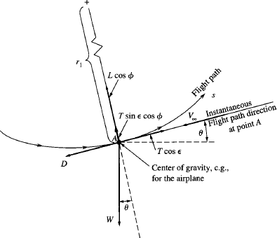

Fig.1.8.Forcesprojectedintotheplaneformedbythelocalfree-streamvelocity𝑉∞andthevertical.
The thrust is represented by its components in this plane, 𝑇 𝑐𝑜𝑠 𝜖and 𝑇 sin 𝜖 cos ∅,parallelandperpendicular,respectively,tothelocalfree-streamvelocity𝑉∞.Thecurvilinearmotionoftheairplanealongthecurvedflightpath,projectedintotheplaneofFig.1.8,canbeexpressed by Newton's second law, by first taking components parallel to the flight path andthen taking components perpendicular to the flight path. The component of force parallel to theflightpathis,

𝐹∥=𝑇𝑐𝑜𝑠𝜖−𝐷−𝑊sin𝜃
Theaccelerationparalleltotheflightpathis,

𝑎∥=
𝑑𝑉∞

𝑑𝑡

Hence,Newton'ssecondlaw,takenparalleltotheflightpath,is
𝑚𝑎∥=𝐹∥

Or
𝑑𝑉∞
𝑚
𝑑𝑡

=𝑇𝑐𝑜𝑠𝜖−𝐷−𝑊 sin𝜃

Inthedirectionperpendiculartotheflightpath,thecomponentofforceis
𝐹⊥=𝐿𝑐𝑜𝑠∅+𝑇sin𝜖cos∅−𝑊cos𝜃
Theradialaccelerationofthecurvilinearmotion,perpendiculartotheflightpath,is
𝑉2

𝑎⊥=
∞

𝑟₁

Where,𝑟₁isthelocalradiusofcurvatureoftheflightpathintheplaneofthepageinFig.1.8.Hence,Newton'ssecondlaw,takenperpendiculartotheflightpath,is
𝑚𝑎⊥ =𝐹⊥
Or
𝑉2
∞
𝑚 =𝐿𝑐𝑜𝑠∅+𝑇sin𝜖cos∅−𝑊 cos𝜃
𝑟₁
Return to Fig. 1.7. and visualize a horizontal plane – a plane parallel to the flat earth.The projection of the curved flight path on this horizontal Plane is sketched in Fig. 1.9. TheplaneofthepageinFig. 1.9isthehorizontalplane.
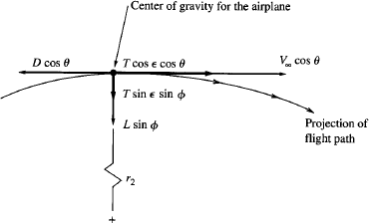

Fig.1.9.Forcesprojectedintothehorizontalplaneparalleltotheflatearth.
The instantaneous location of the airplane’s centre of gravity (c.g.) is shown as the largedot;thevelocityvectoroftheairplaneprojectsintothishorizontalplaneasthecomponent
𝑉∞cos𝜃,tangenttotheprojectedflightpathatthec.g.location.

The local radius of curvature of the flight path in the horizontal plane is shown as 𝑟₂.Theprojectionoftheliftvectorin the horizontalplaneis𝐿𝑠𝑖𝑛∅,andisperpendicularto theflight path, as shown in Fig. 1.9. The components of the thrust vector in the horizontal planeare 𝑇 𝑠𝑖𝑛 𝜖 𝑠𝑖𝑛 ∅ and 𝑇 𝑐𝑜𝑠 𝜖 𝑐𝑜𝑠 𝜃 perpendicular and parallel, respectively, to the projectedflight path in Fig. 1.9. The component of drag in this plane is 𝐷 𝑐𝑜𝑠 𝜃. Since the weight actsperpendiculartothehorizontal,itscomponentiszeroinFig.1.9.
SrinivasanEngineeringCollege,Perambalur–621212. AUCR2013
Consider the force components in Fig. 1.9 that are perpendicular to the flight path at theinstantaneouslocationofthecentreofgravity.Thesumoftheseforces,denotedby𝐹₂,is
𝐹₂=𝐿 𝑠𝑖𝑛∅+𝑇𝑠𝑖𝑛𝜖𝑠𝑖𝑛∅
TheinstantaneousradialaccelerationalongthecurvilinearpathinFig.1.9is
(𝑉∞cos𝜃)²

𝑎2=

𝑟₂

FromNewton’ssecondlawtakenalongthedirectionperpendiculartotheflightpathinthehorizontalplaneshowninFig.4.5, wehave
(𝑉∞cos𝜃)²

𝑚
𝑟₂
=𝐿𝑠𝑖𝑛∅+𝑇𝑠𝑖𝑛𝜖𝑠𝑖𝑛∅

The above three force equations describe the translational motion of an airplane throughthree-dimensional space over a flat earth. They are called the equations of motion for theairplane.
GurunathK.–AE6501FlightDynamics|

ThrustandEfficiency
In an elementary fashion, we can state that a propeller/reciprocating engine combinationproduces comparably low thrust with great efficiency, a turbojet produces considerably higherthrustwithlessefficiency,andarocketengineproducestremendousthrustwithpoorefficiency.
Let us consider the fundamental manner in which thrust is produced. The thrust isexertedonthedeviceviathenetresultantofthepressureandshearstressdistributionsactingontheexposedsurfaceareas,internaland/orexternal,ateachpointwheretheaircontactsanypartofthedevice.Thus,thetimerateorchangeofmomentumoftheairflowingthroughthepropulsion device is simply the momentum flowing out of the device minus the momentumflowingatinlet of the device,namely,𝑚̇𝑉_{𝑗} − 𝑚̇𝑉∞, or 𝑚̇(𝑉_{𝑗} − 𝑉∞).FromNewton's second law,thistimerateofchangeofmomentumisequaltotheforceT.Thatis,
𝑇=𝑚̇(𝑉_{𝑗}−𝑉∞)
The above is the thrust equation for our generic propulsion device. When a force isexertedonabodymovingatsomevelocity,thepowergeneratedbythatforceis
𝑃𝑜𝑤𝑒𝑟=𝐹𝑜𝑟𝑐𝑒×𝑉𝑒𝑙𝑜𝑐𝑖𝑡𝑦
Consider an airplane moving with velocity V, being driven by a propulsion device withthrust𝑇.Theusefulpower,calledthepoweravailable𝑃_{𝐴}providedbythepropulsivedevice,is
𝑃_{𝐴}=𝑇𝑉∞

However,thepropulsivedeviceisactually puttingoutmorepowerthanthisbecausethedeviceisalsoproducingthewastedkineticenergyintheairleftbehind.Thewastedkinetic

energythen¹𝑚̇(𝑉−𝑉
)²isthepowerwastedintheairjetbehindthedevice.Hence,total

2 𝑗 ∞
powergeneratedbypropulsivedevice,is
1
𝑃 2
_{𝑡𝑜𝑡𝑎𝑙}=𝑇𝑉∞+2𝑚̇(𝑉_{𝑗}−𝑉∞)
Thepropulsiveefficiency,denotedby𝜂_{𝑝},canbedefinedas

𝜂_{𝑝}=

Power availableTotalpowergenerated
𝑇𝑉∞

𝜂_{𝑝}=

𝜂_{𝑝}=

1
𝑇𝑉∞+2𝑚̇(𝑉_{𝑗}−𝑉∞)
2
𝑇𝑉∞
∞ 2 𝑗 ∞

𝑇𝑉+𝑇(𝑉−𝑉 )
𝑇𝑉∞

𝜂_{𝑝}=

1𝑉_{𝑗}

𝜂_{𝑝}=
𝑇𝑉∞[1+2(𝑉∞−1)]
2

(1+𝑉𝑗)
𝑉∞

Thusthepropulsiveefficiencyismaximumwhen𝑉_{𝑗}≈𝑉∞.

ThrustRequired
Imagineanairplaneinsteady,levelflightatagivenvelocityandaltitude.Tomaintainthisspeedand altitude,enoughthrustmustbegenerated toexactlyovercomethedragandtokeep the airplane going – this is the thrust required to maintain the flight conditions. Indeed,thethrustrequiredissimplyequaltothedragoftheairplane.
For the given airplane, we know the following physical characteristics: weight 𝑊,aspectratio𝐴𝑅,andwingplanformarea𝑆.Thedragpolarofanairplane,is
𝐶_{𝐷}=𝐶_{𝐷,0}+𝐾𝐶²
𝐿
Assume 𝐶_{𝐷,0}and 𝐾 are known for the given airplane. To calculate the thrust requiredcurve,proceedasfollows:
    - Chooseavalueof𝑉∞.
    - Forthechosen𝑉∞,calculate𝐶_{𝐿}fromtherelation,

1
𝐿=𝑊= 𝜌

𝑉²𝑆𝐶

2 ∞ ∞ 𝐿
2𝑊

𝐶_{𝐿}=𝜌
∞
∞
𝑉²𝑆

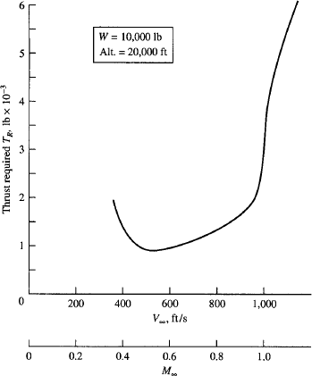

    - Calculate𝐶_{𝐷}.
Fig.1.5.Typicalthrustrequiredcurve.

    - Calculatedrag,hence𝑇_{𝑅},from

𝑇

1
=𝐷= 𝜌

𝑉²𝑆𝐶

𝑅 2 ∞ ∞ 𝐷
SrinivasanEngineeringCollege,Perambalur–621212. AUCR2013
GurunathK.–AE6501FlightDynamics|
    - Fordifferentvaluesof𝑉∞,shallgenerateenoughpointstoplotthethrustrequiredcurve.

VariationsofThrustandSpecificFuelConsumptionwithVelocityandAltitude

Engine | Thrust | TSFC
TheTurbojetEngine | 𝑇isreasonablyconstantwith𝑉∞ | For𝑀∞<1,  𝑇𝑆𝐹𝐶=1+𝑘𝑀∞  where𝑘isafunctionofaltitudeandthrottlesetting.  For𝑀∞>1,  𝑇𝑆𝐹𝐶isconstantwith𝑀∞.
TheTurbojetEngine | As the altitude increases, 𝜌∞decreases. Since 𝑇 is almost directlyproportionalto𝑚̇ _{𝑎𝑖𝑟},thrustalsodecreaseswithaltitude.  𝑇 𝜌  =  𝑇₀ 𝜌₀  where𝑇₀&𝜌₀are thesea-levelthrust&densityrespectively. | 𝑇𝑆𝐹𝐶isconstantwithaltitude.
TheTurbofanEngine | For a given, constant altitude,thedecreaseinthrustwithMachnumbercanbecorrelatedby  𝑇  =𝐴𝑀^{−𝑛}  𝑇𝑣=0 ∞  where𝐴and𝑛arefunctionsofaltitude. | The variation of  𝑇𝑆𝐹𝐶, with velocity at agiven altitude follows therelation  𝑇𝑆𝐹𝐶=𝐵(1+𝑘𝑀∞)  where 𝐵and 𝑘areempiricalconstants.
TheTurbofanEngine | The variationofTwithaltitudeisapproximatedby  𝑇 𝜌 𝑚  =( )  𝑇₀ 𝜌₀  Thevalueof𝑚dependsontheenginedesign;itisusuallynear1. | 𝑇𝑆𝐹𝐶isconstantwithaltitude.

  - PowerRequired
SrinivasanEngineeringCollege,Perambalur–621212. AUCR2013
Consider a force F acting on an object moving with velocity V, as sketched in Fig. a.Both F and V are vectors and may have different directions, as shown in Fig. a. At some instant,the object is located at a position given by the position vector r, as shown in Fig. b. Over, a timeincrementdt,theobjectisdisplacedthroughthevectordr,showninFig.b.TheworkdoneontheobjectbytheforceFactingthroughthedisplacementdrisF∙dr.Poweristhetimerateofdoingwork,or

𝑃𝑜𝑤𝑒𝑟=
𝑑

𝑑𝑡

(𝐹∙𝑑𝑟)=𝐹∙
𝑑𝑟

𝑑𝑡

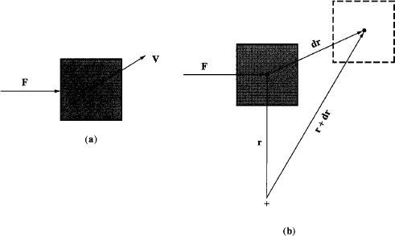

Since

Then
Forceactingonamovingbody
- Forceandvelocityvectors(b)Forceanddisplacementvectors.

𝑑𝑟
=𝑉
𝑑𝑡

𝑃𝑜𝑤𝑒𝑟=𝐹∙𝑉
Theaboveequationisthemoregeneralversionofpower,whichholdswhentheforce

andvelocityareinthesamedirection.
GurunathK.–AE6501FlightDynamics|
Let us now apply the above equation toan airplane in straight and level flight, as sketchedinFig.ThevelocityoftheairplaneisV∞.
We know that thrust required, TR= D.So, the analogous concept of power required,denotedbyPRisgivenby
𝑃_{𝑅}=𝑇_{𝑅}𝑉∞

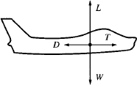

Forcediagramforsteady,levelflight

For some aspects of airplane performance, power rather than thrust is more germane. Agraphical plot of PR versus V∞ for a given airplane at a given altitude is called the power requiredcurve.Thepowerrequiredcurveiseasilyobtainedbymultiplyingthrustrequiredbyvelocityviaaboveequation.
SrinivasanEngineeringCollege,Perambalur–621212. AUCR2013
Asimpleequationfor PRin terms oftheaerodynamiccoefficientsis obtainedasfollows.
𝑊

𝑃_{𝑅}=𝑇_{𝑅}𝑉∞=
𝐶/𝐶
𝑉∞

SinceL=Wforsteady,levelflight,
𝐿 𝐷

1
𝐿=𝑊= 𝜌

𝑉²𝑆𝐶

SolvingforV∞,wehave,
2 ∞ ∞ 𝐿

𝑉∞ =√𝜌
2𝑊
𝑆𝐶

So,
∞ 𝐿

𝑃_{𝑅}=
𝑊
𝐶/𝐶
2𝑊
√
𝜌𝑆𝐶

𝐿 𝐷

Or
∞ 𝐿

2𝑊³𝐶²
𝐷
𝑃= √
𝑅 3
𝜌∞𝑆𝐶
𝐿

Examiningaboveequation,weseethat

𝑃_{𝑅}𝖺

1
3/2

𝐶𝐿
/𝐶_{𝐷}

Hence,minimumpowerrequiredoccurswhentheairplaneisflyingsuchthat𝐶^{3/2}/𝐶

isamaximumvalue.Atminimum𝑃_{𝑅}wehave
  - Thefollowing
𝐿 𝐷

𝐶3/2
(𝐿 )
𝐶_{𝐷}

1
= (4
𝑚𝑎𝑥

3
3/2
𝐾𝐶
𝐷,0

3/4
)

  - Zero-liftdragequalsone-thirdofthedragduetolift.
  - Thevelocityatwhich𝑃_{𝑅}isaminimumoccursat

1/2

𝑉 3/2
2 𝐾 𝑊
=( √ )

(𝐶𝐿
/𝐶𝐷)
𝑚𝑎𝑥
𝜌∞ 3𝐶_{𝐷,0}𝑆

Thisvelocityislessthanthatforminimum𝑇_{𝑅},where𝐶_{𝐿}/𝐶_{𝐷}isamaximum.Indeed,

𝑉 3/2
= 0.76𝑉_{(𝐿/𝐷)}𝑚𝑎𝑥

(𝐶𝐿
/𝐶𝐷)
𝑚𝑎𝑥

PowerAvailable
Bydefinitionthepoweravailable,denotedby𝑃_{𝐴},isthepowerprovidedbythepowerplantoftheairplane.Thepoweravailableisgivenby
𝑃_{𝐴}=𝑇_{𝐴}𝑉∞
The maximum power available compared with the power required allows the calculationofthemaximumvelocityofthe airplane. Wewillexaminethecalculationof𝑉_{𝑚𝑎𝑥},bymeansof power considerations. However, there are some aspects of airplane performance, rate ofclimb, for example, that depend more fundamentally on power than on thrust. Hence, theconsiderationof𝑃_{𝐴}and𝑃_{𝑅}isimportantinitsownright.

Propeller-DrivenAircraft
Propellers are driven by reciprocating piston engines or by gas turbines. The engines inboth these cases are rated in terms of power. Hence, for propeller-driven airplanes, poweravailableismuchmoregermanethanthrustavailable.Poweravailable forapropeller drivenreciprocatingengine/turbopropengineisrespectively,
𝑃_{𝐴}=𝜂_{𝑝𝑟}𝑃 / 𝑃_{𝐴}=𝜂_{𝑝𝑟}𝑃_{𝑒𝑠}
where 𝜂_{𝑝𝑟}is the propeller efficiency, 𝑃 is the shaft power from the reciprocating engine,and𝑃_{𝑒𝑠}istheequivalentshaftpowerfromtheturbopropengine,whichincludestheeffectofthejetthrust.

Thevelocityandaltitudeeffectson𝑷forapistonengineareasfollows:
      - Power𝑃isreasonablyconstantwith𝑉∞,
      - Foranunsuperchargedengine,

𝑃

𝑃₀
𝜌
=
𝜌₀

where 𝑃 and 𝜌 are the shaft power output and density, respectively, at altitudeand 𝑃₀and 𝜌₀are the corresponding values at sea level. Taking into account thetemperatureeffect,aslightlymoreaccurateexpressionis

𝑃

𝑃₀

=1.132
𝜌

𝜌₀

−0.132

      - For a supercharged engine, 𝑃 is essentially constant with altitude up to the critical designaltitude of the supercharger. Above this critical altitude. P decreases according to abovetwoequationswith𝜌₀intheseequationsreplacedbythedensityatthecriticalaltitude,denotedby𝜌_{𝑐𝑟𝑖𝑡}.

Thevelocityandaltitudevariationsof𝑷_{𝑨}foraturbopropareasfollows:
- Poweravailable𝑃_{𝐴}isreasonablyconstantwith𝑉∞.

- Thealtitudeeffectisapproximatedby
SrinivasanEngineeringCollege,Perambalur–621212. AUCR2013

𝑃_{𝐴}

𝑃𝐴,0
𝜌 𝑛
=( )
𝜌₀

; 𝑛=0.7

TurbojetandTurbofanEngines
Turbojetandturbofanenginesareratedintermsofthrust.Hence,tocalculatethepoweravailable,
𝑃_{𝐴}=𝑇_{𝐴}𝑉∞
Thevariationof𝑃_{𝐴}withvelocity andaltitudeforaturbojet/turbofanengineisreflectedthroughthevariationof 𝑇_{𝐴}.

Thevelocityandaltitudevariationsof𝑷_{𝑨}foraturbojetareasfollows:
      - Atsubsonicspeeds,𝑇_{𝐴}isessentiallyconstant.Hence,fromaboveequation,𝑃_{𝐴}isdirectlyproportionalto𝑉∞.Forsupersonicspeeds,𝑇_{𝐴}is,
𝑇_{𝐴}

(𝑇_{𝐴})

𝑀𝑎𝑐ℎ1
=1+1.18(𝑀∞−1)

Inthiscase,𝑃_{𝐴}forsupersonicspeedsisanonlinearfunctionof𝑉∞.
      - Theeffectofaltitudeon𝑃_{𝐴}isthesameof𝑇_{𝐴}.

𝑃_{𝐴}(𝑃_{𝐴})₀
𝜌
=
𝜌₀

Thevelocityandaltitudevariationsof𝑷_{𝑨}foraturbofanareasfollows:
- TheMachnumbervariationofthrustiswrittenas
𝑇𝐴 =𝐴𝑀^{−𝑛}
(𝑇𝐴)𝑣=0 ∞
Power available is then obtained from equation, 𝑃_{𝐴} = 𝑇_{𝐴} 𝑉∞. This will not, ingeneral, be a linear variation for 𝑃_{𝐴}. However, for turbofans in the cruise range, 𝑇_{𝐴}isessentiallyconstant;henceinthecruiserange,𝑃_{𝐴}variesdirectlywith𝑉∞.
- Thealtitudevariationforturbofanthrustisapproximatedby

𝑇_{𝐴}(𝑇_{𝐴})₀
𝜌 𝑚
=( )
𝜌₀

Hencethevariationof𝑃_{𝐴}withaltitudeisthesameasgivenfor𝑇_{𝐴}.

𝑃_{𝐴}(𝑃_{𝐴})₀
𝜌 𝑚
=( )
𝜌₀

MaximumVelocity
Consider a propeller-driven airplane. The power available 𝑃_{𝐴}is essentially constant withvelocity,assketchedinFig.a.Theintersectionofthemaximumpoweravailablecurveandthepowerrequiredcurvedefinesthemaximumvelocityforstraightandlevelflight,asshowninFig.a.
Consider a jet-propelled airplane. Assuming 𝑇_{𝐴}is constant with velocity, the poweravailable at subsonic speeds varies linearly with 𝑉∞and is sketched in Fig. b. The powerrequired 𝑃_{𝑅}is also sketched in Fig. b. The high-speed intersection of the maximum poweravailable curve and the power required curve defines the maximum velocity for straight andlevelflight,asshownin Fig.b.
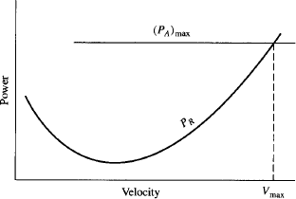
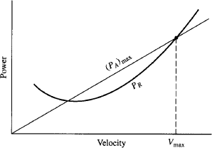

- Forapropeller-drivenairplane,poweravailableis essentially constant with velocity The high-speedintersectionofthemaximumpoweravailable curve and the power required curvedefinesthemaximumvelocityoftheairplane.
- Faraturbojet-poweredairplane,poweravailablevariesessentiallylinearlywithvelocity. The high-speed intersection of themaximumpoweravailablecurveandthepower required curve defines the maximumvelocityofthe airplane.

VariationsofPowerandSpecificFuelConsumptionwithVelocityandAltitude

Engine | Power | SFC
TheReciprocatingEngine/  PropellerCombination | 𝑃isreasonablyconstantwith𝑉∞. | 𝑆𝐹𝐶 isconstantwith𝑉∞.
TheReciprocatingEngine/  PropellerCombination | 𝑃isdecreasingwhenaltitudeisincreased. | 𝑆𝐹𝐶isconstantwithaltitude.
TheTurboprop | 𝑃_{𝐴}isconstantwith𝑀∞. | 𝑆𝐹𝐶 isconstantwith𝑉∞.
TheTurboprop | 𝑃_{𝐴} 𝜌𝑛  =( )  𝑃₀ 𝜌₀ | 𝑆𝐹𝐶isconstantwithaltitude.

UnitII ManoeuvringFlightPerformance
SrinivasanEngineeringCollege,Perambalur–621212. AUCR2013

Range
Rangeisthetotaldistancetraversedbyanairplaneononeloadoffuel.
Considerthefollowingweights:
𝑊₀- grossweightoftheairplaneincludingeverything;fullfuelload,payload,crew,structure,etc.
𝑊_{𝑓}- weightoffuel;thisisaninstantaneousvalue,anditchangesasfuelisconsumedduringflight.
𝑊_{𝑒}- weightoftheairplanewhenthefueltanksareempty.
Atanyinstantduringtheflight,theweightoftheairplane𝑊is,
𝑊=𝑊_{𝑒}+𝑊_{𝑓}
Since𝑊_{𝑓}isdecreasingduringtheflight,𝑊isalsodecreasing.Indeed,thetimerateofchangeofweightis
𝑑𝑊 𝑑𝑊_{𝑓}
=− =−𝑊

𝑑𝑡
𝑑𝑡 ^{𝑓}

The above equation is negative because fuel is being consumed. Range is intimatelyconnectedwithengineperformancethroughthespecificfuelconsumptionforapropeller-driven/reciprocatingengine.

𝑐=−

where,𝑃→shaftpower.
𝑊̇𝑓

𝑃

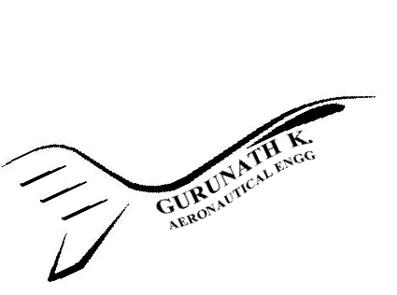Andthethrustspecificfuelconsumptionforajet-propelledairplaneis,
𝑊̇𝑓
𝑐_{𝑡}=− 𝑇
where,𝑇→availablethrust.
Now𝑐_{𝑡}canbeexpressedintermsof𝑐andviceversa.So,
𝑐𝑉∞
𝑐_{𝑡}=
𝜂
𝑝𝑟
where,𝜂_{𝑝𝑟}→propellerefficiency.
Aboveequationisparticularlyusedforgeneratinganequivalent"thrust"specificfuelconsumptionforpropeller-drivenairplanes.
Consideranairplaneinsteady,levelflight.Let𝑠denotehorizontaldistancecoveredovertheground.Theairplane’svelocity𝑉∞is,
𝑑𝑠
𝑉∞=𝑑𝑡
𝑑𝑠=𝑉∞𝑑𝑡
Thethrustspecificfuelconsumptionforajet-propelledairplanecanbewrittenas

𝑊̇𝑓
𝑑𝑊_{𝑓}1

𝑐_{𝑡}=−𝑇 =−

𝑑𝑡𝑇

𝑑𝑡=−

Thenthe𝑑𝑠willbeasfollows.Where,𝑑𝑊_{𝑓}=𝑑𝑊
𝑉∞
𝑑𝑊_{𝑓}

SrinivasanEngineeringCollege,Perambalur–621212. AUCR2013
𝑐_{𝑡}𝑇

𝑉∞

𝑑𝑠=−𝑐𝑇𝑑𝑊_{𝑓}=−𝑐𝑇𝑑𝑊

𝑑𝑠=−
𝑡 𝑡
𝑉∞𝑊𝑑𝑊

𝑐_{𝑡}𝑇 𝑊
Insteady,levelflight,𝑇=𝐷and𝐿=𝑊.

𝑑𝑠=−
𝑉∞𝐿𝑑𝑊

𝑐_{𝑡}𝐷𝑊
Integratingabovefrom𝑠=0where𝑊=𝑊₀to𝑠=𝑅where𝑊=𝑊_{𝑒}willgive

𝑅
∫𝑑𝑠=−∫
𝑊𝑒𝑉∞𝐿𝑑𝑊

0 𝑊0
𝑐_{𝑡}𝐷 𝑊

𝑉∞𝐿
=
𝑊0𝑑𝑊
∫

𝑅=
𝑐_{𝑡}𝐷
𝑉∞𝐿

𝑐_{𝑡}𝐷
𝑊𝑒𝑊
𝑊₀
ln
𝑊_{𝑒}

ThisequationiscalledtheBreguetrangeequation.Sotherangeisinfluencedby,
    - Lifttodragratio.
    - Specificfuelconsumption
    - Velocity
    - Initialamountoffuel.

RangeforPropeller-DrivenAirplanes
TheBreguetrangeequationis

Weknowthat𝑐_{𝑡}intermsof𝑐is,

𝑅=
𝑉∞𝐿

𝑐_{𝑡}𝐷
𝑊₀
ln
𝑊_{𝑒}

Then,
𝑐𝑉∞
𝑐_{𝑡}=
𝜂
𝑝𝑟

𝑅=
𝜂𝑝𝑟𝐿

𝑐 𝐷
𝑊₀
ln
𝑊_{𝑒}

ThisisthehistoricalBreguetrangeequation.Formaximumrange,thepropeller-driven
GurunathK.–AE6501FlightDynamics|
/reciprocatingenginepowerplantshould;
      - Flyatmaximum𝐿/𝐷.
      - Havethehighestpossiblepropellerefficiency.
      - Havethelowestpossiblespecificfuelconsumption.
      - Havethehighestpossibleratioof𝑊₀to𝑊_{𝑒}.

RangeforJet-PropelledAirplanes
The Breguet range equation is the range equation for a jet-propelled airplane. Themaximum value of the range is obtained from the product 𝑉∞(𝐿/𝐷). Let us examine this productforsteady,levelflight,

1
𝐿=𝑊= 𝜌

𝑉²𝑆𝐶

2 ∞ ∞ 𝐿

𝑉∞ =√𝜌
2𝑊
𝑆𝐶

Thus,
∞

𝐿 2𝑊 𝐶
𝐿

2𝑊𝐶1/2

𝑉 𝐿 𝐿
=√ √=

∞𝐷
𝜌∞𝑆𝐶𝐿𝐶𝐷
𝜌∞𝑆
𝐶𝐷

Thustheproduct𝑉∞(𝐿/𝐷)ismaximumwhentheairplaneisflyingatamaximumvalue

of𝐶^{1/2}/𝐶
.Now

𝐿 𝐷

𝑅=

1 2𝑊𝐶^{1/2}
√ 𝐿 ∫

𝑊0𝑑𝑊

𝑐_{𝑡}
𝜌∞𝑆
𝐶_{𝐷}
𝑊𝑒𝑊

Assumingofconstant𝑐 ,𝜌
, 𝑆, and𝐶^{1/2}/𝐶
areconstant.

𝑡 ∞
𝐿 𝐷

1 2

𝐶1/2

𝑊0

𝑑𝑊

𝑅=
√ 𝐿 ∫

𝑐_{𝑡}

2
𝜌∞𝑆

2
𝐶_{𝐷}

𝐶1/2
𝑊𝑒
𝑊1/2

𝑅=
√ 𝐿 (𝑊1/2−𝑊1/2)

𝑐_{𝑡}
𝜌∞𝑆
𝐶𝐷 0 𝑒

Fromthisequation,theflightconditionsformaximumrangeforajet-propelledairplaneare
      - Flyatmaximum𝐶^{1/2}/𝐶.
𝐿 𝐷
      - Havethelowestpossiblethrustspecificfuelconsumption.
      - Havethehighestpossibledifferencebetween𝑊₀and𝑊_{𝑒}.
      - Flyathighaltitude,where𝜌∞issmall.

Endurance
Enduranceistheamountoftimethatanairplanecanstayintheairononeloadoffuel.
Weknowthat,

𝑊̇𝑓
𝑑𝑊_{𝑓}1

𝑐_{𝑡}=−𝑇 =−
𝑑𝑊_{𝑓}

𝑑𝑡𝑇

𝑑𝑡 =−𝑐_{𝑡}𝑇
𝑑𝑊_{𝑓}

𝑑𝑡=−

𝑐_{𝑡}𝑇

Since𝑇=𝐷and𝐿=𝑊insteady,levelflight,the𝑑𝑡willbeasfollows.Where,𝑑𝑊_{𝑓}=𝑑𝑊
SrinivasanEngineeringCollege,Perambalur–621212. AUCR2013

𝑑𝑡=−
𝑑𝑊

1𝐿𝑑𝑊
=−

𝑐_{𝑡}𝐷 𝑐_{𝑡}𝐷𝑊
Integratingabovefrom𝑡=0where𝑊=𝑊₀to𝑡=𝐸where𝑊=𝑊_{𝑒}willgive

𝐸
∫𝑑𝑡=−∫
𝑊𝑒 1𝐿𝑑𝑊

0 𝑊0
𝑐_{𝑡}𝐷 𝑊

𝐸=∫
𝑊01𝐿𝑑𝑊

𝑊𝑒
𝑐_{𝑡}𝐷 𝑊

Aboveequationisthegeneralequationfortheendurance𝐸ofanairplane.

EnduranceforPropeller-DrivenAirplanes
Thespecificfuelconsumptionforpropeller-drivenairplanesisgivenintermsofpowerratherthanthrust.Therelationbetween𝑐and𝑐_{𝑡}is
𝑐𝑉∞
𝑐_{𝑡}=
𝜂
𝑝𝑟
Substitutingthisrelationinenduranceequationwillgive
𝑊0𝜂_{𝑝𝑟}𝐶_{𝐿}𝑑𝑊

𝐸=∫
𝑊𝑒

𝑐𝑉∞𝐶_{𝐷}𝑊

𝐸=∫
𝑊0𝜂𝑝𝑟

√𝜌∞𝑆𝐶_{𝐿}𝐶_{𝐿}𝑑𝑊

𝑊𝑒 𝑐
2𝑊
𝐶_{𝐷}𝑊

𝑊0𝜂𝑝𝑟
𝜌𝑆𝐶3/2
𝑑𝑊

𝐸=∫
√∞ 𝐿

𝑊𝑒 𝑐
2 𝐶_{𝐷}
𝑊3/2

Bymakingtheassumptionsofconstant𝜂
,𝑐,𝜌
,and𝐶^{3/2}/𝐶

𝜂𝑝𝑟
𝑝𝑟

𝜌
∞

𝑆𝐶3/2

𝑊0
𝐿 𝐷

𝑑𝑊

𝐸=
√∞ 𝐿 ∫

𝑐 2
𝐶_{𝐷}
𝑊𝑒
𝑊3/2

𝜂𝑝𝑟
𝜌 𝑆𝐶3/2
𝑊0

𝐸=
√∞ 𝐿 ∫ 𝑊−3/2𝑑𝑊

𝑐 2
𝐶_{𝐷}
𝑊𝑒

3/2[𝑊−1/2]𝑊0

𝐸=
√
𝜂𝑝𝑟

𝑐

𝜂𝑝𝑟
𝜌∞𝑆𝐶𝐿
2 𝐶_{𝐷}
𝐶3/2

−1/2
𝑊𝑒

𝐸=
√2𝜌

𝑆𝐿 (𝑊−1/2−𝑊−1/2)

𝑐 ∞
𝐶𝐷 𝑒 0

Themaximumenduranceforapropeller-drivenairplanecorrespondstothefollowingconditions.
      - Flyatmaximum 𝐶^{3/2}/𝐶.
𝐿 𝐷
      - Havethehighestpossiblepropellerefficiency.

      - Havethelowestpossiblespecificfuelconsumption.
      - Havethehighestpossibledifferencebetween𝑊₀and𝑊𝑒.
      - Flyatsealevel,where𝜌∞isthelargestvalue.

EnduranceforJet-PropelledAirplanes
Ifweassumeflightatconstant𝑐_{𝑡}and𝐿/𝐷.Theequationintermsofthrustspecificfuelconsumptionistheenduranceforajet-propelledairplane.

𝐸=
1𝐿

𝑊0𝑑𝑊
∫

𝐸=
𝑐_{𝑡}𝐷
1𝐿

𝑐_{𝑡}𝐷
𝑊𝑒𝑊
𝑊₀
ln
𝑊_{𝑒}

Themaximumenduranceforajet-propelledairplanecorrespondstothefollowingconditions:
      - Flyatmaximum𝐿/𝐷.
      - Havethelowestpossiblethrustspecificfuelconsumption.
      - Havethehighestpossibleratioof𝑊₀to𝑊_{𝑒}.

RateofClimb
Focustoanairplaneinsteady,unacceleratedclimbingflight.Theclimbangle𝜃definedastheanglebetweentheinstantaneousflightpathdirectionandthehorizontal.
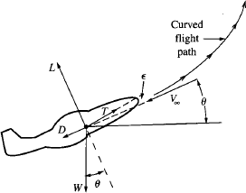

Fig.2.1.Climbingflight.
Theequationsofmotionforacceleratedflightalongacurvedflightpatharegivenby,
𝑑𝑉∞

𝑚
𝑑𝑡
𝑉2
=𝑇 cos𝜖−𝐷−𝑊sin𝜃

𝑚∞=𝐿cos∅+𝑇sin𝜖 cos∅−𝑊 cos𝜃
𝑟₁

(𝑉∞cos𝜃)²
𝑚
𝑟₂

=𝐿sin∅+𝑇 sin𝜖sin∅

Theequationsofmotionforsteady,unacceleratedclimbingflightalongastraightpatharegivenby,

𝑇cos𝜖−𝐷−𝑊 sin𝜃=0
SrinivasanEngineeringCollege,Perambalur–621212. AUCR2013
𝐿+𝑇sin𝜖−𝑊 cos𝜃=0
Thenassumethethrustlineisinthedirectionofflight.
𝑇−𝐷−𝑊sin𝜃=0
𝐿−𝑊cos𝜃=0
Sotheforcediagramis,
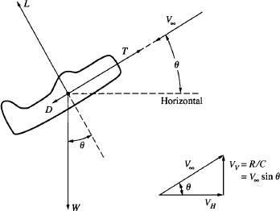
Fig.2.2.Forceandvelocitydiagramsforclimbingflight.
Thevelocityoftheairplane𝑉∞isresolvedintoitshorizontalandverticalcomponents
𝑉_{𝐻}and𝑉_{𝑉},respectively.Theverticalcomponentis,bydefinition,therareofclimboftheairplane;wedenotetherateofclimbby𝑅/𝐶.Fromthisdiagram,
𝑅/𝐶=𝑉∞sin𝜃
Takethefirstequationofmotion,
𝑇−𝐷−𝑊sin𝜃=0
𝑇 −𝐷

Whentheabovemultipliedwith𝑉∞,
(𝑇−𝐷)
=sin𝜃
𝑊

𝑉∞
𝑊 =𝑉∞sin𝜃

𝑇𝑉∞− 𝐷𝑉∞
𝑊 =𝑉∞sin𝜃=𝑅/𝐶
where,𝑇𝑉∞,isthepoweravailable,and𝐷𝑉∞,isthepowerrequiredtoovercomethedrag.So,
𝑇𝑉∞−𝐷𝑉∞=𝑒𝑥𝑐𝑒𝑠𝑠𝑝𝑜𝑤𝑒𝑟

Hence,

𝑅/𝐶=

𝑒𝑥𝑐𝑒𝑠𝑠𝑝𝑜𝑤𝑒𝑟

𝑊

Clearly, rate of climb depends on raw power in combination with the weight of theairplane. The higher the thrust, the lower the drag, and the lower the weight, the better the climbperformance.

Fromthesecondequationofmotion,

𝐿=𝑊cos𝜃

For steady climbing flight, lift is less than weight; indeed, for climbing flight, part ofthe weight of the airplane is supported by the thrust, and hence less lift is needed than for levelflight. In turn, this has an impact on drag; less lift means less drag due to lift. For a givenvelocity𝑉∞,thedraginclimbingflightislessthanthatforlevelflight.Fromthedragpolar,
𝐷=𝑞∞𝑆𝐶_{𝐷}=𝑞∞𝑆(𝐶_{𝐷,0}+𝐾𝐶²)
𝐿

where,

𝐿 𝑊 cos𝜃
∞

Thenthedragis,
𝐶_{𝐿}=𝑞 𝑆=

𝑞∞𝑆

𝑊cos𝜃²

𝐷=𝑞∞𝑆[𝐶_{𝐷,0}+𝐾(
)]
𝑞∞𝑆

Weknowthat,

𝐷=𝑞∞𝑆𝐶_{𝐷,0}+

(𝑇−𝐷)
𝐾𝑊²cos²𝜃

𝑞∞𝑆

𝑅/𝐶=𝑉∞sin𝜃=𝑉∞ 𝑊
𝑉∞
𝑉∞sin𝜃=𝑊[𝑇− (𝑞∞𝑆𝐶_{𝐷,0}+

𝐾𝑊²cos²𝜃
)]
𝑞∞𝑆

𝑇 1 𝑊
−1
𝑉∞sin𝜃=𝑉∞[ − 𝜌∞𝑉²( )
∞
𝑊 2 𝑆

𝐶𝐷,0−
𝑊2𝐾cos²𝜃
]
𝑆 𝜌∞𝑉²
∞

Theaboveequationisthekeytotheexactsolutionoftheclimbperformanceofanairplane.
GurunathK.–AE6501FlightDynamics|

Gliding(Unpowered)Flight
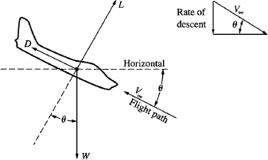
Wheneveranairplaneisflyingsuchthatthepowerrequiredislarger than the power available, it willdescendratherthanclimb.Intheultimate situation, there is no powerat all; in this case, the airplane will beingliding,orunpowered,flight.Thiswill occur for a conventional airplanewhen the engine quits during flight.TheforcediagramforanunpoweredaircraftindescendingflightisshowninFig.2.3.Forsteady,unaccelerateddescent,where𝜃istheequilibrium
glideangle, Fig.2.3.Forceandvelocitydiagramsforglidingflight.

𝐿=𝑊cos𝜃
𝐷=𝑊sin𝜃

Theequilibriumglideangleis
SrinivasanEngineeringCollege,Perambalur–621212. AUCR2013

𝐷 sin𝜃
=
𝐿 cos𝜃
1

tan𝜃=

𝐿/𝐷

Clearly, the glide angle is strictly a function of the lift-to-drag ratio; the higher the 𝐿/𝐷,the shallower the glide angle. From above equation, the smallest equilibrium glide angle occursat(𝐿/𝐷)_{𝑚𝑎𝑥}.

1
tan𝜃_{𝑚𝑖𝑛}=(𝐿/𝐷)
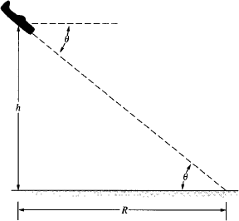
Foranaircraftatagivenaltitudeh,thisisthecasefor maximumhorizontaldistancecoveredovertheground.Thisdistance,denotedbyR,isillustrated inFig.2.4foraconstant𝜃.
Theequilibriumglideangle𝜃doesnot depend on altitude or wing loading, orthe like; it simply depends on the lift-to-dragratio.

𝑚𝑎𝑥

However, to achieve a given 𝐿/𝐷 ata given altitude, the aircraft must fly at aspecified velocity 𝑉∞, called the equilibriumglide velocity, and this value of 𝑉∞doesdependonthealtitudeandwingloading,as
follows.Since Fig.2.4.Rangecoveredinonequilibriumguide.
𝐿=𝑊 cos𝜃

1𝜌 𝑉²𝑆𝐶

=𝑊cos𝜃

2 ∞ ∞ 𝐿

2cos𝜃𝑊

𝑉∞=√𝜌
∞
Clearly,theequilibriumglidevelocitydepends on altitude and wing loading. The valueof 𝐶_{𝐿}in above equation is that particular valuewhich corresponds to the specific value of 𝐿/𝐷used in the equilibrium glide angle. Recall thatboth 𝐶_{𝐿}and 𝐿/𝐷 are aerodynamic characteristicsof the aircraft that vary with angle of attack, assketched in Fig. 2.5. Note from Fig. 5.4 1 that aspecific value of 𝐿/𝐷 say (𝐿/𝐷)₁, corresponds toa specific angle of attack ∞₁, which in turn dictatesthe lift coefficient (𝐶_{𝐿})₁,. If 𝐿/𝐷 is held constantthroughout the glide path, then 𝐶_{𝐿}is constant alongtheglidepath.However,theequilibriumvelocityalong this glide path will change with altitude,decreasingwithdecreasingaltitude.
𝐶_{𝐿}𝑆

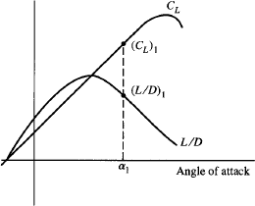
Fig. 2.5. Sketch of the variation of𝐶𝐿and 𝐿/𝐷versusangleofattackforagivenairplane.

Consider again the case for a minimum glide angle. For a typical modem airplane,(𝐿/𝐷)𝑚𝑎𝑥 = 15, and for this case from minimum glide angle equation 𝜃𝑚𝑖𝑛 = 3.8° - a smallangle.Hence,wecanreasonablyassumecos𝜃=1forsuchcases.Recall,
SrinivasanEngineeringCollege,Perambalur–621212. AUCR2013

𝐿 1
( ) = √

𝐷𝑚𝑎𝑥
4𝐶_{𝐷,0}𝐾

andfor𝐿=𝑊,thevelocityatwhich𝐿/𝐷ismaximumisgivenby,

2
𝑉(𝐿/𝐷)𝑚𝑎𝑥=(

𝐾 𝑊
√
1/2

)

𝜌∞
𝐶𝐷,0 𝑆

Hence,for𝜃_{𝑚𝑖𝑛},theaboveistheequilibriumvelocityalongtheglidepath.
The rate of descent, sometimes called the sink rate, is the downward vertical velocity oftheairplane𝑉_{𝑉}. It is, forunpoweredflight,theanalogofrateofclimb forpoweredflight.AsseenintheinsertinFig. 2.3,
𝑅𝑎𝑡𝑒𝑜𝑓𝑑𝑒𝑠𝑐𝑒𝑛𝑡=𝑉_{𝑉}=𝑉∞ sin𝜃
Rateof descentis apositivenumberinthedownward direction. MultiplyingDragby
𝑉∞,wehave
𝐷𝑉∞=𝑊sin𝜃 𝑉∞=𝑊𝑉_{𝑉}
𝐷𝑉∞
𝑉_{𝑉}=𝑊
𝐷𝑉∞, is simply the power required for steady, level flight. Hence, the variation of 𝑉_{𝑉}withvelocity is the same as the power required curve, divided by the weight. This variation issketchedinFig.2.6,withpositivevaluesof𝑉_{𝑉},increasingalongthedownwardverticalaxis.Clearly,minimumsinkrateoccursattheflightvelocityforminimumpowerrequired.Hencetheconditionsforminimumsinkratearethesameasthosefor(PR)min,
𝐶3/2
^{𝐿} 𝑖𝑠𝑚𝑎𝑥𝑖𝑚𝑢𝑚
𝐶_{𝐷}

2
𝑉∞𝑚𝑖𝑛.𝑠𝑖𝑛𝑘𝑟𝑎𝑡𝑒=(

𝐾 𝑊
√
1/2

)

𝜌∞ 3𝐶_{𝐷,0}𝑆
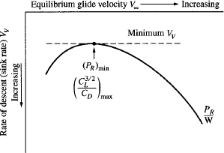
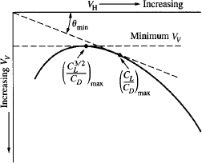

Fig.2.6.Rateofdescentversusequilibriumglidevelocity
GurunathK.–AE6501FlightDynamics|
Fig.2.7.Hodographforunpoweredflight.

ThehodographdiagramissketchedinFig.2.7wherealinefromtheorigintangenttothe hodograph curve defines 𝜃𝑚𝑖𝑛. This sketch is shown just to emphasize that the minimumsinkratedoesnotcorrespondtotheminimumglideangle.Theflightvelocityfortheminimum
sinkratelessthanthatforminimumglideangle.Ananalyticalexpressionforthesinkrate 𝑉_{𝑉}canbeobtainedasfollows.
1 2
𝐿=𝑊cos𝜃=2𝜌∞𝑉∞𝑆𝐶_{𝐿}

2cos𝜃𝑊

Then,
∞
𝑉∞=√𝜌
𝐶_{𝐿}𝑆

2cos𝜃 𝑊

𝑅𝑎𝑡𝑒𝑜𝑓𝑑𝑒𝑠𝑐𝑒𝑛𝑡=𝑉𝑉=𝑉∞sin𝜃=sin𝜃√𝜌
∞
𝐶_{𝐿}𝑆

Dividingdragbylift,weobtain

So,

sin𝜃=

𝐷
cos𝜃=
𝐿

𝐶_{𝐷}

𝐶_{𝐿}

cos𝜃

𝐶_{𝐷}
2cos𝜃𝑊
2cos³𝜃 𝑊

𝑉_{𝑉}=𝐶
cos𝜃√
𝜌𝐶
=√
𝑆 𝜌
(𝐶³/𝐶²) 𝑆

𝐿 ∞ 𝐿

Bymakingtheassumptionthatcos𝜃=1,
∞ 𝐿 𝐷

2 𝑊

𝑉_{𝑉}=√𝜌
(𝐶³/𝐶²) 𝑆

∞ 𝐿 𝐷

Aboveequationexplicitlyshowsthat(𝑉_{𝑉})_{𝑚𝑖𝑛}
occursat(𝐶^{3/2}/𝐶)

𝑚𝑎𝑥
𝐿 𝐷

.Italsoshows

thatthesinkratedecreaseswithdecreasingaltitudeandincreasesasthesquarerootofthewingloading.

TimetoClimb
Therateofclimb,bydefinition,istheverticalcomponentoftheairplane'svelocity,whichissimplythetimerateofchangeofaltitude𝑑ℎ/𝑑𝑡.Hence,
𝑑ℎ

𝑑𝑡
Or
=𝑅/𝐶

𝑑ℎ

𝑑𝑡=

𝑅/𝐶

In above equation 𝑅/𝐶 is a function of altitude, and 𝑑𝑡 is the small increment in timerequiredtoclimbthesmallheight𝑑ℎatagiveninstantaneousaltitude.Thetimetoclimbfromone altitude ℎ₁to another ℎ₂is obtained by integrating above equation between the twoaltitudes:

ℎ2
SrinivasanEngineeringCollege,Perambalur–621212. AUCR2013
𝑡=∫
𝑑ℎ

Normally,theperformancecharacteristic labeled time to climb isconsideredfromsealevel,whereℎ₁=
0. Hence, the timc to climb from sealeveltoanygivenaltitudeℎ₂is,
ℎ1 𝑅/𝐶

ℎ2
𝑡=∫
0
𝑑ℎ

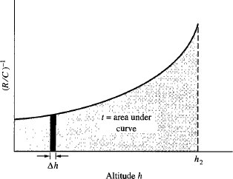
𝑅/𝐶

If the maximum rate of climb isused at each altitude, then 𝑡 becomesthe minimum time to climb to altitudeℎ₂.

ℎ2
GurunathK.–AE6501FlightDynamics|
𝑡_{𝑚𝑖𝑛}=∫
0
𝑑ℎ(𝑅/𝐶)_{𝑚𝑎𝑥}

Fig.2.8.Graphicalrepresentationofthetimetoclimbtoaltitudeℎ2.

LevelTurn
TheflightpathandforcesforanairplaneinalevelturnaresketchedinFig.2.9.Here,theflightpathiscurved,incontrasttotherectilinearmotionstudiedinsteadyflight.
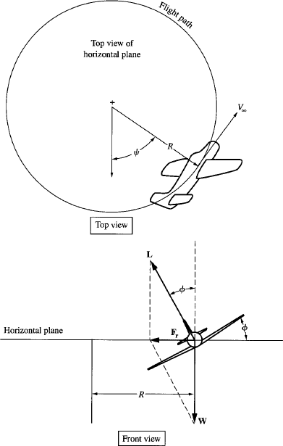
Fig.2.9.Anairplaneinalevelturn.
Bydefinition,alevelturnisoneinwhichthecurvedflightpathisinahorizontalplaneparalleltotheplaneoftheground;thatis,inalevelturnthealtituderemainsconstant.
The relationship between forces required for a level turn is illustrated in Fig. 2.9. Here,theairplaneisbankedthroughtherollangle∅.Themagnitudeofthelift𝐿andthevalueof∅are adjusted such that the vertical component of lift, denoted by 𝐿 𝑐𝑜𝑠 ∅, exactly equals theweight,
𝐿 𝑐𝑜𝑠∅=𝑊
Under this condition, the altitude of the airplane will remain constant. Hence, the aboveequation applies only to the case of a level turn; indeed, it is the necessary condition for a levelturn. Another way of stating this necessary condition is to consider the resultant force 𝐹_{𝑟}, whichisthevectorsumofvectors𝐿and 𝑊.

As shown in Fig. 2.9, for the case of the level turn, the magnitude and direction of 𝐿 areadjusted to be just right so that the vector sum of 𝐿 and 𝑊 results in 𝐹𝑟always being in thehorizontalplane.Inthisfashionthealtituderemainsconstant.
SrinivasanEngineeringCollege,Perambalur–621212. AUCR2013
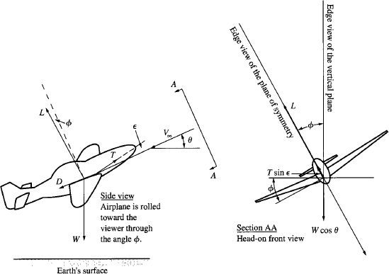

Fig.2.10.Airplaneinclimbingflightandrolledthroughangle∅.
The generalized force diagram for an airplane in climbing and banking flight is given inFig. 2.10. When this figure is specialized for level flight, that is, 𝜃 = 0, and assuming the thrustvectorisparalleltothefree-streamdirection,thatis,𝜖=0,thentheforcediagramforalevelturnisobtainedassketchedinFig.2.9.Thegoverningequationofmotionisgivenby
(𝑉∞cos𝜃)²

𝑚
𝑟₂
=𝐿sin∅+𝑇 sin𝜖sin∅

Theaboveequationisspecializedforthecaseof𝜃=0and𝜖=0,namely,
𝑉2
𝑚∞=𝐿sin∅
𝑟₂
Weseethat𝑟₂isthelocalradiusofcurvatureoftheflightpathinthehorizontalplane.This is the same as the radius 𝑅 shown in Fig. 2.9. Hence, for a level turn, the governingequationofmotionis,
𝑉2
∞
𝑚 =𝐿sin∅
𝑅
Theaboveequationissimplyaphysicalstatementthatthecentrifugalforce𝑚𝑉²/𝑅
∞
balancedbytheradialforce𝐿sin∅.
Thetwoperformancecharacteristicsofgreatestimportanceinturningflightare
    - Theturnradius𝑅.
    - The turnrate𝜔≡𝑑𝜓/𝑑𝑡,where𝜓isdefinedinFig.2.9.Theturnrateissimplythelocalangularvelocityoftheairplanealongthecurvedflightpath.

Thesecharacteristicsareparticularlygermanetocombataircraft.Forsuperiordog-fighting capability, the airplane should have the smallest possible turn radius R and thefastestpossibleturnrate𝜔.
SrinivasanEngineeringCollege,Perambalur–621212. AUCR2013
Theairplaneisturningduetotheradialforce𝐹_{𝑟}.Thelargerthemagnitudeofthisforce
𝐹_{𝑟},thetighterandfasterwillbetheturn.Themagnitude𝐹_{𝑟}isthehorizontalcomponentofthelift𝐿sin∅.As𝐿increases,𝐹_{𝑟}increasesfortworeasons:
- Thelengthoftheliftvectorincreases.
- ∅increasesbecauseforalevelturn,𝐿𝑐𝑜𝑠∅mustremainconstant,namely,equaltoW.
Hence, the lift vector 𝐿 controls the turn; when a pilot goes to turn the airplane, he orsherollstheairplaneinordertopointtheliftvectorinthegeneraldirectionoftheturn.Keepin mind that 𝐿 and ∅, are not independent; they are related by the condition for a level turn,whichcanbewrittenas

𝑊
𝑐𝑜𝑠 ∅=
𝐿
1
=
𝐿/𝑊

Inaboveequation,theratio𝐿/𝑊isanimportantparameterinturningperformance;itisdefinedastheloadfactor𝑛,hence
1
𝑐𝑜𝑠∅=
𝑛
1
∅=𝐴𝑟𝑐𝑐𝑜𝑠
𝑛
Therollangle∅dependsonlyontheloadfactor;ifyouknowtheloadfactor,thenyouknow ∅, and vice versa. The turn performance of an airplane strongly depends on the loadfactor.
Toobtainanexpressionfortheturnradius,insert𝑚=𝑊/𝑔inthegoverningequationofmotionforlevelturn,andsolvefor𝑅.

𝑊
𝑅=
𝑉2
=
∞
∞
𝑉2

andfromthetrigonometricidentity,
𝐿𝑔sin∅
𝑔𝑛sin∅

sin²∅+cos²∅=1
sin²∅+(1) =1
2
𝑛

Thentheturnradiusisexpressedas,

𝑅=
sin∅=√1−

𝑉2
∞

𝑔√𝑛²−1
1
𝑛2=
1
√𝑛²−1
𝑛

Fromaboveequation,theturnradiusdependsonlyon𝑉∞and𝑛.Toobtainthesmallestpossible𝑅,wewant

  - Thehighestpossibleloadfactor(i.e.,thehighestpossible𝐿/𝑊).
SrinivasanEngineeringCollege,Perambalur–621212. AUCR2013
  - Thelowestpossiblevelocity.
Toobtain anexpressionfortheturn rate𝜔, returnto Fig. 2.9and recallfromphysicsthatangularvelocityisrelatedto𝑅and𝑉∞as

Thenwehave,

𝜔=
𝑑𝜓

𝑑𝑡
𝑉∞
=
𝑅

𝜔=
𝑔√𝑛²−1

𝑉∞

Toobtainthelargestpossibleturnrate,wewant
    - Thehighestpossibleloadfactor.
    - Thelowestpossiblevelocity.

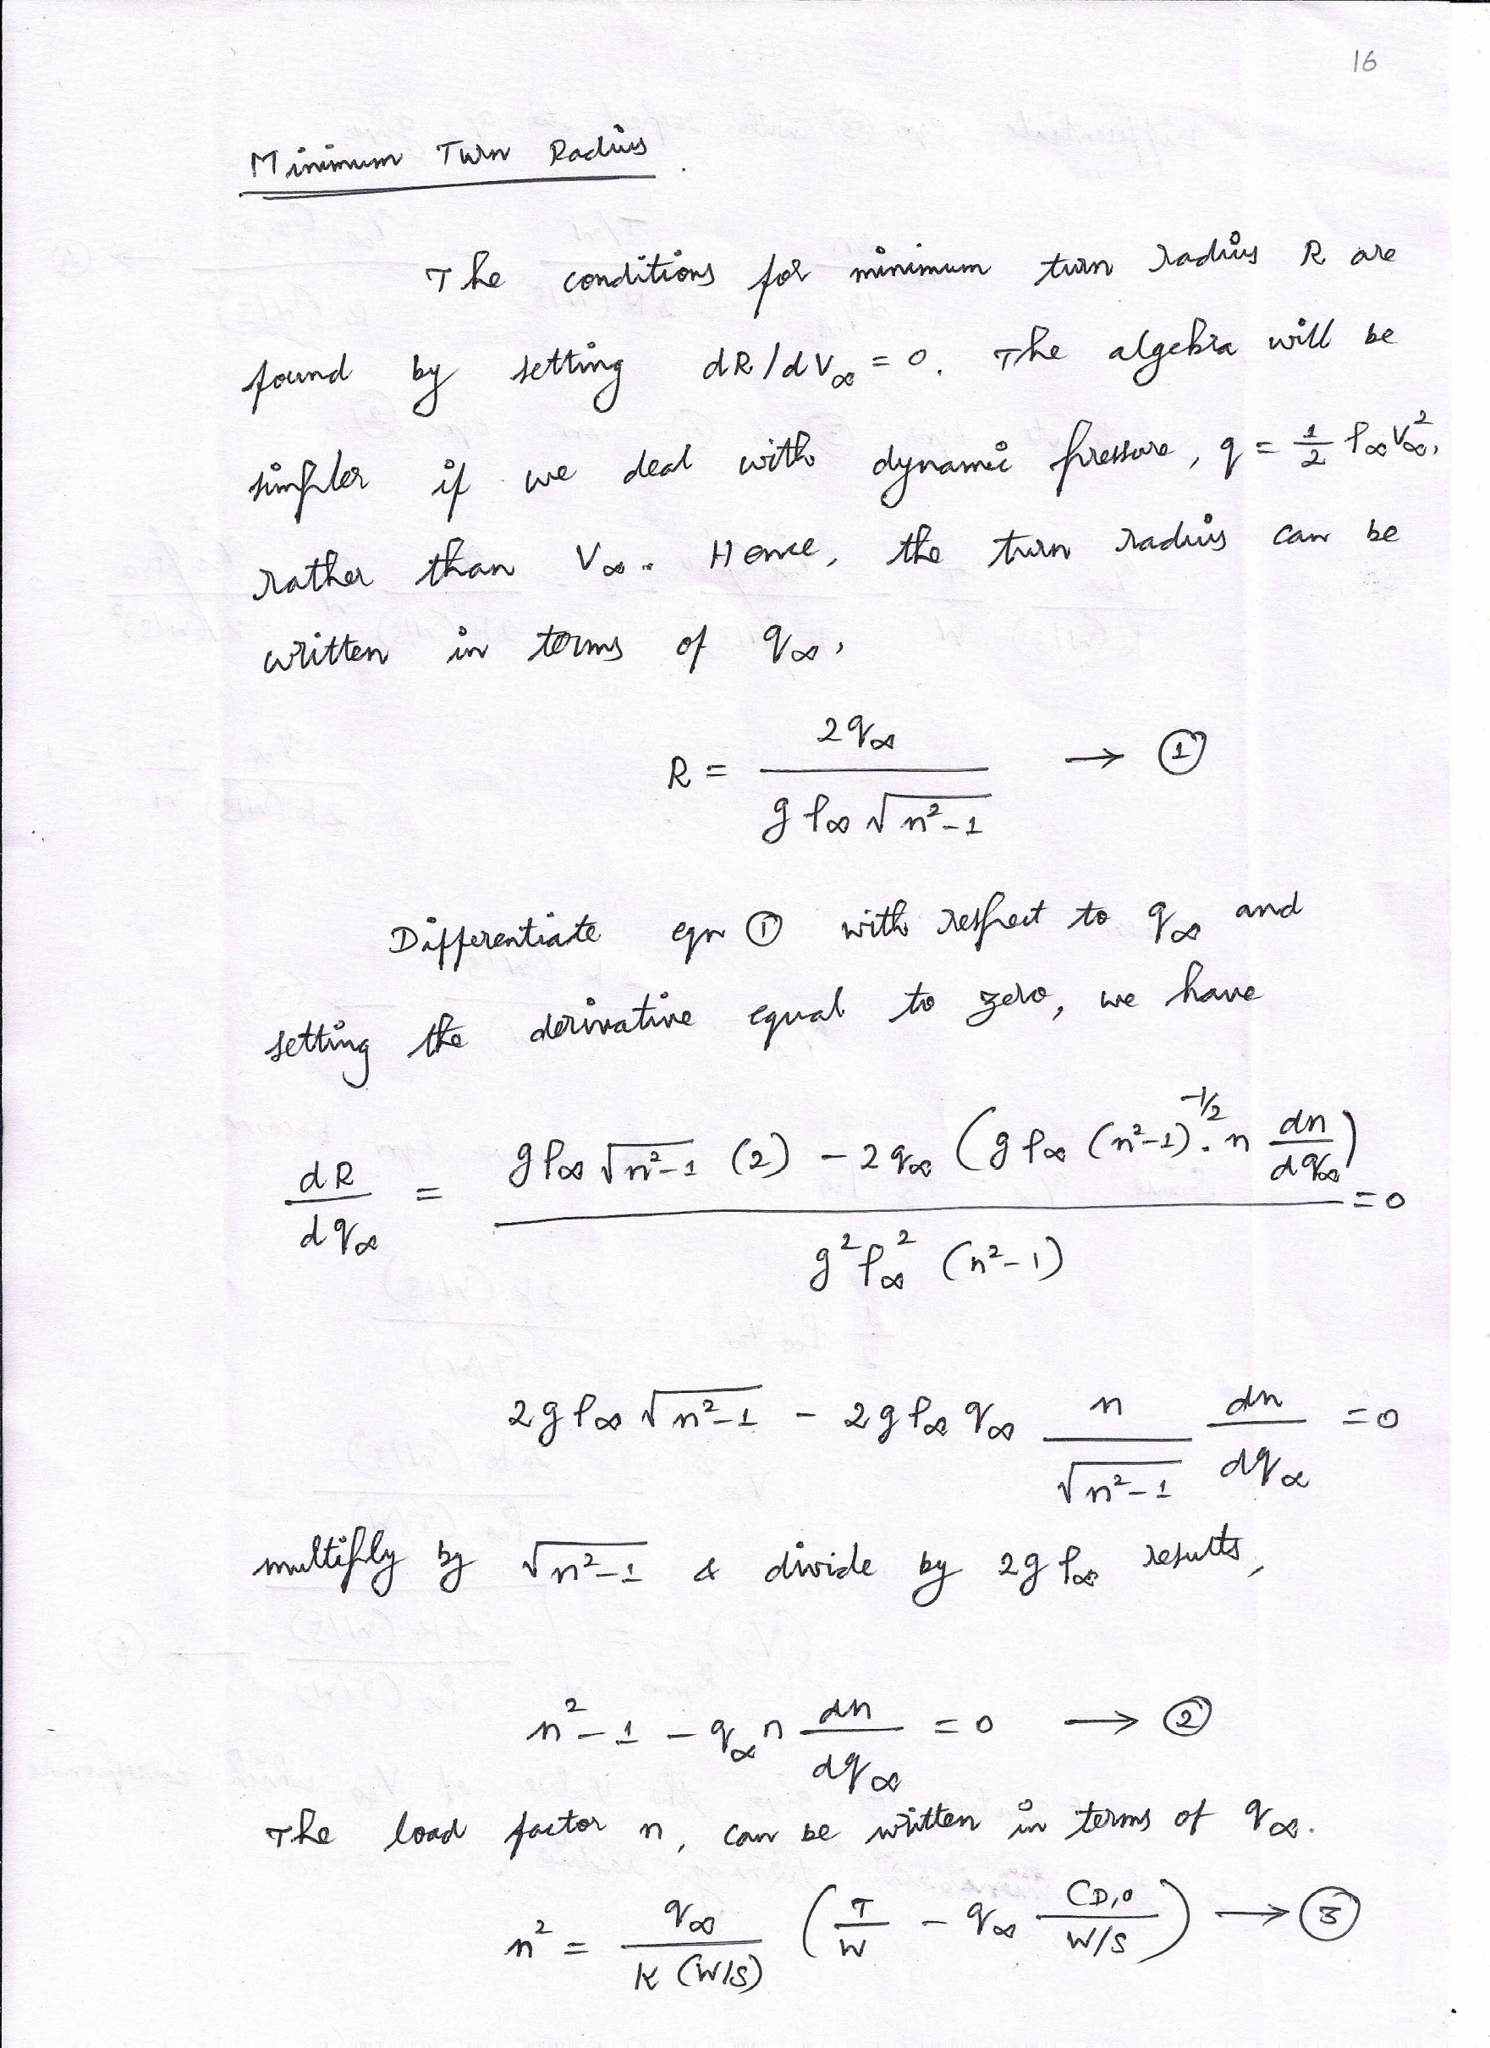

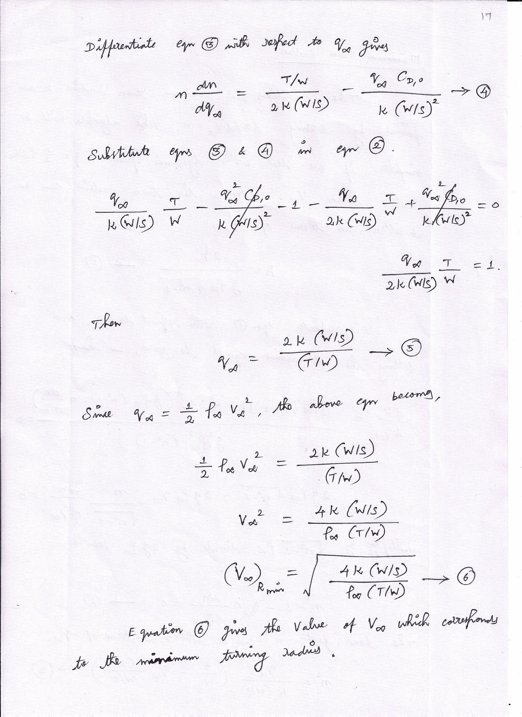

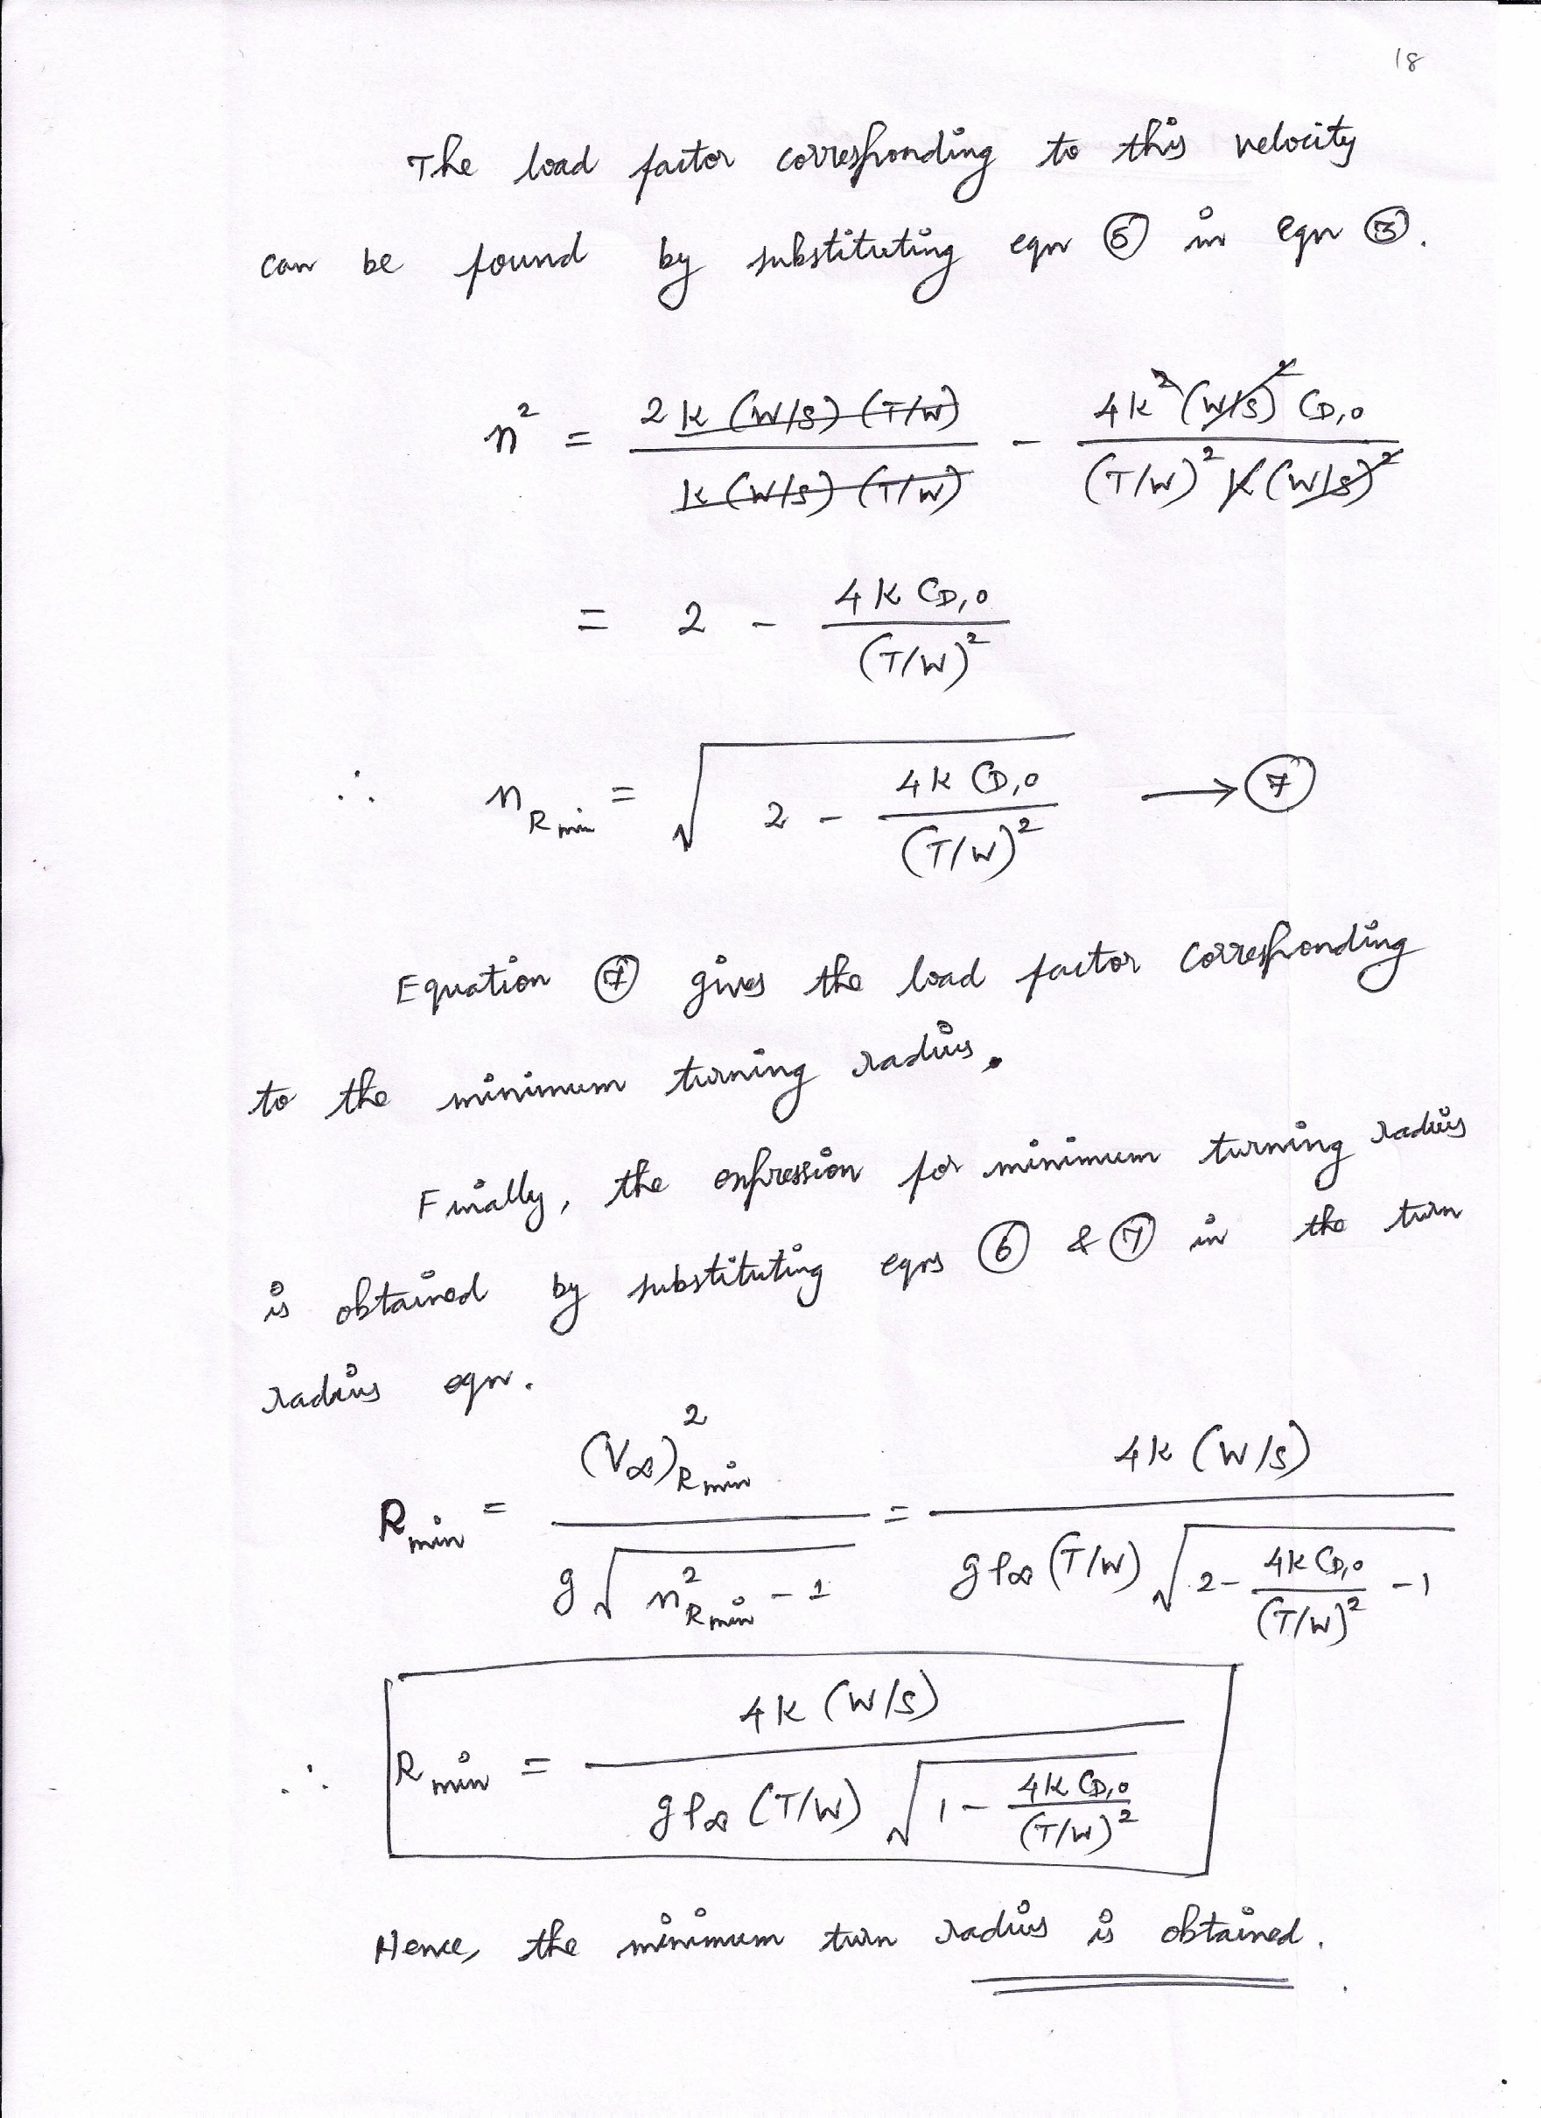

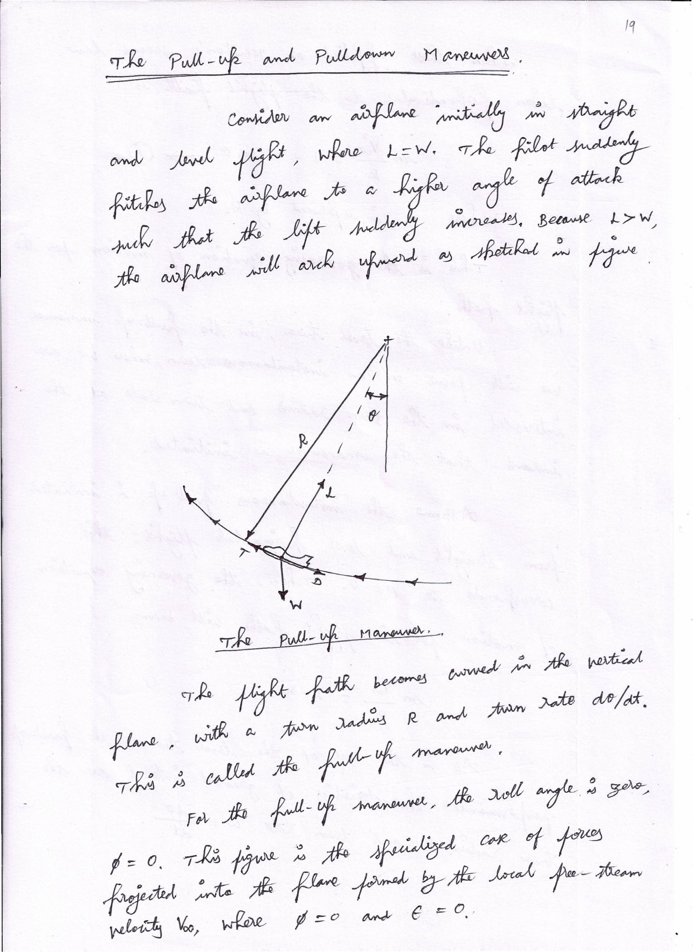

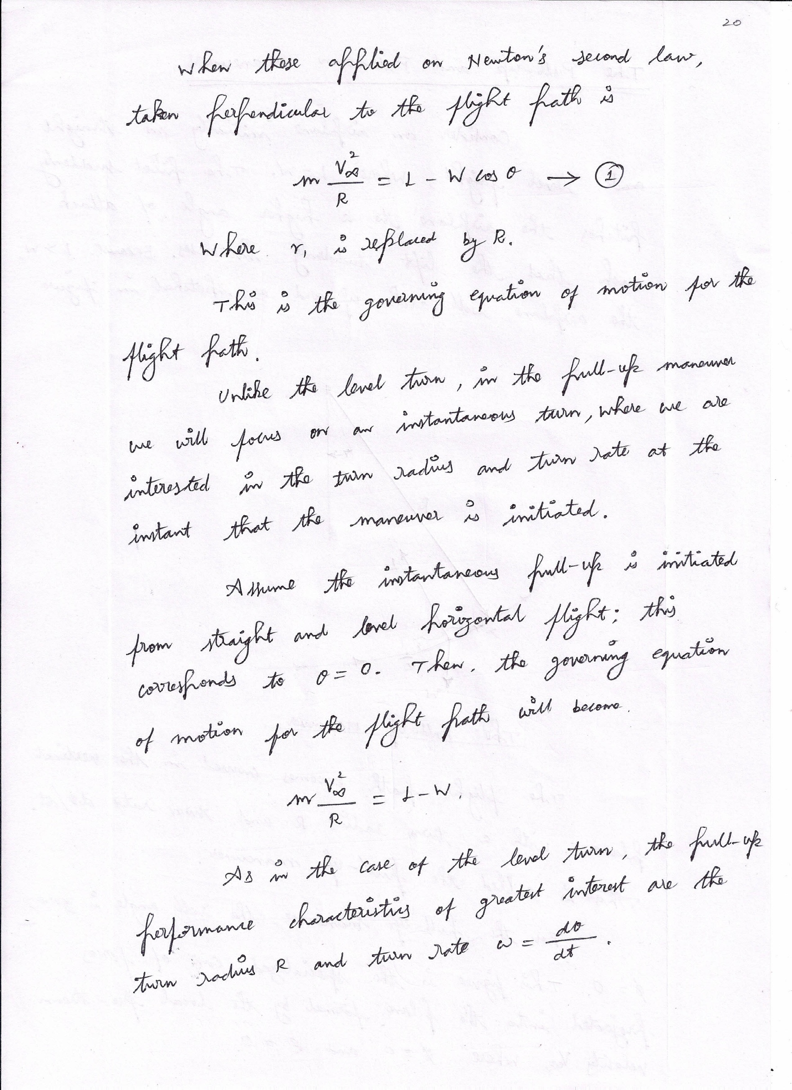

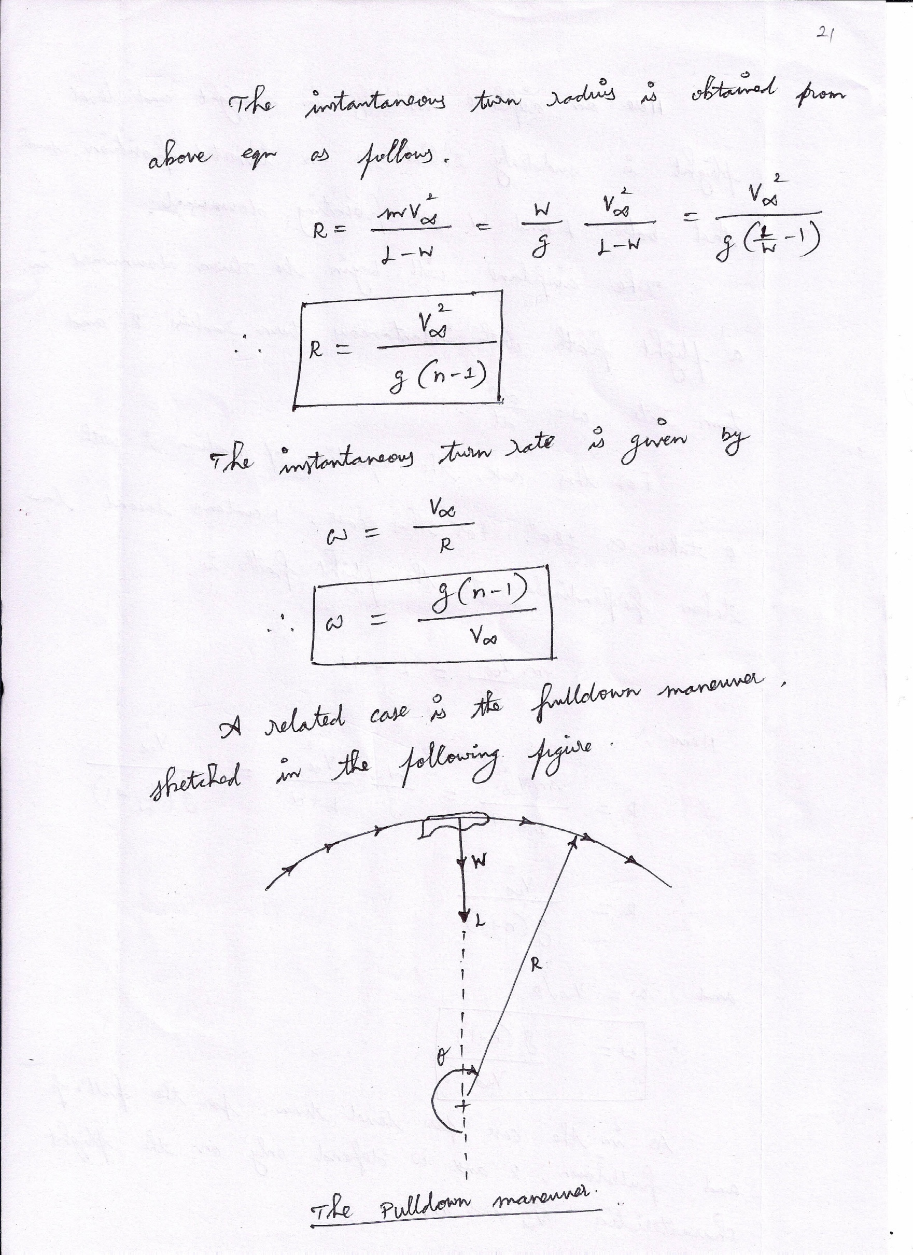

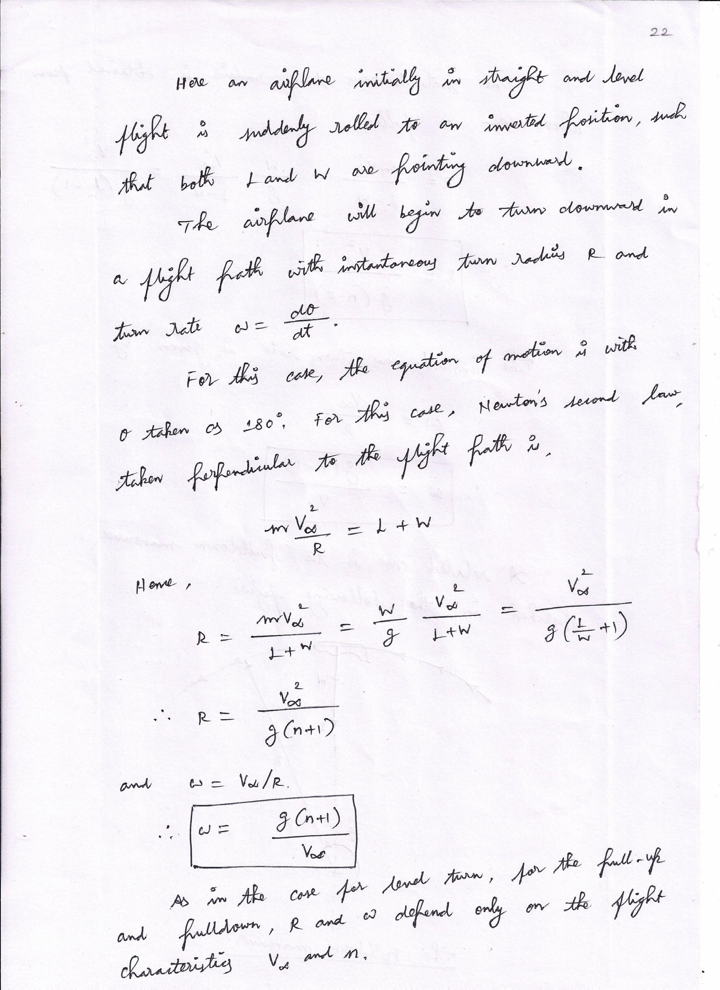

TheV-nDiagram
Therearetwocategoriesofstructurallimitationsonthemaximumloadfactorallowedforagiven airplane.
    - Limit load factor. This isthe boundary associatedwith permanent structural deformationof one or more parts of the airplane If 𝑛 is less than the limit load factor, the structuremaydeflectduringamanoeuvre,butitwillreturntoitsoriginalstatewhen𝑛=1.If𝑛is greater than the limit load factor, then the airplane structure will experience a permanentdeformation,thatis,itwillincurstructuraldamage.
    - Ultimateloadfactor.Thisistheboundaryassociatedwithoutrightstructuralfailure.If𝑛
isgreaterthantheultimateloadfactor,partsoftheairplanewillbreak.
BoththeaerodynamicandstructurallimitationsforagivenairplaneareillustratedintheV-n diagram, a plot of load factor versus flight velocity, as given in Figure 2.11. A V-n diagramis a type of "flight envelope" for a given airplane; it establishes the manoeuvre boundaries. Thecurve between points A and B represents the aerodynamic limit on load factor imposed by(𝐶_{𝐿})_{𝑚𝑎𝑥},Thiscurveisliterallyaplotoffollowingequation.

1
𝑛 = 𝜌

𝑉2(𝐶𝐿)𝑚𝑎𝑥

𝑚𝑎𝑥
2 ∞ ∞
𝑊/𝑆

The region above curve AB in the V-n diagram is the stall region. To understand thesignificanceofcurveABbetter,consideranairplaneflyingatvelocity𝑉₁,where𝑉₁isshown.Assumetheairplaneisatanangleofattacksuchthat𝐶_{𝐿}<(𝐶_{𝐿})_{𝑚𝑎𝑥}.
This flight condition is represented by point 1. Now assume the angle of attack is increasedto that for (𝐶𝐿)𝑚𝑎𝑥, keeping the velocity constant at 𝑉1. The lift increases to its maximum valueforthegiven𝑉₁,andhencethelocalfactor𝑛=𝐿/𝑊reachesitsmaximumvalueforthegiven
𝑉₁. This value of 𝑛_{𝑚𝑎𝑥}is given by above, and the corresponding flight condition is given bypoint2.Iftheangleofattackisincreasedfurther,thewingstallsandtheloadfactordecreases.Therefore,point3isunobtainableinflight.Point-3isinthestallregionoftheV-ndiagram.
Consequently, point 2 represents the highest possible load factor that can be obtained at thegiven velocity 𝑉₁. As 𝑉∞is increased, say, to a value of 𝑉₄, then the maximum possible loadfactor 𝑛_{𝑚𝑎𝑥}also increases, as given by point 4. However, 𝑛_{𝑚𝑎𝑥}cannot be allowed to increaseindefinitely.Itisconstrainedbythestructurallimitloadfactor,givenbypointB.
The horizontal line BC denotes the positive limit load factor in the V-n diagram. The flightvelocity corresponding to B is designated as 𝑉∗. At velocities higher than 𝑉∗, say, 𝑉₅, theairplane must fly at values of 𝐶_{𝐿}less than (𝐶_{𝐿})_{𝑚𝑎𝑥}so that the positive limit load factor is notexceeded. If flight at (𝐶_{𝐿})_{𝑚𝑎𝑥}is obtained at velocity 𝑉₅, corresponding to point 5, then structuraldamageorpossiblystructuralfailurewilloccur.Theright-handsideoftheV-ndiagram,lineCD, is a high-speed limit. At flight velocities higher than this limit the dynamic pressure ishigherthanthedesignrangefortheairplane.
Thiswillexacerbatetheconsequencesofotherundesirablephenomenathatmayoccurinhigh speed flight, such as encountering a critical gust and experiencing destructive flutter,aileronreversal,wingorsurfacedivergence,andseverecompressibilitybuffeting.Anyoneofthese phenomena in combination with the high dynamic pressure could cause structural damageorfailure.

43
GurunathK.–AE6501FlightDynamics|

SrinivasanEngineeringCollege,Perambalur–621212. AUCR2013
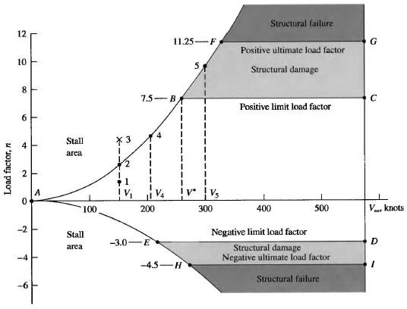
Fig.2.11.TheV-ndiagramforatypicaljettraineraircraft.
The high-speed limit velocity is a red-line speed for the airplane; it should never beexceeded.Bydesign,itishigherthanthelevelfightmaximumcruisevelocity𝑉_{𝑚𝑎𝑥},byatleastafactorof1.2. Itmaybeashighastheterminaldivevelocityoftheaircraft.Thebottompartof the V-n diagram, given by curve AE and the horizontal line ED corresponds to negativeabsolute angles of attack, that is, negative lift, and hence the load factors are negative quantities.Curve AE defines the stall limit. Line ED gives the negative limit load factor, beyond whichstructural damage will occur. Line HI gives the negative ultimate load factor beyond whichstructuralfailurewilloccur.
For instantaneous manoeuvre performance, point B on the V-n diagram is veryimportant. This point is called the manoeuvre point. At this point, both𝐶_{𝐿}and 𝑛aresimultaneouslyattheirhighestpossiblevaluesthatcanbeobtainedanywherethroughouttheallowable flight envelope of the airplane. In turn, this point is simultaneously corresponding tothesmallestpossibleinstantaneousturnradiusandthelargestpossibleinstantaneousturnratefortheairplane.
ThevelocitycorrespondingtopointBiscalledthecornervelocityandisdesignatedby
𝑉∗.ThecornervelocitycanbeobtainedbysolvingEq.(6.23)forvelocity,yielding

𝑉∗=√2𝑛_{𝑚𝑎𝑥} 𝑊
𝜌∞(𝐶𝐿)𝑚𝑎𝑥𝑆
Inaboveequation,thevalueof𝑛_{𝑚𝑎𝑥}correspondstothatatpointBinFigure2.11.Thecornervelocityisaninterestingdividingline.Atflightvelocitieslessthan𝑉∗,itisnotpossibleto structurally damage the airplane due to the generation of too much lift. In contrast, atvelocities greater than 𝑉∗, lift can be obtained that can structurally damage the aircraft, and thepilotmustmakecertaintoavoidsuchacase.

44
GurunathK.–AE6501FlightDynamics|

GurunathK.–AE6501FlightDynamics|
UnitIII StaticLongitudinalStability

AircraftAxes
The dashed lines in Figure 3.1 describe an aircraft’s x-y-z fixed body axes,emanating from the centre of gravity. This system, with the mutually perpendicular axes infixedreferencetotheaircraft,istheonemostpilotsrecognize.Theexactalignmentisabitarbitrary.Boeingsetsthex-axisparalleltothefloorboardsinitsaircraft.Thegeometricalplane that intersects both the x and z body axes is called the plane of symmetry, since astandard aircraft layout is symmetrical left and right (Figure 3.1, bottom). There arealternative axis systems (zero-lift body axis, stability axis, for example). For pilots, the windaxis system is the most useful, because it best helps in visualizing how aircraft actuallybehave.
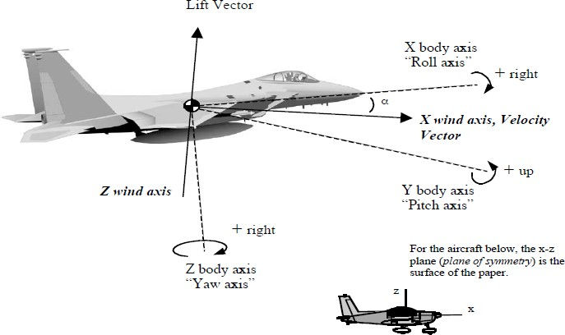
Fig.3.1.AircraftAxes
The wind axis system sets the x-axis in alignment with the aircraft’s velocity vector,whichpointsinthedirectioninwhichtheaircraftisactuallymoving.Usuallythevelocityvector/windaxisliesontheaircraft’splaneofsymmetry,butnotalways.Iftheaircraftisina sideslip, the velocity vector moves off the plane to some sideslip angle, β, as Figure 3.2illustrates. The velocity vector also changes direction when aircraft angle of attack, α,changes.
The velocity vector is projected onto the x-z plane of symmetry for measuring α, andontothex-yplaneformeasuringβ.Thusitcontainsbothαandβ,asthebottomofFigure3.2shows.Boththeyandzwindaxesremainperpendiculartothexwindaxis.So,as the velocity vector changes direction, these axes change orientation, as well. Thus they’recarriedalongbytheaircraft,butnot“fixed.”Here’stheessenceofwhythevelocityvectoris important to pilots: Much of aircraft response is pinned to it, both during normal flight andinunusualattitudes.

Laterallyanddirectionallystableaircraftnormallytendtorollawayfrom,butyawtoward,thevelocityvectorwhenthevectorisofftheplaneofsymmetry.Unstableaircraftlacktheseinstincts,orlacktheminpropercombination.
SrinivasanEngineeringCollege,Perambalur–621212. AUCR2013
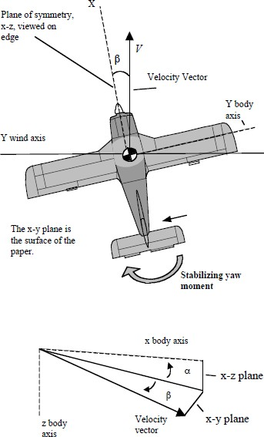
Inaddition,atrimmed,longitudinallystableaircrafttendstoholdthevelocity vectorataconstantangleofattack,unlesscommandedotherwise.Anunstableaircraftdoesnot.
Aerodynamicallystableaircrafttendtoroll,pitch,andyawaroundtheirrespectivewindaxes—notaroundtheirfixedbodyaxes,asmostpilotsaretaught.
The picture becomes morecomplicated when those axes thenbegin to change their direction inspace, but a simplified notion ofwind axis rotation is often helpfulinvisualizingmanoeuvringflight.
There’sanotheraxissystem,basedontheaircraft’sdistribution of mass: the inertia orprincipalaxissystem.Themomentsofinertiaaboutthethree,mutually perpendicular, principalaxes determine how quickly ratesof roll, pitch and yaw can changearoundtheaircraft’scentreofgravity.
Fig.3.2.SideslipAngle,β
For example, an aircraft with tip tanks has more x-axis roll inertia when the tanksarefullthanwhenempty,andforagivenairspeed,altitude,andailerondeflectionwilltakelongertoachievearollrate.Itwillalsotakelongertostoprolling.
Theprincipalaxesarethelinesaroundwhichmassissymmetricallyarranged.Theymay not always be shown as coincident with the aircraft fixed body axes—although, becauseaircraft are essentially symmetrical, they’re often close enough to be considered as such.Differencesinmomentsofinertiaaroundeachaxiscanleadtovariouscouplingeffects.

GurunathK.–AE6501FlightDynamics|

LiftVector
A directionally stable aircraft returns the velocity vector to the plane of symmetry ifthevectorbecomesdisplacedtosomesideslipangle,β(asthe“stabilizingyawmoment”isdoing in Figure 3.2). In coordinated flight, the velocity vector lies on the plane of symmetry,asdoestheliftvector.
As illustrated in Figure 3.1, the lift vector is the upward projection of the z wind axis.Since lift is perpendicular to the air stream generated by the aircraft’s velocity, it makessensetothinkofitsvectorinwindaxisterms.Fighterpilotstalkcrypticallyofkeepingthelift vector on the bogey, while an instructor might direct an inverted-attitude recovery bysaying “roll the lift vector toward the sky.” They generally mean a fixed vector perpendiculartothewingspan—boltedon,figurativelyspeaking.
That’s sufficient and appropriate most of the time. The direction relative to thehorizon of the lift vector so defined has a profound effect on an aircraft’s manoeuvringperformance, but it’s also possible to consider the lift vector as free to rotate around thex-axis, as it does in uncoordinated flight. For example, if a pilot uses top rudder (fuselagelift) to keep the nose up during a steep bank, the lift vector will tilt toward the high wing.Sometimes it’s useful to think of the lift vector as staying oriented in space while the aircraftrotates beneath it, as it does, essentially at least, during a properly flown “slow” roll. Halfwaythrough the slow roll, when the pilot pushes on the stick and the aircraft is producing liftinverted, the lift vector points heavenward, as it does normally. At each knife-edge, whenthewingsareunloadedandthe pilotpressestop ruddersothatthefuselageisusedbrieflyforlift,thevectorstillpointsheavenward,butouttheside.We’llrefertoafixedorfreeliftvector,asthesituationrequires.

Signs,Moments,Symbols
In the sign system used with the axis notation, positive values are in the directionshown by the curved arrows in Figure 3.1, negative values are opposite. For example, whenyou pull the stick back and add left aileron, you’re generating a positive pitching momentandanegativerollingmoment(thereforeapositivepitchrateandangle,andanegativerollrateandangle).Thesignsarenotrelatedtotheaircraft’sattituderelativetotheearthortothepullofgravity.
Amomentisaforceproducingrotationaroundanaxis.Anaerodynamicmomentistheproductofaforceactingonasurface—saythecentreofpressureofaverticalstabilizerwith a deflected rudder—times the perpendicular distance from that surface to the respectiveaxis—thez-axisforadeflectedrudder.Whenanaircraftisinequilibriumaboutanaxis,allthepositiveandnegativemomentsaroundtheaxissumtozero.
Theprimarymoments;aileronsproducerollingmoments,elevatorspitchingmoments,ruddersyawingmoments,butthere’safurthercollectionofdirectandcross-coupledmomentsessentialtoaircraftcontrolandoftencomplicitinunusualattitudes.

SrinivasanEngineeringCollege,Perambalur–621212. AUCR2013

Axis | MomentApplied | AngularVelocity | AngularPosition | MomentofInertia | ControlDeflection
x | l | Rollrate,p | Rollangle,φ(phi) | RollInertia,Ixx | Aileron,(δa)
y | m | Pitchrate,q | Pitchangle,θ(theta) | PitchInertia,Iyy | Elevator,(δe)
z | n | Yawrate,r | Yawangle,ψ(psi) | YawInertia,Izz | Rudder,(δr)

For reference, the table above shows notations used for moments, angular velocities,angularpositions,momentsofinertia,andcontroldeflectionsabouteachaxis.
Notice the preference for arranging things by alphabetical order. Thus the letters don’talwaysmeanwhatyourmnemonicallyinclinedbrainwouldlikethemtomean(“r”doesn’tstand for roll rate; “p” doesn’t stand for pitch rate, and, while “L” stands for lift, a lowercase“l”standsforrollmoment).

StabilityandControlDerivatives
Moments about the axes drive aircraft attitude. Stability is the tendency of an aircraft,to generate the aerodynamic moments necessary to return it to its original equilibrium, whendisturbed.Duringunusualattitudes,ifanaircraftislefttoitshands-offfreeresponse,thosesame moments can become destabilizing. At high bank angles, for example, directionalstability causes the nose to descend below the horizon and speed to increase. When anaircraftisinverted,longitudinalstabilitycausesthenosetofallbelowthehorizon,aswell.And at angles of attack past stall, rolling moments that would ordinarily damp out can insteadproduceautorotationand spindeparture.
Innormalmanoeuvringinastableaircraft,apilotusesthecontrolstoovercometheaircraft’sstabilizingmomentsandtoestablishanewequilibrium,atleasttemporarily.Thismay be easy or not so easy, depending on the degree of inherent stability and the availabilityofcontrolpowertodothejob.
Stability and control are measured in terms of derivatives—the rate of change of onevariablewithchangeinanother.Theratesofchangeofmomentsinpitch,roll,andyawcanvary with angle of attack, sideslip angle, the presence of aerodynamic and/or inertial couples,controldeflections,andwithairspeed.

    - AerodynamicDerivativesforRoll

AerodynamicStabilityDerivativeSymbol | Name | Description
−𝐶_{𝑙}𝛽  C = coefficientl=rollmoment  β=sideslipangle | Rollingmomentduetosideslip.  (Lateral stability  produced bydihedraleffect) | Aircraftrollsawayfromthedirectionofsideslip.Maincausesaregeometricaldihedraland/orwingsweep,andfuselage-inducedairflowchangesthatplacethewingsatdifferentanglesofattack.  Rollduetosideslipisproportionaltosideslipangle,β,andtothecoefficientoflift,CL,uptothestall,butmayvaryafterwards.  Rollratecommandedbyaileron/spoilersisaffectedbysideslipangleanddirection.  Wingtipwashout,and/orflapdeployment,reduce−𝐶_{𝑙}𝛽.  Dependsonwingpositionrelativetofuselage.  Decreasedbywingtaperandlowaspectratio(wingspan²/wingarea).
−𝐶_{𝑙}𝑝  l=rollmomentp=rollrate | Rolling moment duetorollrate.(Rolldamping) | Asanaircraftrollsinresponsetoadisturbance,theangleofattackincreasesonthedown-goingwinganddecreasesontheup-goingwing.Theresultingchangeinliftproducesanopposingrollingmoment.The aircraft stops rolling. If the pilot holds aileron deflection, roll damping moment builds until it’s equaltotheopposingmomentproducedbytheailerondeflection.Rollratethenbecomesconstant.  Rolldampingdisappearsonwingsectionsatstall;autorotationisthereversalofrolldamping.  DampingincreaseswiththeslopeoftheCLcurve.  Reducedbylowaspectratiosand/orwingtaper.  Rolldampingdecreaseswithaltitude.

49
GurunathK.–AE6501FlightDynamics|

+𝐶_{𝑙}𝑟  l=rollmomentr=yawrate | Rollingmomentduetoyawrate. | Yawratecausesairflowvelocitytoincreaseontheadvancingwinganddecreaseontheretreatingwing,causingaspanwisechangeinliftandarollingmoment.  Theeffectfollowstheliftcurve,becominggreatestatCLmaxandthenfalling offafter thestall.(𝐶_{𝑙}𝑟=approx.CL/4).  Rollingmomentduetoyawratecontributestospiralinstabilityandtospindeparture.  When entering a sideslip, rolling moments due to the temporary yaw rate and the growing sideslipangleareadditive.  Wingtipwashout,and/orflapdeployment,reduces𝐶_{𝑙}𝑟.  Littleaffectedbywingpositiononfuselage.  Increaseswithaspectratio,decreaseswithwingtaper.  Varieswiththesquareofthedifferenceintipspeed(sinceliftvarieswithV²).

    - AerodynamicDerivativesforYaw

AerodynamicStabilityDerivativeSymbol | Name | Description
+𝐶_{𝑛}𝛽  n=yawmoment | Yawing momentduetosideslip. | Alsoknownasweathercockstability.Aircraftyawstowardthedirectionofsidesliptoalignthelongitudinal,x-axiswiththerelativewind.  Thefuselagealoneisusuallydestabilizing;principalstabilitycontributioncomesfromverticaltail,althoughsweptwingsarestabilizing,aneffectthatincreaseswithCL.  Spiralinstabilityoccurswhendirectionalstabilityishighandlateralstabilityislow.  LowdirectionalstabilityandhighlateralstabilitypromotesDutchroll.
β=sideslip | (Directional  stability)
angle

50
GurunathK.–AE6501FlightDynamics|

−𝐶_{𝑛}𝑝  n=yawmomentp=rollrate | Yawing momentduetorollrate. | The induced change in angle of attack on a rolling wing causes the lift vector to tilt back on the winggoingup,andforwardonthewinggoingdown.Thisaddscomponentsofthrustanddrag,whichproduceayawingmomentoppositethedirectionofroll(similartoadverseaileronyaw).  Increaseswithaspectratio,rollrate.  IncreaseswithCL.(𝐶_{𝑛}𝑝=approx.CL/8).  Wingtipwashout,and/orflapdeployment,reduces𝐶_{𝑛}𝑝.  Largelyindependentoftaper.  Reverseseffectwhenthewinggoesintoautorotation.
−𝐶_{𝑛}𝑟  n=yawmomentr=yawrate | Yawing momentduetoyawrate.  (Yawdamping) | Whenanaircrafthasayawrate,opposingaerodynamicdampingforcesbuildupaheadandbehindthecentreof gravity.  Maincontributioncomesfromtheverticaltail,buttheforwardfuselagecanalsocontribute(unlike𝐶_{𝑛}𝑝,inwhichthefuselageforwardofthewingisdestabilizing).  Wings also contribute, since the advancing wing produces more induced and profile drag thantheretreatingwing.  Wingcontributiontoyawdampingincreaseswithangleofattack;thetail’scontributionmaydecreaseduetodisrupted airflowathighα.  Yawdampingdecreaseswithaltitude.

51
GurunathK.–AE6501FlightDynamics|

    - Rudder/AileronCrossDerivatives

ControlDerivativeSymbol | Name | Description
𝑪_{𝒍}𝜹𝒓 |  | Arollmomentisproducediftheliftgenerated byrudderdeflectionactsat apointabovetherollaxis.Right rudder, for example, produces a left rolling moment. This can become apparent in aircraft withoutdihedraleffect.  Diminishesasangleofattackincreases.
l=rollmomentδ=deflection | Rollingmomentduetorudder  deflection.
r=rudder
𝑪_{𝒏}𝜹𝒂  n=yawmomentδ=deflection | Yawingmomentdue to ailerondeflection. | Anailerondeflecteddowncreatesmoreinduceddragthantheoppositeailerondeflectedup.Theresultis a yawing moment opposite the direction of bank. Profile drag increases on both wings when theaileronsaredeflected,thedifferencedependingonailerondesign.  Adverseyawincreaseswithwingangleofattack,becausedragrisesfasterthanliftathighα.  Spoilersforrollcontrolcanproduceproverseyaw.  DifferentialaileronsorFriseaileronscounteractadverseyawwithopposingdrag—althoughtheirprimaryfunctionistoloweraileroncontrolforce.
a=aileron | (Adverseyaw)

52
GurunathK.–AE6501FlightDynamics|

    - PitchDamping

AerodynamicDerivativeSymbol | Name | Description
𝐶_{𝑚}𝑞  m = pitchingmoment  q=pitchrate | Pitching momentduetopitchrate.(Pitchdamping) | Whenaircraftpitchesupordown,themotionofthehorizontalstabilizercausesachangeinthestabilizer’sangleofattack,whichgeneratesanopposing,ordamping,pitchingmoment.  Pitch-dampingmomentincreaseswithpitchrate(andthuswithgload).  Pitchingmomentduetopitchrateaffectsshort-periodresponseandstickforceperginpull-upsandturns.  Pitchdampingdecreaseswithaltitude.  Pitchdampingincreaseswithincreaseddistancebetweenthehorizontalstabilizerandtheaircraftcentreof gravity.

53
GurunathK.–AE6501FlightDynamics|

AxesandDerivatives
SrinivasanEngineeringCollege,Perambalur–621212. AUCR2013
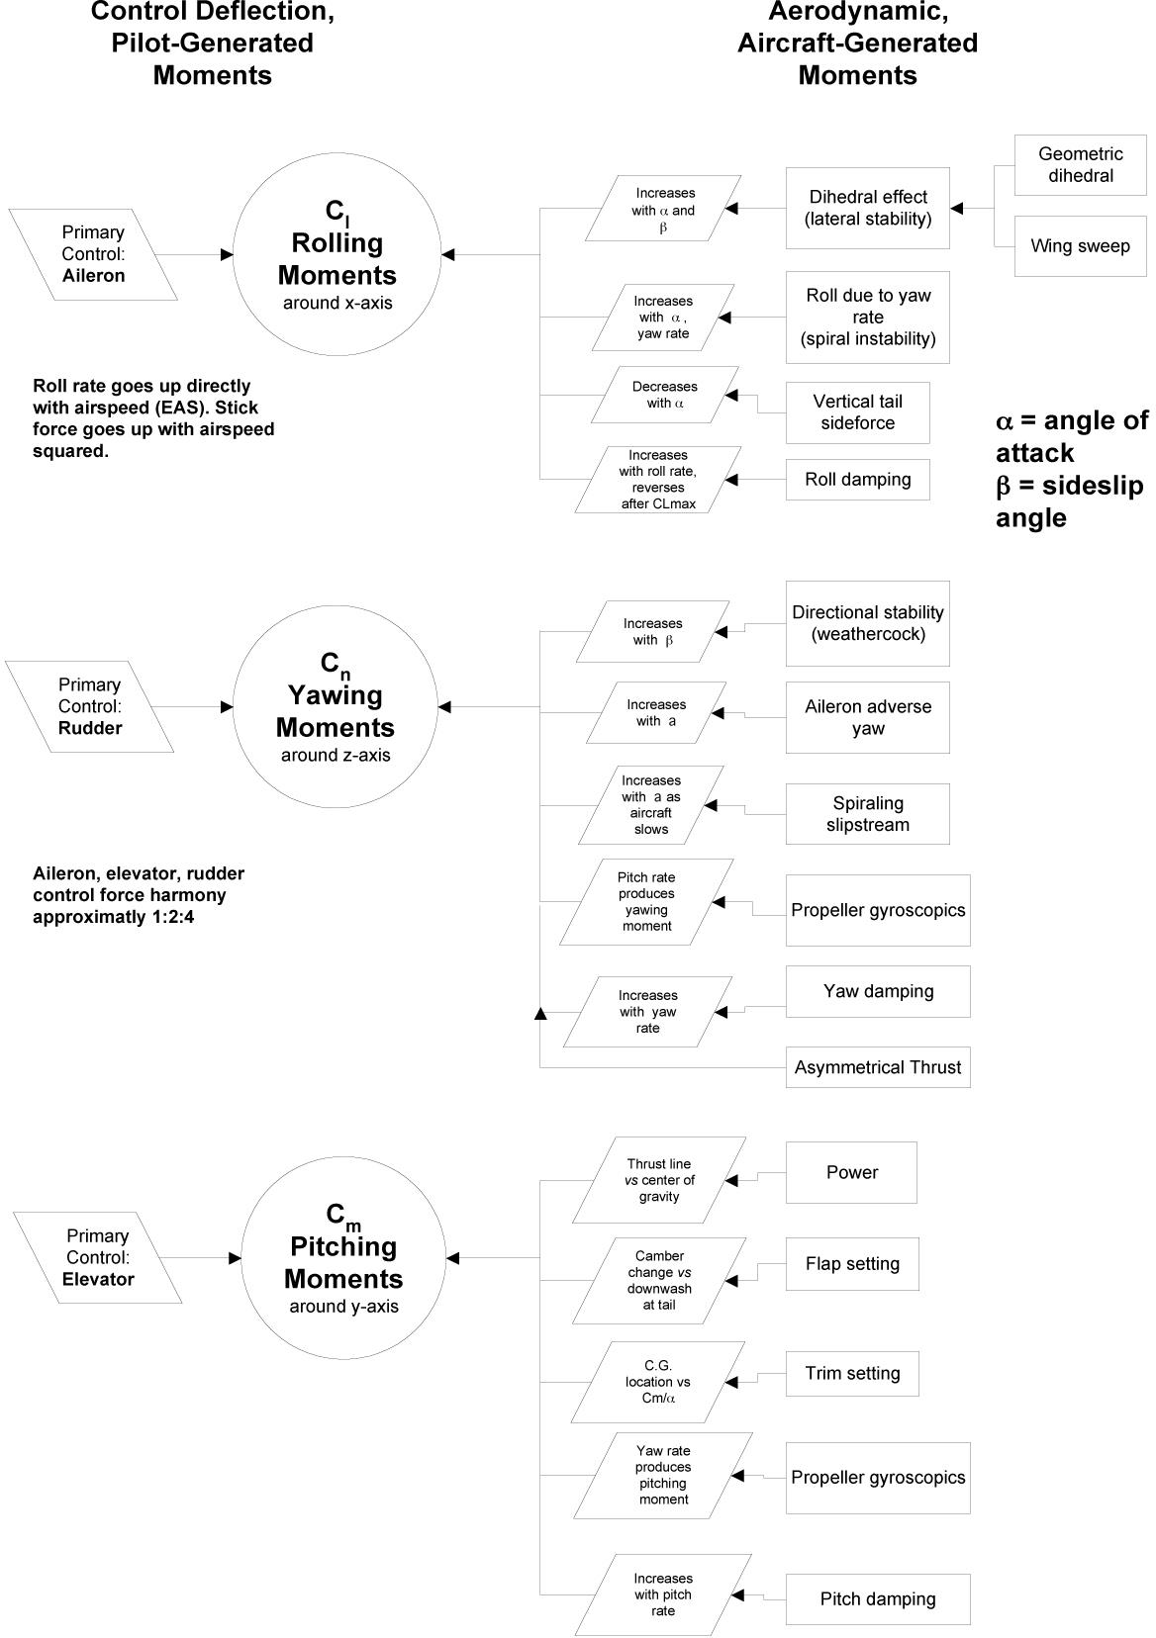

  - LongitudinalStaticStability
SrinivasanEngineeringCollege,Perambalur–621212. AUCR2013
Anaircrafthaspositivelongitudinalstaticstabilityifitsinitialresponseinpitch,in1-g flight, is to return to equilibrium around its trim point after displacement by a gust or bythetemporarymovementoftheelevatorcontrol.
When you trim an aircraft to fly at a given coefficient of lift, CL, but then push orpull on the stick and hold it there in order to fly at a different CL you’re working against theaircraft’s inherent stability. The aircraft generates a restoring moment that’s proportional, ifyou don’t retrim, to the force you feel against your hand. The faster that force rises withstickdeflection,themorestableyouraircraft.
Classical stability depends on the distance between the aircraft’s center of gravityand a set of neutral points farther aft along the longitudinal axis—the larger the distancebetween c.g. and neutral point the higher the stability. An aircraft in trim is in an equilibriumstate around its pitch, or y, axis. All the competing up or down moments (see Figure 3.6)generated by the various parts of the aircraft, and acting around its c.g., are in balance. Inaerodynamicsnotation,apitch-downmomentcarriesanegativesign;pitchupispositive.Inequilibrium,allmomentssumtozero.
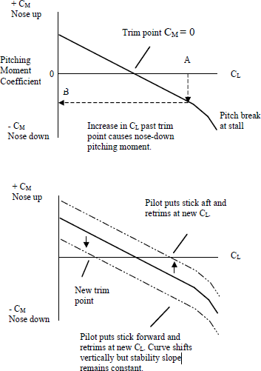
Figure 3.3, top, showsthechangeincoefficientofmomentinpitch,CM,whichresultsfromachangeincoefficientofliftforastaticallystableaircraft.
The longitudinal staticstability curve crosses theCL axis at the trim point, whereCM= 0. If the relative wind isdisplaced by a temporary gust ora pull on the stick, so that the CLof the wing goes up to point A,anegativepitchingmomentresults,B,whichrestorestheaircraft to its trimmed angle ofattack,α,andthusCL.
The bottom ofFigure3.3showshowthestabilitycurvemovesverticallywhen you change elevator angleto fly at a different CL. Note thattheaircraft’sstabilityremains

thesame,butthetrimpointshifts.
Fig.3.3.PitchingMomentversusCL

Thestabilitycurvetypicallytakesadownwardturntoamorenegativeslopeastheaircraft passes the stalling angle of attack. This is because the downwash at the tail decreasesas the wing gives up lift, and because the pitching moment of the wing itself becomes morenegative as its center of pressure suddenly moves rearward at the stall. The increase indownwardpitchingmoment,-CM,ishelpfulsinceitaidsstallrecovery.
SrinivasanEngineeringCollege,Perambalur–621212. AUCR2013
A negative slope is necessary for positive static stability. The more negative theslope the more stable the aircraft. In addition, there must be a positive pitching moment, CM,associated with CL = 0. The curve for a neutrally stable aircraft has a zero slope; so nochangeinpitchingmomentresultsfromachangeinangleofattack(Figure3.4).
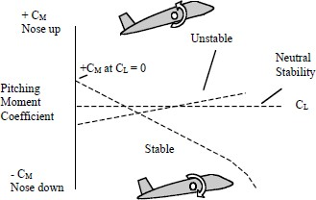
The stability curve for astaticallyunstableaircrafthasapositiveslope.Fornormalcertification, it must be necessarytopullinordertoobtainandholdaspeedbelowtheaircraft’strimspeed,andpushtoobtainandholdaspeedabovetrimspeed.Astatically unstable aircraft doesn’tobeythis(Figure3.5).Instead,a

changeinangleofattackfromtrimleads to a pitching moment thattakestheaircraftfartherfromequilibrium,andactuallyproducesa reversal in the direction of stickforces.
Fig.3.4.CurveSlope

Theresultofmoderateinstability might still be a flyableaircraft,buttheworkloadgoesup.Look at the positive, unstable slopein Figure 3.5. If you pulled back onthe stick the aircraft would pitch upand slow. But if you then let go ofthestickthenosewould continueto

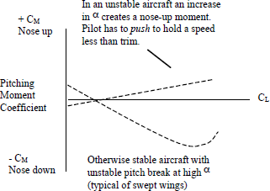
Fig.3.5.ExamplesofInstability

pitchup,sinceapositivepitchingmomentwouldremain.Itwouldrequireapushforcetomaintain your climb angle, not the mandated pull. If you pitched down and let go, the nosewould tend to tuck under. You’d have to apply a pull force to hold your dive angle, not themandatedpush.
Pilots experience longitudinal static stability most directly through the control forceneeded to change the aircraft’s equilibrium from one airspeed trim point to another. Thesteepertheslopeofthestabilitycurve,themoreforceneeded.
High performance, competition aerobatic aircraft tend to be somewhere on the stablesideofneutral.Comparedtoothertypes,aerobaticaircraftcan feeltwitchyat first,partly

becausethelightcontrolforcesassociatedwiththeirshallowΔCM/ΔCLcurvescausepilotsto over control. But compared to aerobatic types, more stable aircraft can feel stiff andreluctant.
SrinivasanEngineeringCollege,Perambalur–621212. AUCR2013
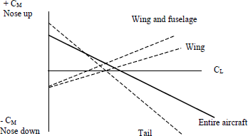
Figure 3.6 shows howthe different parts of an aircraftcontributetolongitudinalstabilitycharacteristics.Thefuselageandthewingaredestabilizing.Staticstabilitydependsontherestoringmomentsuppliedbythehorizontal tail being greater thanthedestabilizingmoments

caused by the other parts of theaircraft. If you require an aircraftwith a wide center of gravityloading range, make sure to giveit a powerful enough tail (largearea, large distance from c.g.,both) to supply the necessaryrestoringmoments.
On conventionalaircraft, once the design is set,static longitudinal stability andthe control force necessary toovercomethatstabilityarebothfunctions of aircraft center ofgravity location. Both decreaseasthec.g.movesaft.Figure3.7shows how the stability curvechangeswithc.g.position.
Figure 3.8 shows howthecurveforcontrolforcenecessary to fly at airspeed otherthantrimvarieswithc.g.position.
Fig.3.6.StabilityComponents
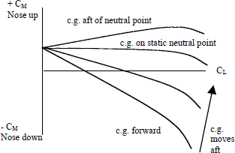

Fig.3.7.Stabilityversusc.g.
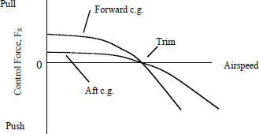

Fig.3.8.Controlforceversusc.g.

Theforcesnecessaryare greatestatforwardc.g.Notethatwe’reswitchingfromastability curve, which a pilot can infer but can’t experience directly, to forces and speedsthathecan.
Thetendencyofanaircrafttoreturntotrimspeedwhenthecontrolsarereleasedisfrictionandc.g.dependent.Asthec.g.goesaftandtheforcereturningthesticktothetrimpositionbecomeslesspowerful,frictioneffectsbecomemoreapparent.

The aircraft can appear to have nearly neutral stability within a given airspeed bandwhenthere’sappreciablefriction.If youdisplacethestick,lettheaircraftestablishanewspeed, and then let go, friction may prevent the elevator from returning to its originalpositionandtheaircraftfromsettlingbacktoitsoriginalspeed.
SrinivasanEngineeringCollege,Perambalur–621212. AUCR2013
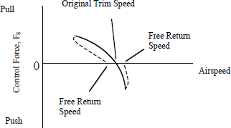
Thespeeditdoessettleoniscalledthefreereturnspeed,which for Part 23 certification mustbe less than or equal to ten percentoftheoriginaltrimspeed.
To determine free returnspeeds,trimyouraircraftforcruiseand then raise the nose, allowingspeedtostabilizeabout15knots
slower. Fig.3.9.FreeReturnSpeed.
Then slowly, so as not to provoke the phugoid, release aft pressure to lower the nosebackdowntotrimattitudeandholditthere, graduallyreleasingaftpressureasnecessary.(Don’t push, since this immediately wipes out the friction—the effect of which you’re tryingtomeasure.)Whenyou’vereleasedallaftpressure,notethespeed.Repeattheexercisewithapush.
Firstlettheaircraftaccelerate15knots,andthenreleaseforwardpressuretobringthe nose slowly back up to trim attitude. (Don’t pull—friction, again) Hold that attitude andnotethespeedatwhichthenecessarypushforcedisappears.Thenumbersshowyourfreereturn trim speed band, and may explain why you’re always fussing with the trim wheel! Awidebandmakesanaircraftdifficulttotrim.
The trim speed band may become wider as the c.g. moves aft. Aft movement reducesstability,whichinturncausestheslopeofthecontrolforcecurvetobecomelessnegative(Figure3.8).Lessreturnforceisthengeneratedtoopposethefrictionwithinthesystem.

InfluenceofFuselageon𝑪_{𝒍}𝖰
The flow field of the body interacts with the wing in such a way as to modify itsdihedral effect. To illustrate this, consider a long cylindrical body, of circular cross section,yawed with respect to the main stream. Consider only the cross-flow component of thestream, of magnitude Vβ, and the flow pattern which it produces about the body. This isillustratedinFigure3.10.
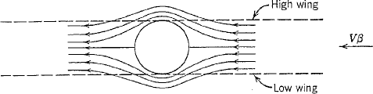
Fig.3.10.Influenceofbodyon𝐶𝑙𝛽

It is clearly seen that the body induces vertical velocities which, when combinedwiththemainstreamvelocity,alterthelocalangleofattackofthewing.Whenthewingisatthetopofthebody,thentheangleofattackdistributionissuchastoproduceanegativerolling moment; i.e. the dihedral effect is enhanced. Conversely, when the airplane has alowwing,thedihedraleffectisdiminishedbythefuselageinterference.Themagnitudeoftheeffectisdependentuponthefuselagelengthaheadofthewing,itscross-sectionshape,and the planform and location of the wing. Generally, this explains why high-wing airplanesoften have little or no dihedral, whereas low-wing airplanes may have dihedral angles of asmuchas10°.
SrinivasanEngineeringCollege,Perambalur–621212. AUCR2013

CGLimits
One of the dominant parameters of longitudinal stability and control has been shownin the fore-and-aft location of the CG. The question now arises as to what range of CGposition is consistent with satisfactory flying qualities. This is a critical design problem, andoneofthemostimportantaimsofthestabilityandcontrolanalysisistoprovidetheanswerto it. Since aircraft always carry some disposable load, and since they are not always loadedidenticallytobeginwith,itisalwaysnecessarytocaterforavariationintheCGposition.The range to be provided for is kept to a minimum by proper location of the items of variableload,butstillitoftenbecomesadifficultmattertokeeptheflyingqualitiesacceptableoverthewholeCGrange.Sometimestheproblemisnotsolved,andtheairplaneissubjectedtorestrictionsonthefore-and-aftdistributionofitsvariableloadwhenoperatingatpartload.

TheAftLimit
The permissible aft CG limit is determined by stability considerations. It is based onthe location of the neutral-point stick-free ℎ′_{𝑛}when normal manual or ratio-type controls areemployed, and on the stick-fixed neutral point ℎ_{𝑛}if the elevator control is irreversible.Conservative practice is to keep the aft limit a small distance forward of the relevant neutralpoint, computed with due allowance for the effects of wing flaps, the propulsive system,andaeroelasticdeformation.
Itshouldbepointedoutherethatbytheuseofautomaticdevicesthestabilitymaybeincreasedsothattheneutralpointisartificiallymovedrearward.IftheCGislocatedaftofthe“natural”neutralpointonthestrengthofsuchsyntheticstability,thenfailureoftheautomatic stabilizer will result in an unstable airplane. This design practice may beacceptable if failure of the automatic stabilizer is no more probable than failure of theprimarycontrolsystem.
Where,
ℎ′_{𝑛}-neutralpointofairplane,fractionofmeanchord,elevatorfree.
ℎ_{𝑛}-neutralpointofairplane,fractionofmeanchord,elevatorfixed.

TheForwardLimit
SrinivasanEngineeringCollege,Perambalur–621212. AUCR2013
As the CG moves forward, the stability of the airplane increases, and larger controlmovementsandforcesarerequiredtomaneuverorchangethetrim.TheforwardCGlimitis therefore based on control considerations and may be determined by any one of thefollowingrequirements:
      - Thestickforceper𝑔 shallnotexceedaspecifiedvalue.
      - Thestickforcegradientattrim,dP/dV,shallnotexceedaspecifiedvalue.
      - Thestickforcerequiredtoland,fromtrimattheapproachspeedshallnotexceedaspecifiedvalue.
      - Theelevatoranglerequiredtolandshallnotexceedmaximumupelevator.
      - Theelevatoranglerequiredtoraisethenose-wheeloffthegroundattakeoffspeedshallnotexceedthemaximumupelevator.

NeutralPoints
Whentheangleofattackofanaircraftchanges,thenetchangeinliftgeneratedbythewings,stabilizer,andfuselageactsattheneutralpoint.Theneutralpointissometimesreferredtoastheaerodynamiccenteroftheaircraftasawhole,similartothemorefamiliaraerodynamiccenterofawing.There’snomomentchangeabouttheneutralpoint(oraboutwingaerodynamiccenter)asangleofattackchanges—onlyachangeinliftforce.
In order for an aircraft to be longitudinally stable, the center of gravity must be aheadof the neutral point. Given that condition, the top left of Figure 3.11 shows what happenswhenagustorapilotinputincreasesangleofattack,α,abovetrim.
Theincreasedlift,actingattheneutralpointsomedistancefromthec.g.,generatesa stabilizing, nose-down pitching moment around the c.g. A stabilizing, nose-up pitchingmomentoccursifαgoesdown.Theaircraftontherightshowstheunstableresponsewhenthec.g.liesbehindtheneutralpoint.
Static stability decreases as the c.g. moves aft, toward the neutral point. The stabilitycurvebecomesincreasinglyflat.Ifyoushift thec.g.allthewaybacktotheneutralpoint,there’llbeachangeinliftwheneverαchanges,butnomomentchange.Withthec.g.attheneutral point, pitching moment, Cm, becomes independent of α. The aircraft will haveneutralstaticstability.Sincetheaircraftnolongergeneratesastabilizingmoment,thepilotfeelsnoopposingforceinthestickwhenhemovesittoflyatanewCL.
The aircraft becomes statically unstable when the elephant finally gets loose andmovesthec.g.aftoftheneutralpoint.Onceagainthere’sachangeinmomentaroundthe
c.g.whenαchanges,butnowit’sdestabilizing.Onastaticallystableaircraft,thedistancebetweenthemostpermissibleaftc.g.andtheneutralpoint(bothofwhichareexpressedaspercentages of the mean aerodynamic chord of the wing) is known as the static margin. Thegreaterthestaticmargin,thegreaterthestabilitybecomes(andthusthemorenegativetheslopeofthestabilitycurve).

SrinivasanEngineeringCollege,Perambalur–621212. AUCR2013

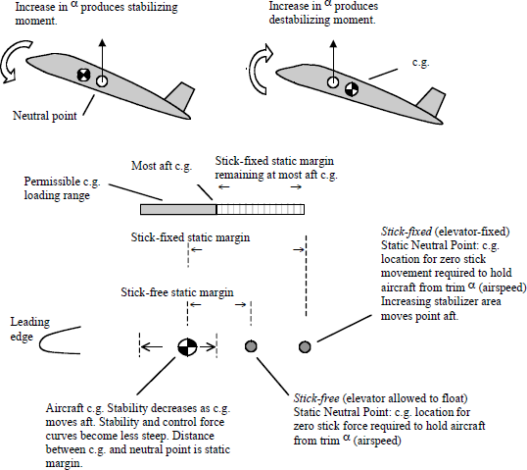
Fig.3.11.StaticNeutralPoints.
Actually, as Figure 3.11 indicates, there’re two static stability neutral points:stick-fixed (elevator and trim tab held in the prevailing trim position), and stick-free (handsoff,elevatorallowedtofloatinstreamlineastheangleofattackatthetailchanges).
Inflight-testing,stick-fixedstabilitydeterminestheamountofcontrolandelevatormovement needed to change airspeed (or CL, or α) from trim. Stick-free stability determinestherequiredforce.We’llamplifythisbelow.

Stick-fixedNeutralPoint
With a powered, irreversible control system the elevator usually doesn’t float unlesssomethingbroke,andsoonlythestick-fixedstabilitynormallymatters.(However,sometimes a programmed, artificial float is introduced to cure stability problems. Also, acontrol system can revert in case of hydraulic failure. The Boeing 737 reverts to a reversiblesystemfollowinghydraulicfailure.Itspredecessor,the707,wasreversibletobeginwith.)
At a given center of gravity position, an aircraft’s static stick-fixed stability isproportional to the rate of change of elevator angle with respect to aircraft lift coefficient(aircraftliftcoefficientincludesthecombinedwingandfuselagelifteffects).

In other words, the more stable the aircraft is (the larger the static margin) the fartheryouhavetohaulbackorpushonthestick.Asyoubringthec.g.back,lessstickmovementis needed to produce an equivalent change in CL and airspeed—and less spinning of the trimwheel is necessary to trim out the resulting forces. If the c.g. is brought back to thestick-fixed static neutral point, the change in stick position needed to sustain a change ofairspeediszero.Onceyou’vemovedthesticktoattainanewangleofattack,youcanputitbacktowhereitwasbefore.
SrinivasanEngineeringCollege,Perambalur–621212. AUCR2013
Reportedly,theSpitfirehasjustaboutneutralstick-fixedstaticstabilityinallflightmodes.TheDC-3isstableinpower-offglidesoratcruisepowerbutunstableatfullpowerorinapower approachatanaftc.g.

Stick-freeNeutralPoint
The stick-free static neutral point is the c.g. position at which the aircraft exhibitsneutralstaticstability(slopeoftheΔCM/ΔCLstabilitycurve=0)withtheelevatorallowedtofloat.Inotherwords,it’sthepositionwherepitchingmoment,CM,isindependentofCLwiththestickleftfree.
Your intuition may tell you that stick-fixed static stability is likely to be greater thantheelevator-floppysituationofstick-free,becauseofthefixedelevator’sgreaterefficiencyinproducingrestoringpitchingmoments.Theactual differencebetweenfixedandfreeinan aircraft with reversible controls (with reversible controls, wiggling the control surfacewiggles the stick) depends on elevator control system design, in particular the controlsurfacehingemoments.
Aerodynamic balance used to reduce hinge moments, and thus reduce the force apilot has to apply to deflect the elevator, also reduces floating tendency—and thereforeincreases the stick-free static stability margin. The stick-free neutral point usually lies aheadof the stick-fixed point. Just how far ahead depends directly on how much the elevator tendstofloat.
Figure 3.8 showed how the longitudinal stick force, FS, necessary to move an aircraftoff its trim point decreases as the center of gravity moves aft. This is the logical result of theaccompanying decrease in static stability. When the aircraft’s c.g. lies on the stick-freeneutralpoint,nochangeinforceisneededtochangeairspeeds.
Conventional handling qualities require that the aircraft c.g. lie ahead of thestick-freestaticneutralpoint.Ifc.g.movesbehindtheneutralpoint,controlforcesreverse.A pull force becomes necessary to hold the aircraft in a dive; a push force becomes necessaryinaclimb.

GurunathK.–AE6501FlightDynamics|

LongitudinalManeuveringStability
SrinivasanEngineeringCollege,Perambalur–621212. AUCR2013
Longitudinal maneuvering stability is really just static stability with an additionalfactor: pitch rate. An aircraft in accelerated (curved) flight—whether pulling up, pushingover,orturning—hasapitchrate.
Figure 3.12 shows the simple case of an aircraft in a pull-up. The aircraft pitchesabout its c.g. The tail sweeps along behind, on its arm, lT. The tail’s motion creates a changeinitsrelativewindandthusintailangleofattack,αT.Thechangeintailangleofattackduetopitchrateproducesanopposingpitchingmoment,knownaspitchdamping.
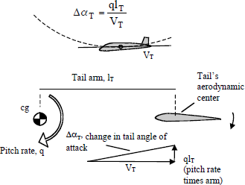
The change in tail angle ofattack, ΔαΤ, due to pitch rate is shownintheformulabelow,whereqispitchrateinradianspersecond(oneradianequals57.3°;and0.1radian/secondisapproximately1RPM).lTisthedistance between aircraft c.g. and theaerodynamic center of the tail. VT isthevelocityofthetail(takentangentiallytotheaircraft’sflightpath).Thusthefasteryoupitch,and/or the farther back your tail, thegreater the change in αΤ, but it’s allinverselyproportionaltospeed,VT,as
theformulashows. Fig.3.12.PitchDamping.
The actual tail angle of attack will also depend on the increased downwash producedbythewingasitsliftcoefficientrisesinthepull-up,andaproperformulawouldtakethatintoaccount.
Becauseofpitchdamping,anaircraftisactuallymorestableinmaneuveringflightthaninflightat1-g.Remember,weassessstabilityintermsoftheforceneededtodisplacethe aircraft from equilibrium (trim). We assess static stability in terms of the push or pull onthesticknecessarytochangethecoefficientoflift, CL,andtoproduceairspeedsdifferentthantrim,whileflyingat1-g.
Inmaneuveringflightatmorethan1-g,pitchdampingincreasesthestickforcewehave to apply to displace the aircraft from equilibrium. How rapidly stick forces willincreaseasweincreasegdependsonthemaneuveringcharacteristicsforwhichtheaircraftwasdesigned,anditsc.g. location.
We can examine an aircraft’s stick-fixed (elevator position-per-g) and the reallymoregermane—sinceit’swhatthepilotfeels—stick-free(stickforce-per-g)maneuveringcharacteristics.

GurunathK.–AE6501FlightDynamics|
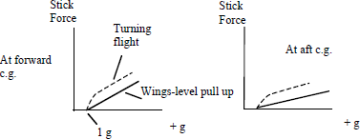
Figure 3.13 showshow the gradient, or slope,of stick force-per-g dependsonthelocationoftheaircraftc.g.Forwardc.g.increasesanaircraft’smaneuvering stability, andthereforestickforces
becomeheavier. Fig.3.13.Stickforceper-ggradientversusc.g.
As you move the c.g. back, stick forces required to pull g go down. (The stickposition-per-gcurvebehavessimilarly.Asc.g.movesaft,thedeflectionrequiredtopullggoesdown.)
Stickforce-per-galsovariesdirectlywithwingloading(aircraftweightdividedbywingarea).Highlywingloadedaircraftmayneedthehelpofapoweredcontrolsystemtokeep forces in check. Raising the wing loading has the same effect as moving the c.g.forward.
Stick force-per-g is a particularly important parameter and one of the basic handlingquality differences between aircraft designed for different missions. When we maneuver anaircraft, we tend to evaluate its response in terms of the force we apply to the stick ratherthan the change in stick position. We know the stick has returned to the equilibrium trimposition, for example, when the force disappears (at least ideally—friction and other factorscan get in the way). And when we move the c.g. well aft in an aircraft—or take that firstaerobaticflight—it’sthereductioninstickforcesweprobablynoticefirst.
Fighters and aerobatic aircraft require lower forces-per-g than do normal or transportcategoryaircraftbecausetheirgenvelopesarewiderandthetotalstickforcenecessaryathighgwouldotherwisebetoogreatforthepilot tosustain.Soafighteroperatingatupto9-gormoreneedsashallowerforce-per-ggradientthanatransportexpectedtooperateatno greater than the 1.5-g approximately required for a 45-degree-bank level turn. Thefighter’sshallowforce-per-ggradientwouldbedevastatinginatransportbecausethepilotcouldeasilyoverstresstheaircraft.Thetransport’ssteepergradientwouldhavethefighterpilotpullingwithbothhandswhilepushingontheinstrumentpanelwithhisfeet.
The importance of stick force-per-g in fighters became apparent during WorldWar II. It was decided that the upper limit should be about 8 lb/g to keep the pilot fromtiringinafight,withalowerlimitof3lb/gtopreventoverstressingtheaircraftandlosingbydefault.
Overstress is the big worry; so FAR Part 23.155 specifies the minimum total controlforcenecessarytoreachanaircraft’spositivelimitmaneuveringloadfactor(glimit). It’sbasedonaircraftweightandthetypeofcontrol.Forwheelcontrolstheminimumforcehastobeatleast1%oftheaircraft’smaximumweightor20pounds,whicheverisgreater,butdoesn’thavetoexceed50pounds.Forstickcontrols,minimumforceformaximumghasto be at least max weight/140, or 15 pounds, whichever is greater, but doesn’t have to exceed35pounds.

Tofigureoutwhatthatwouldmeanintermsofrequiredaverageminimumcontrol-force-per-g gradient, you can take the design load limit of the airplane (6-g’s for ourtrainers), subtract 1-g to get the maximum g-load actually applied, and then divide that intothe minimum total force required by regulation. For the Air Wolf (6-g’s and 2900 lbs.maximumaerobaticweight):
SrinivasanEngineeringCollege,Perambalur–621212. AUCR2013
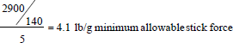
ACessna172’syokeforceisgreaterthan20lb/g. Awings-level,1.7-gpull-upinaBoeing 777 requires 135 pounds. The Boeing is certified under FAR Part 25, which actuallydoesn’tcontainsustainedmaneuveringcontrolforcerequirements.
The FARs doesn’t specify maximum stick-force per-g, but the military does,dependingonthetypeofaircraft.
Aircraft with shallow stick force-per-g gradients can feel dramatically sensitive ifyour muscle memory expectsgreater forces. Evenexperienced aerobatic pilots stepping upto higher performance aerobatic aircraft usually find themselves pulling too hard, detachingthe boundary layer, and buffeting the aircraft—especially in the excitement of aerobaticcompetition. This is seen from the ground as an abrupt flattening in the arc of a loop, andfromthecockpitasasuddeng-break.Butafteronebecomesaccustomedtothoseshallowgradients, the lower performance aerobatic aircraft one trained in can seem disagreeablyreluctanttomaneuver.Thephysicaleffortnowfeelsoutofproportiontotheresult.
On the other hand, pilots of early swept wing fighters had to worry about “g-limitovershoot” because of the forward shift in the center of lift as the tips began to stall. TheF-86E Sabre Aircraft Operating Instructions cautioned pilots against “A basic characteristictoward longitudinal instability under conditions of high load factor, which … results in atendency to automatically increase the rate of turn or pull-up to the point where the limitloadfactormaybeexceeded.”Fortunately,thiswasprecededbylotsofwarningbuffet.
Asnoted,pitchdampingdependsonpitchrate.Pitchratedependsnotjustonhowhardyoupull,butalsoonthekindofmaneuveryou’repullingin.Atagivenloadfactor,n,(wheren=lift/weight)alevelturnactuallyrequiresahigherpitchratethanawings-levelpull-up.
Foralevel(constantaltitude)turnatagivenvelocity,pitchrateisafunctionofn - 1/n, but for a wings-level pull-up it’s the smaller function of n - 1. That greater pitch ratein the level turn means more pitch damping. As a result, a 2-g turn, for example, requiresmorestickforcethana2-gpull-up.Accordingly,ahigh-performanceturntakesmorepilotmuscle than a loop entry at the same load factor. See the dotted versus the solid lines inFigure3.13.
Our trainers have reversible controls (wiggle an elevator by hand and the stickwiggles as well). In aircraft with reversible controls, at any given altitude and c.g., thegradientofthestickforceper-gcurveisindependentofairspeed.Figure3.14showshowthegradientremainsconstantasairspeedshiftsfromtrim.

Thefigurealsoshowshowtheabsolutestickforceneededtoobtaina givengwilldependontherelationshipbetweentrimspeedandactualairspeed.Forexample,whentheaircraft is flying slower than trim, static stability leads to a nose-down pitching moment,whichaddstothepullforceapilothastoholdto maintainagiveng.
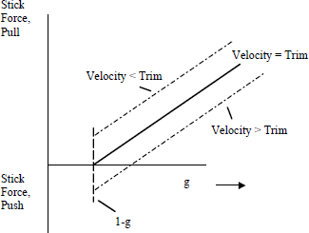
Butwhenflyingfasterthantrim,staticstabilityleadstoanose-uppitchingmomentthatdecreases the pull force necessary tomaintainagiveng.
Because of the change inabsolutestickforcenecessarytohold a given g at speeds slower orfaster than trim, test pilots try tomaintaintrimspeedwhenexaminingstickforce-per-gin“windupturns.”Otherwisethedata

wouldplotaninaccuratestickforce-per-ggradient.
Fig.3.14.Stickforce-per-ggradientisconstantatconstantcgand altitude.

The stick force needed to pull a given g remains the same at any trim speed. Say thetrim speed rises. Because the elevator’s effectiveness increases with airspeed, you don’thavetodeflectitasmuchtoproduceagivenpitchrateandload factorasyoudoatlowerspeeds. Less deflection would mean lower forces, except that control surface hingemoments—which are what the pilot feels through the control system gearing—also increasewithairspeed.Thedecreaseinrequireddeflectioniscanceledoutbytheincreaseinhingemoment,andthestickforcerequiredforagivengloadisthesameatalltrimvelocities(ata constant altitude and c.g.). This holds as long as compressibility effects associated withhigh Mach numbers don’t become a factor. Compressibility tends to produce an increase instickforce-per-g.

DampingversusAltitude
While static stability is not a function of altitude, maneuvering stability is. Stickforce-per-g goes down as you go up. That’s because damping decreases along with thedecreaseinairdensityasyouclimb.
At least that’s the short explanation. Actually, in responding to a given control inputan airplane doesn’t care about altitude, it cares about airspeed. Compressibility effects aside,for a given input it will generate the same pitching (or rolling or yawing) moment at a givenEAS (equivalent airspeed, meaning calibrated airspeed corrected for compressibility)regardlessofwhetherit’sflyingdownloworuphigh.Butthedampingthismomenthastoovercomeisafunctionofaltitude,becausedampingisafunctionofTAS(trueairspeed,orequivalent airspeed corrected for density altitude), as Figure 3.15 explains. TAS goes up asaltitudeincreases.

The figure shows that for agivenpitchrate,q,thevelocitycomponent generated by the movementof the tail, qlT, is the same regardless ofaltitude.Butsincetrueairspeedishigherataltitude,thevectorsadduptoless change in tail angle of attack, andsolessdamping.
SrinivasanEngineeringCollege,Perambalur–621212. AUCR2013
This is why an airplane willfeelmoreresponsiveandlessstableataltitude, or perhaps even lower downonahot,high-density-altitudeday.

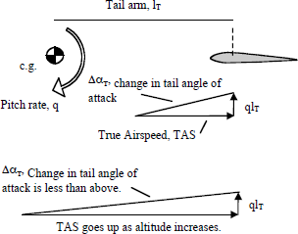
Fig.3.15.DampingandTAS.

Thereductionindampingalsoappliesto anaircraft’sdirectional andlateralstability.
Stabilityaugmentationsystems,likeyawdampers,earntheirkeepuphigh.

TailVolume
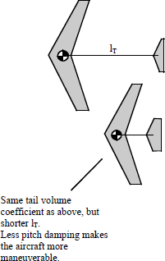
Stabilitydependsontherestoringmomentsupplied by the horizontal tail being greater than thedestabilizing moments caused by the other parts of theaircraft.Onefactoristhetail-volumecoefficient,𝑉̅.This istheproductofthedistancebetweentheaircraftc.g.
andthetail’saerodynamiccenter,lT,timesthetailarea,
ST.Theresultisthendividedbythemeanaerodynamic
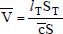
chordofthewing,𝑐timesthewingarea,S.

Inotherwords,thetailvolumecoefficientrelates the area of the tail and its distance from the c.g.to the chord and area of the wing. It suggests howeffective the tail is going to be at producing pitchingmoments.
Fig.3.16.TailVolumeCoefficient.
You can achieve a given tail volume for a wing of a given size either by having asmalltailonalongfuselage,oralargetailonashortfuselage(Figure3.16).
Since pitch damping is a function of the square of the tail’s lever arm, lT2, the fartherbackyourtailisthegreatertheopposingaerodynamicdampinggeneratedwhenyoustartpitchingitaroundtomaneuver.Thedesigncriterionforrapidmaneuveringisabigtailona short fuselage—a hallmark of modern fighter design. Transports have proportionatelysmallertailsonlongerfuselages.

NeutralPointsAgain
SrinivasanEngineeringCollege,Perambalur–621212. AUCR2013
Figure 3.17 adds the stick-fixed maneuver neutral point and the stick-free maneuverneutral point to the stick-fixed and stick-free static neutral points discussed in the groundschool briefing “Longitudinal Static Stability”. The aft shift of the corresponding maneuverpoints reflects the stabilizing effect of pitch damping. Because damping goes down withaltitude,themaneuverpointsactuallysneakforwardas youclimb.
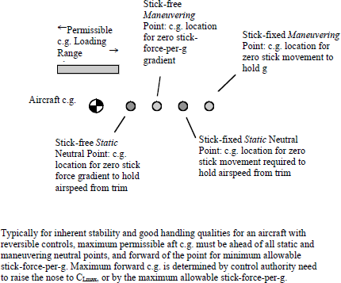
Fig.3.17.Stick-fixedandfree NeutralPoints.
The stick-free maneuver point is the c.g. position at which the gradient of stick force-per-g becomes zero. The more rearward stick-fixed maneuver point is the c.g. position atwhichstickmovement-per-gbecomeszero.
Ifwehadaweightonrailsandcouldmovethec.g.rearwardduringflight,thefirstthing we’d notice is a reduction in control force necessary to change α and thus airspeedfrom trim (static stability), accompanied by a reduction in stick force needed to pull g(maneuveringstability).Shortofshiftingthec.g.,aknowledgeableinstructorcansimulatethis for a student by manipulating the trim. As tail volume increases, the neutral points moveaft.Thisinturnincreasestheaftc.g.loadingrange.

AerodynamicBalancing
The ways and means of reducing the magnitudes of 𝐶_{ℎ}𝛼𝑡and 𝐶_{ℎ}δ𝑒are calledaerodynamicbalancing.Themethodsforaerodynamicbalancingare:
- Setbackhinge
- Hornbalance
- Internalbalance.

Setbackhingeoroverhangbalance
SrinivasanEngineeringCollege,Perambalur–621212. AUCR2013
Inthis case,thehingelineisshiftedbehindtheleadingedgeofthecontrol(seeupperpartofFigure3.18).
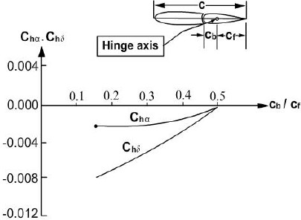
Fig.3.18.EffectofsetbackhingeonChαandChδ–NACA0015Airfoilwithbluntnoseandsealedgap
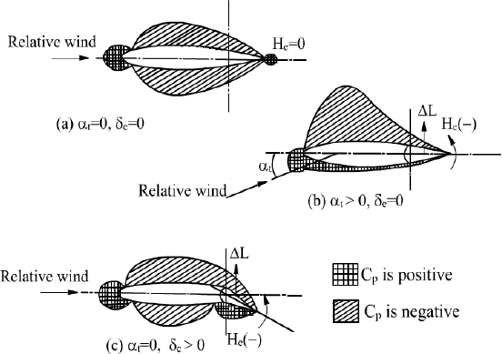

Fig.3.19.Changesindistributionofpressurecoefficientwithαtandδe
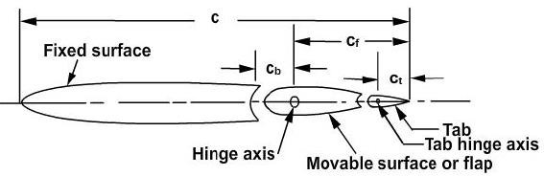

Fig.3.20.Parametersofcontrolsurface -chordlengths

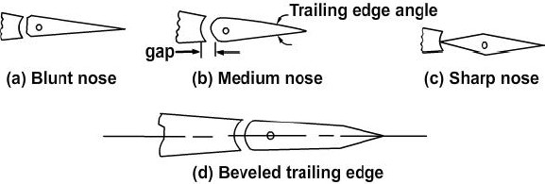

Fig.3.21.Parametersofcontrolsurface-shapesofnoseandtrailingedge
Asthehingelineshifts,theareaofthecontrolsurfaceaheadofthehingelineincreasesandfromthepressuredistributioninFigure3.19itisevidentthat|𝐶_{ℎ}𝛼𝑡|and
|𝐶_{ℎ}δ𝑒|woulddecrease.TheoverhangischaracterizedbyCb/Cf.Figure3.18alsoshows
typicalexperimentaldataonvariationsof𝐶_{ℎ}𝛼and𝐶_{ℎ}δwithCb/Cf.Itmaybeaddedthatthechangesin𝐶_{ℎ}𝛼and𝐶_{ℎ}δalsodependon(a)gapbetweennoseofthecontrolsurfaceandthemainsurface,(b)noseshapeand(c)trailingedgeangle(Figure3.20and3.21).

Hornbalance
Inthismethodofaerodynamicbalancing,apartofthecontrolsurfacenearthetip,is ahead of the hinge line (Figure 3.22 and 3.23). There are two types of horn balances –shielded and unshielded (Figure 3.22). The following parameter is used to describe the effectofhornbalanceon𝐶_{ℎ}𝛼and 𝐶_{ℎ}δ.

Parameter=

(Area of horn) × (mean chord of horn)(Areaofcontrol)×(meanchordofcontrol)

GurunathK.–AE6501FlightDynamics|

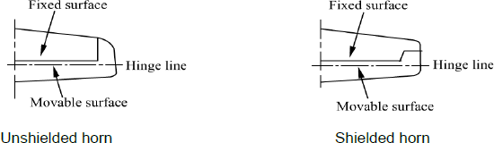

Fig.3.22Unshieldedandshieldedhorn
Figure3.23showstheareasofthehornandcontrolsurface.Figure3.23alsoshowsthe changes ∆𝐶_{ℎ}𝛼and ∆𝐶_{ℎ}δdue to horn as compared to a control surface without horn. Hornbalance is sometimes used on horizontal and vertical tails of low speed airplanes (seeFigure3.24).

SrinivasanEngineeringCollege,Perambalur–621212. AUCR2013
GurunathK.–AE6501FlightDynamics|

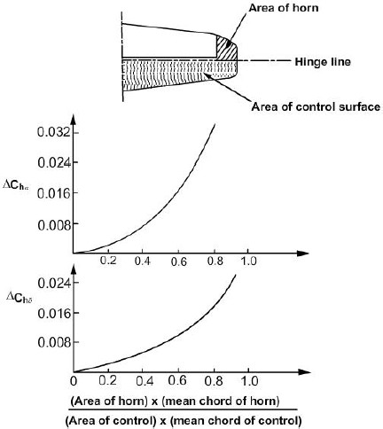

Fig.3.23.Unshieldedhornandthechanges∆𝐶ℎ𝛼and∆𝐶ℎδascomparetocontrolsurfacewithouthorn
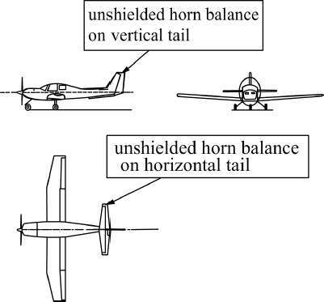
Fig.3.24.Airplanewithhornbalanceonhorizontaltailandverticaltail

Internalbalanceorinternalseal
In this case, the portion of the control surface ahead of the hinge line, projects in thegap between the upper and lower surfaces of the stabilizer. The upper and lower surfaces oftheprojectedportionareventedtotheupperandlowersurfacepressuresrespectivelyatachosenchordwiseposition(upperpartofFigure3.25).

GurunathK.–AE6501FlightDynamics|
Asealattheleadingedgeoftheprojectingportionensuresthatthepressuresonthetwosidesoftheprojectiondonotequalize.Figure3.25 alsoshowsthechanges∆𝐶_{ℎ}𝛼and
∆𝐶_{ℎ}δduetointernalsealbalance.Thismethodofaerodynamicbalancingiscomplexbutis
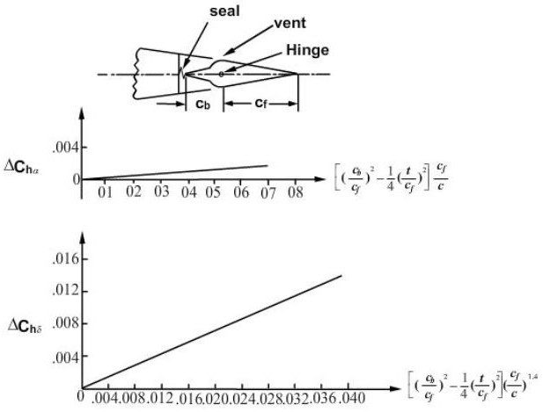
reliable.Itisusedonlargeairplanestoreduce𝐶_{ℎ}𝛼and𝐶_{ℎ}δ.
Fig.3.25.Internalsealandthe changes∆𝐶_{ℎ}𝛼and∆𝐶_{ℎ}δascomparedtocontrolsurface withCb/Cf= 0.

Friseaileron
The frise aileron is shown in Figure 3.26. The leading edge of the aileron has aspecificshape.Thedownwarddeflectedaileronhasnegative𝐶_{ℎ}δandtheupwarddeflectedaileron has positive 𝐶_{ℎ}δ. This reduces the net control force. Further, owing to the specialshape of the leading edge, the upward deflected aileron projects into the flow field andincreasesthedrag.Thisreducesadverse yaw.
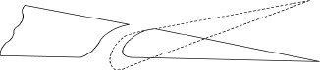

Fig.3.26.Friseaileron

UnitIV LateralandDirectionalStability
SrinivasanEngineeringCollege,Perambalur–621212. AUCR2013
  - Lateral(Rolling)Dynamics

TheAircraftinRoll
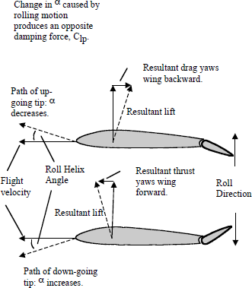
Arollstartswiththecreationofanasymmetricliftdistribution along the wingspan. Inthecaseofaileronrollcontrol,deflecting an aileron down increaseswing camber and coefficient of lift;raising the opposite aileron reducescamber and coefficient of lift. Theresultingspanwiseasymmetryproducesarollingmoment.
As the aircraft begins to rollinresponsetothemomentproducedby the ailerons, the lift distributionagain begins to change. The rollingmotion induces an angle of attackincrease on the down-going wing,andanangleofattackdecreaseon
theup-goingwing(Figure4.1).
Fig.4.1.RollDamping,Clp,YawduetoRollRate,Cnp.

This creates an opposing aerodynamic moment, called roll damping (or rollingmomentduetorollrate,Clp).Rolldampingincreaseswithrollrate(andvarieswithotherfactors we’ll get to). When the damping moment produced by the roll rate rises to equal theopposingmomentproducedbytheailerons,therollratebecomesconstant.
In Figure4.1youcanseethatastheairplanerolls,theliftvectortiltstoaccommodateitselftothenewdirectionoftherelativewind,creatingnewvectorsofthrustanddrag.Asaresult,therollingmotionproducesadverseyawallbyitself,ayawingmomentthatgoesaway when the roll stops. This yaw due to roll rate, Cnp, is in addition to the adverse yawcreated by the displaced ailerons, and increases with coefficient of lift. Depending on wingplanform, at aspect ratios above 6 or so, adverse yaw due to roll rate actually becomes moresignificantthanthatduetoailerondeflection.

SideslipsandDirectionalStability,Cnβ
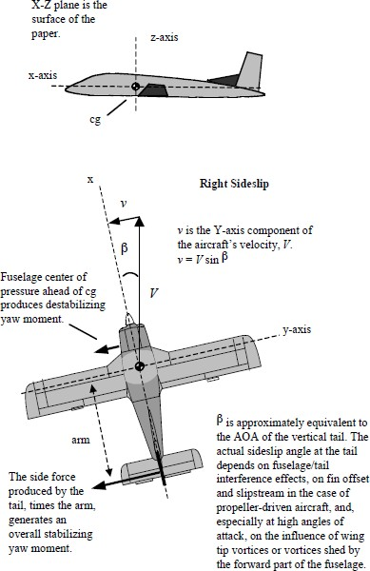
Most aerodynamicstextscoverlongitudinal(pitch axis stability) beforetacklingcoupledlateral/directional behaviors. Sinceourflightprogramemphasizes those behaviors,we’ll do things in our ownorder.
An aircraft is in asideslipwhenitsdirectionofmotion (its velocity vector)does not lie on the xz planeofsymmetry.Thetopdrawing in Figure 4.2 definesthex-zplane,andinthebottomdrawingwe’relooking down the z-axis. Theangle between the velocityvector, V, and the x-z planeisthesideslipangle,β(pronounced“beta”).Inaerodynamics notation β ispositive to the right, negativetotheleft.(Justsothere’snoconfusion, a -β sideslip to theleft,forexample,meansthatthe nose is pointing to theright of the aircraft’s actualdirectionofmotion.)
Fig.4.2.DirectionalStability.

Rudder deflections, wind gusts, asymmetric thrust, adverse yaw, yaw due to roll,and bank angles in which the effective lift is less than aircraft weight can all cause sideslips.In response, sideslips typically create both yawing and rolling moments. A stable aircraftyaws toward the velocity vector, but rolls away. These moments interact dynamically—playing out over time, most notably in the form of the disagreeable undulation called theDutchroll.
The notation for the yawing moment coefficient is Cn (positive to the right, negativetotheleft).Rememberthatamomentproducesarotationaboutapointoraroundanaxis.
An aircraft has static directional stability if it tends to respond to a sideslip by yawingarounditsz-axisbackintoalignmentwiththerelativewind.Anotherwaytoputitistosaythat a directionally stable aircraft yaws toward the velocity vector, returning it to theaircraft’sx-zplaneofsymmetry.

Thisisalsocalled“weathercock”stability,inhonorofa much simpler invention. Figure 4.3showsthatthisstabilizingyawmoment is not typically linear, buttends to decrease at high β angles. Inthefigure,apositiveslope(risingtothe right) in the Cnβ curve indicatesdirectionalstability.Thesteepertheslopethestrongeristhetendencytoweathercock.
SrinivasanEngineeringCollege,Perambalur–621212. AUCR2013
Not all parts of the aircraftcontributetodirectionalstability.Alone,thefuselageisdestabilizing.

Insubsonicflight,thecenter of pressure on a fuselage inasideslipisusuallysomewhereforwardof25percentofthefuselage length. Since the aircraft’scenter of gravity is typically aft ofthis point, the fuselage alone wouldtendtoturnbroadsidetotherelative wind in a sideslip. NoticeinFigure4.4howthedestabilizingcontributionfromthefuselagelevels out as β increases. Figure 4.4breaks down the components ofdirectional stability. A sideslip totheright(+β)producesanose-right, stabilizing yaw moment fortheentireairplane,butadestabilizingyawtotheleft(-Cn)

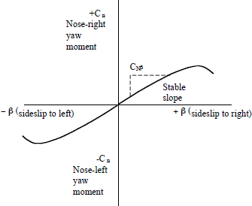
Fig.4.3.DirectionalStabilityResponse.
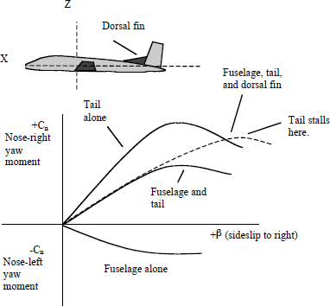

forthefuselagealone. Fig.4.4.ContributionstoDirectionalStability.
Of course, the vertical tail contributes most to directional stability. The yaw momentproduced by the tail depends on the force its surface generates and on the moment armbetweenthetail’scenterofliftandtheaircraft’scenterofgravity.(Therefore,asmallertailneedsalongerarmtoproduceayawmomentequivalenttoabiggertailonashorterarm.That being said, changing the c.g. location for a given aircraft, within the envelope forlongitudinalstability,haslittleeffectonitsdirectionalstability.)
Therateoftheincreaseinforcegeneratedbythetailasβincreasesdependsonthetail’sliftcurveslope(justastherateofincreaseinCLwithangleofattackdependsontheslopeoftheliftcurveofawing).Liftcurveslopeisitselfafunctionofaspectratio.Higheraspectratiosproducesteeperslopes.

The Cnβ directional stability curve for the fuselage and tail together reaches its peakwhen the tail stalls. You can see in Figure 4.4 that adding a dorsal fin increases the tail’seffectiveness(andwithoutaddingmuchweightordrag).Becauseofitshigheraspectratioand steeper lift curve, the vertical tail proper produces strong and rapidly increasing yawmoments at lower sideslip angles, but soon stalls. But the dorsal fin, with its low aspect ratioand more gradual lift curve, goes to a higher angle of attack before stalling, and so helps theaircraftretaindirectionalstabilityathighersideslipangles.Thedorsalfincanalsogenerateavortexthatdelaystheverticaltail’sstall.
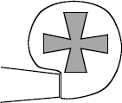
TheFokkerDr1triplaneprovidesanextremeexampleof a low-aspect-ratio tail (there’s a rough approximation inFigure 4.5). Without a fixed vertical fin, the aircraft had lowdirectional stability. The low-aspect-ratio rudder stalled at about30-degree deflection. The combination gave the pilot the abilitytoyawthenosearoundrapidlyifnecessary togetoffashot.But
instraight-aheadflighttheaircraftneededconstantdirectional
attention(atypicalattributeofWW-Ifighters). Fig.4.5.WorldWarI
FokkerDr1rudder.
Comingbacktomodernexamples,it’sappropriatetonotethattheliftcurveslopeoftheverticaltailtendstogodownathighMachnumbers,takingdirectionalstabilitywithit. This tendency is one reason why supersonic fighters need to compensate with suchapparently oversized tails. Another reason is that the slope of the Cnβ stability curve alsotends to go down at high angles of attack as the fuselage begins to interfere with the airflowover the tail. This is especially so with swept-wing aircraft that require higher angles ofattacktoachievehighliftcoefficients.Directionalstabilityisessentialtopreventasymmetries in lift caused by sideslip that can lead one wing to stall before the other andsendtheaircraftintoadeparture.

PropellersandDirectionalStability
Propellersaheadoftheaircraftc.g.aredirectionallydestabilizing,mostlybecauseof slipstream effects and P-factor (Figure 4.6). Our Air Wolf is an example of an aircraftthat requires lots of directional trimming (or just rudder pushing) to compensate forpropeller effects as angle of attack and airspeed change. In this respect it’s quite unlike a jet,say, or an aircraft with counter-rotating propellers, which typically have no associateddirectionaltrimchanges.
Notethatasanairplaneslowsdown,asymmetricalpropellereffectscauseittoyaw.If the pilot cancels the yaw rate, using rudder, while keeping the ball centered and the wingslevel,theaircraftwillendupinasideslip(tothelefttogeneratethesideforcerequiredtocounteract the usual yawing effects due to a clockwise-turning propeller). Thus even a“straight-ahead” stall at idle power has a small sideslip component that may affect itsbehavior.

SrinivasanEngineeringCollege,Perambalur–621212. AUCR2013

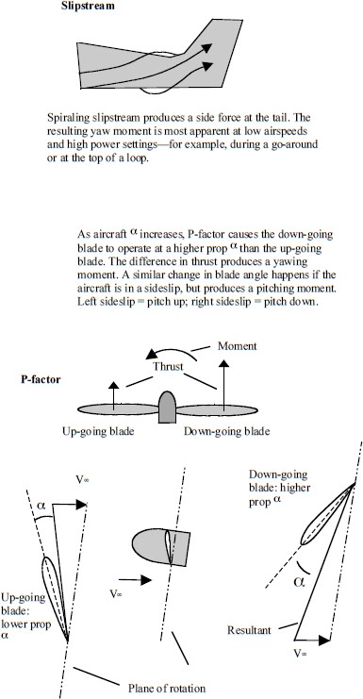

Fig.4.6.SlipstreamandP-factor.

  - DihedralEffect,𝑪_{𝒍}𝖰
SrinivasanEngineeringCollege,Perambalur–621212. AUCR2013
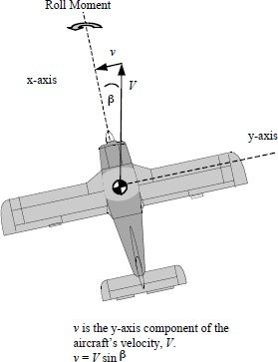
An aircraft with dihedral effectrolls away from a sideslip (away from thevelocityvector).Thetermdescribesasingle behaviour with more than a singlecause. Dihedral effect was observed first asresulting from actual geometric dihedral(wingtipshigherthanwingroots),butit’salso produced by wing sweep, by a highwinglocationonafuselage,andbyforcesactingontheverticaltail.
Forconvenience,Figure4.7illustrates sideslip angle, β, and sideslipvelocity, v, velocity vector, V, plus thedirectionofroll.Duringourflightprogram, we’ll do steady heading sideslipsto assess the presence of dihedral effect.We’llpressonarudderpedalwhileapplyingoppositeaileron,sothatthe
airplanewillbebankedbutnotturning. Fig.4.7.SideslipAngle,β.
We’ll note the deflections necessary to keep the aircraft tracking on a steady heading,and we’ll see what happens when we release the controls. Steady-heading sideslips give testpilotsinformationabouttherollingmomentsaslippingaircraftgeneratesanditslateral/directional handling qualities. We use them to illustrate the nature of yaw/roll coupleand to demonstrate the effects of sideslip under various flap configurations, during aerobaticrolling manoeuvres, and during simulated control failures. As you’ll see, an aircraft cansideslipinanyattitude—includingupside-down.
Theinteractionbetweensideslipanddihedraleffectformsthebasisofanaircraft’slateral stability. Lateral stability can’t appear unless an aircraft starts to sideslip first. Anaircraft with positive lateral stability rolls away from the sideslip (velocity vector) thatresults when a wing drops, and that usually means back toward level flight (although anaircraft with dihedral effect can go into a spiral dive if the bank angle is high and othermomentsprevail).
InthenotationusedinFigure4.8,sideslipangleisβ(beta),andtherollingmomentcoefficientisCl,sotheslopeofthecurveofrollingmomentduetosideslipisClβ.Sinceitdoesrolloffthetongue,ifwelapseintothisterminologyyou’llknowwhatwemean.Thefigure shows that the slope must be negative (descending to the right) for stability when wefollow the standard sign conventions, where aircraft right is positive, left is negative. Alaterallyunstableaircrafttendstocontinuetorolltowardthedirectionofsideslip(positiveslope).

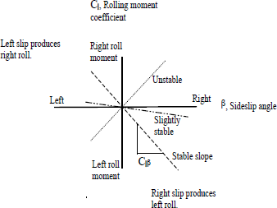

Fig.4.8.LateralStability.
Sweeping the wings forward or mounting them with a downward inclination so thatthetipsarelowerthantheroots(anhedral)producesthistendency.Sometimesanhedralisusedtocorrectswept-wingdesignshavingtoomuchpositivelateralstabilityathighanglesofattack.Toomuchlateralstabilitycancausesluggishrollresponse(especiallyifthere’salsoadverseyawpresent)andatendencytowardthecoupledyaw/rolloscillationofDutchroll.
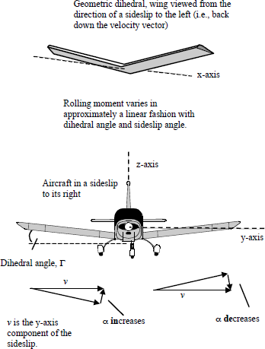
Geometricdihedraleffectiseasytounderstandbecauseit’seasytoseehowwinggeometryandsideslip interact. Just stand on theflightlineatadistanceinfrontofanaircraft with geometric dihedral andpretendthatyou’relookingrightdown the path of the relative wind.You may need to stoop a little toapproximateanin-flightangleofattack.
Maintainthateyeheightabove the ground and move back andforth in front of the aircraft, tryinghard not to look too suspicious topossiblerepresentativesoftheTSA.Noticehowtheangleofattack,α,ofthe near wing increases—you cansee more wing bottom—while that ofthe far wing decreases as you changeyour position, as illustrated at the topofFigure4.9.Withanhedral,you’d
seejusttheopposite. Fig.4.9.Sideslip,DihedralAngle,andResultingChangeinα.

Figure 4.9 also presents the same idea in another way. In the lower figure, the y-axiscomponent of sideslip, v, is in turn broken down into two vector components projected ontothe aircraft’s y-z plane, one parallel to and one perpendicular to the wing. On the upwindwing,theperpendicularcomponentactstoincreasetheangleofattack.Itdoestheoppositeonthedownwindwing.Thedifferenceproducesarollingmoment.
SrinivasanEngineeringCollege,Perambalur–621212. AUCR2013
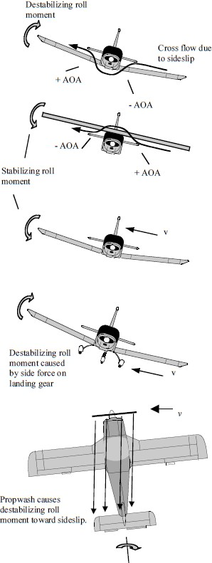
Again, dihedral effect can alsoresult from interference effects due towing placement on the fuselage, fromwingsweep,orfromverticaltailheight.Flap geometry and angle of deploymentinfluencedihedraleffect,asdoespropellerslipstream.
Figure4.10showsthecontributionsofwingposition,tailheight,landinggear,andslipstreamangle to dihedral effect. Wing positionguides the cross flow around the fuselageinasideslip,alteringtheanglesofattackon the near and far wings, and thus therelativelift.Thisisstabilizingonahigh-wingaircraft. It’sdestabilizingonalowwing, which is why low-wing aircrafttypicallyrequiremoregeometricdihedral.Thesefuselageeffectsareenhanced by smooth airflow over thewing-bodyjunction.
They’rediminishedbyflowseparationatthewingrootsattheapproachofastall.Averticaltailproduces a side force during a sideslip. Ifthetailistallenough,sothatitscenteroflift is a good distance above the aircraft’scenter of gravity, the vertical momentarmcanprovokeastabilizingrollresponse.Landinggear,belowtheC.G.,isdestabilizing.
ThebottomillustrationinFigure 4.10 shows how the angle of thepropwashduringasideslipcreatesadestabilizingconditionbyincreasingtheairflow,andthusthelift,overthe
downwindwing.
Fig.4.10.SideslipinducedRoll.

This generates a rolling moment into the sideslip. The destabilizing effect increaseswiththeflapsdown.Italsoincreasesatlowairspeedsandhighpowersettings,astheratioof propwash velocity to freestream velocity increases and the propwash gains relativelymoreinfluence.
The propwash effect may vary somewhat, depending on the direction of the sideslip.Propeller swirl, as it’s sometimes called, creates an upwash on the left wing root and adownwash on the right, leading to a difference in angle of attack between the wings and thusarollingmoment.FortheaircraftatthebottomofFigure 4.10,clock-wisepropellerswirlmayinitiallygeneratearollingmomenttotheright,whichcansuddenlyreverseathighα,whentheleftwingstallsfirstbecauseofitsswirl-inducedhigherangleofattack.Thisisanimportant factor in spin departures, especially during the classic, career-ending skiddingturntofinal.
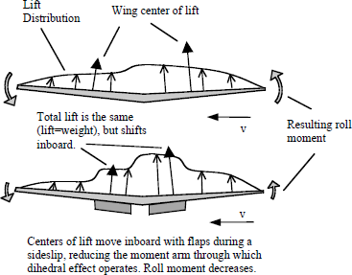

Fig.4.11.FlapEffects.
Propwash effects don’t occur in jets, but flap effects do. Flaps shift the centres of liftinboardonthewings,asillustratedinFigure4.11.Thisshortensthemomentarmsthroughwhichtheliftchangescausedbysideslipact,andsosideslipinducedrollmomentsdecrease.
We’ll explore this effect during steady-heading sideslips by raising and lowering theflaps and watching the roll response. When the flaps go down, dihedral effect will diminishand the aircraft will start to roll in the direction of aileron input. (This demonstration isimportant in understanding the concept of crossover speed.) Propwash increases flap effectsbecause of the added airflow over the flap region of the up going wing, but we candemonstratewiththepropatidle—itwilljusttakemoreflapdeflection.
Becausewingtaperalsoshiftsthecentresofliftinboardonthewings,ahightaperratio(tipchordlessthanrootchord)decreaseslateralstability.Highaspectratiosmovethecentresofliftoutboard,increasinglateralstability.

GurunathK.–AE6501FlightDynamics|

GeometricDihedralandCoefficientofLift,CL
SrinivasanEngineeringCollege,Perambalur–621212. AUCR2013
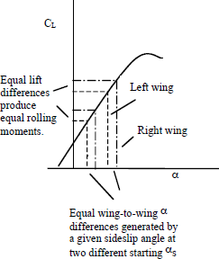
The strength of geometric dihedraleffect does not depend directly on aircraftcoefficient of lift (you’ll see the reason fortheitalictreatmentpresently).TheCL/αcurveforacamberedwinginFigure4.12islinearuptothestall,whichmeansthatforagiven change in angle of attack (produced byasideslip)there’sagivenincrementaldifferenceincoefficient,untiltheslopestarts to decline near the stall. As a result, agiven sideslip angle combined with a givendihedralangle,willgenerateagivendifference in CL. It doesn’t matter if you startatloworhighCL,aslongyoustayonthe
straightline.
Fig.4.12.GeometricDihedralEffect.
That difference then produces a rolling moment that varies directly with speed. Ifyou can tolerate even more confusion, imagine that an aircraft with geometric dihedral isflyingatitszeroliftangleofattack(maybeduringapushoveratthetopofazoom).Iftheairplanestartstosideslip,itwillbegintorollastheangleofattack changesoneach wingand a spanwise asymmetry in lift appears. Without geometric dihedral, a purely swept-wingaircraft,atzerocoefficientoflift,won’trollinthesamesituation,becausethesidesliphasnoinfluenceifliftisnotalreadybeinggenerated.

Swept-wingDihedralEffect
Figure4.13showsthecontributionofwingsweepangle(Λ)todihedraleffect.It’salmostenough tosaythatinasideslip,becauseofthe angleofintercept,thewingtowardthesideslip“getsmorewind”acrossitsspan,whiletheoppositewinggetsless.Butwecangainabetterunderstandingofswept-wingcharacteristicsbyfirstbreakingtheairflowoverthe wing into normal and spanwise vectors. It’s the normal vector (perpendicular to theleading edge on a wing with no taper, or by convention perpendicular to the 25% chord lineon a wing with taper) that does all the heavy lifting, because only the normal vector isaccelerated by the curve of the wing. There’s no acceleration and accompanying drop instaticpressureinthespanwisedirection,becausethere’snospanwisecurve.
When a swept wing sideslips, the relative velocities of the normal and spanwisevectors change. The spanwise component decreases and the normal component increases onthe wing toward the sideslip, and so lift goes up; just the opposite happens on the other wing,and there lift goes down. A roll moment results. A directionally stabilizing yaw momentalsoresults,becauseadifferenceindragaccompaniesthedifferenceinlift—buttheeffectissmallcomparedtothestabilizingmomentprovidedbythetail.

SrinivasanEngineeringCollege,Perambalur–621212. AUCR2013
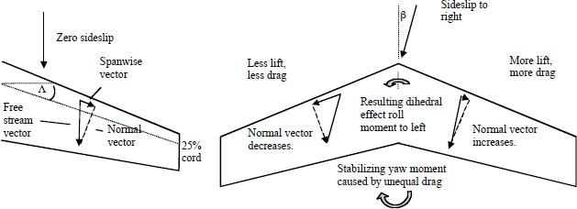
Fig.4.13.WingSweep.
For a swept wing, the roll moment coefficient due to sideslip is directly proportionaltothesideslipangle,tothesineoftwicethesweepangle,andtothecoefficientoflift.
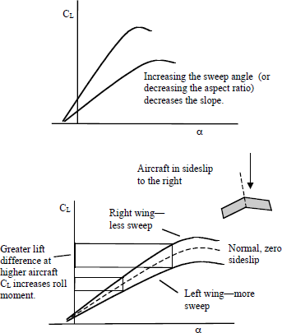
The relationshipbetweensideslipandsweepangles,andsubsequentrollingmoment can be anticipated justfrom looking at Figure 4.13, butthe variation in rolling momentwithCLtakesexplaining.Theeasiest approach is to think ofsideslip as changing the effectivesweep angle of each wing, andthus the slope of their respectiveCL/αcurves.
Sweep angle and slopearerelatedasshownatthetopofFigure4.14.Inasideslip,asshown on the bottom, a swept-wingaircrafthastwoCL/αcurves: a steeper one than normalforthewingintothewind,anda
shalloweronethannormalforthe
trailingwing. Fig.4.14.Swept-WingDihedralandCL.
Thedifferencebetweenthemcreatestherollingmoment.Notehowthedifferenceatanygivenβincreaseswithα,andthereforewithCL.BackinFigure4.13,right,notethedifference in spanwise drag during a sideslip. That difference is directionally stabilizing,andit’sthereasonwhyflyingwingaircraftareswept.
Sincewept-wingdihedraleffectvarieswithliftcoefficient,sodoeslateralstability.AircraftwithhighsweepanglescanhaveacceptabledihedraleffectandlateralstabilityinnormalcruiseflightwhenCLislow,butexcessivedihedraleffectatlowspeeds,orduringaggressiveturning maneuvers,orathighaltitudes,whereineachcaseCLisnecessarilyhigh.

Under those conditions, sideslips can produce strong rolling moments. This canallow a pilot to accelerate a roll rate by forcing a sideslip with rudder, but also increases thepotential for Dutch roll oscillation and rudder misuse. As mentioned, unlike a wing withgeometric dihedral, a purely swept-wing will not roll in response to a sideslip unless it’salready generating lift. There’s no dihedral effect attributable to wing sweep at zero CL. Youcan see that a wing possessing both geometric dihedral and sweep has a kind of multiplepersonality(andusuallyayawdamper).
SrinivasanEngineeringCollege,Perambalur–621212. AUCR2013

StraightWingsandCoefficientofLift—Revisited
Despite the claim made earlier, straight-wing aircraft with geometric dihedral doexhibitaconnectionbetweenincreasedCLandincreaseddihedraleffect.
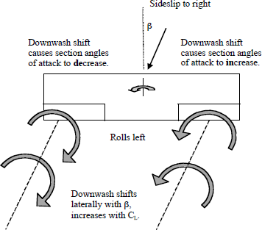
Ifyougototheillustrationsinourbriefingmaterialsonthree-dimensionalwings,you’lldiscoverthatthedownwashcausedbywingtipvortices alters the effective localangle of attack across the span. Thegreater the downwash, the lowerthe local effective angle of attackonthewingaheadofthedownwash. (The angle of attackchanges because the accelerationof air downward by the vorticesactually starts to occur ahead of thewing.Theairstartscomingdown
evenbeforethewingarrives.) Fig.4.15.VortexEffects.
In a sideslip the vortex flow shifts laterally, as in Figure 4.15. This changes theoverall downwash distribution, shifting it to the left in the case illustrated, which in turncausestheaverageeffectiveangleofattackoftheleftwingtobelowerthanitwouldfromdihedralgeometryalone.Theaverageeffectiveangleofattackontherightwingbecomeshigher.Theresultisarollingmomenttotheleft(amomentthatwouldtheoreticallyoccurevenifthewinghadzerodihedral—aslongasliftisbeingproduced).
Since downwash strength is a function of CL, pulling or pushing on the stick willaffectrollmomentduetosideslipinamannersimilartotheswept-wingexamplealreadydescribed.(Ourtrainers’rectangularplanformstendtopromotestrongtipvortices.Otherstraight-wingplanformswithdifferentliftdistributionsmightnotbeaseffective.)Pushingandpullingonthestickduringasideslipalsocausestheaircrafttopitcharounditsywindaxis (as opposed to body axis), which introduces a roll as described in Figure 4.20. Theeffect would be in the same direction as the downwash phenomenon just mentioned, and thetwomighteasilybeconfused.

Fromalltheabove,anunder-appreciatedyetneverthelessgreattruthofairmanshipemerges: For a swept or a straight wing, pulling the stick back tends to increase rollingmomentscausedbysideslip(andbyyawrate),pushingdecreasesthem.

SideslipandRollRate
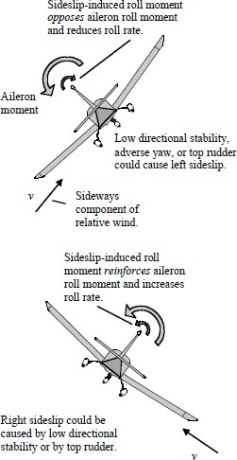
Withourparticularemphasisontheaerodynamicsofunusual-attituderecovery,herearethebehaviorswewanttobesureyouunderstand:
- IncreasingCL(bypullingbackonthecontrol)willincreaserollingmomentduetosideslip and yaw rate. Decreasing CL(bypushingforward)willdecreaserollingmomentduetosideslipandyawrate.We’llexplore the implications of this during ourflight program. (See roll due to yaw rate, andy-wind-axisroll,fartheron.)
- A laterally stable aircraft rolling with ailerontoward the direction of a sideslip/velocityvectorwillexperienceadecreaseinrollrateinproportiontotheopposingrollingmoment the sideslip produces. An aircraftrollingwithaileronawayfromthedirectionofasideslip/velocityvectorwillexperiencean increase in roll rate. You’ll discover thiseffectwhenwestartrollingthetrainingaircraft through 360 degrees and begin usingrudder-controlledsideslipstoaugmentroll
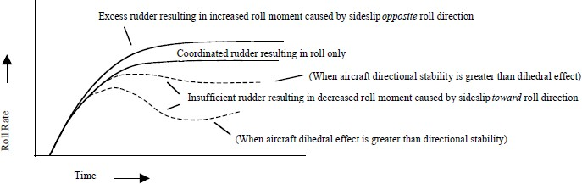
rates. Fig.4.16.SideslipandRollRate.
Fig.4.17.DihedralEffect,RudderUse,RollRate.
Figure4.16describesthelinkbetweensideslipdirectionandrollrateattwopointsduring a 360 degree roll to the left, and Figure 4.17 plots roll rate against time, givendifferencesinrudderuse,dihedraleffect,anddirectionalstability.

AerobaticAircraftandDihedralEffect
SrinivasanEngineeringCollege,Perambalur–621212. AUCR2013
High-performance aerobatic airplanes usually have little or no geometric dihedral,andsoverylittlelateralstabilitythroughdihedraleffect.Onecan’talwaysknowwhatthedesigner had in mind, but the absence of dihedral allows aircraft to roll faster in the presenceof opposing sideslips, and makes them easier to fly to competition standards because rollrateandrudderdeflectionremainessentiallyindependent.
It’s possible to use the rudder to keep the nose up during the last quarter of a slowroll (when an aircraft that’s rolling left, say, and going through the second knife edge is sideslippingtotheright)withouthavingtochangeailerondeflectiontokeeptherollratefromaccelerating. These desirable characteristics for smooth aerobatic flying actually make anaircraftlesssuitableforunusual-attitudetraining.Mostaircraftdoexhibitlateralstability,andtheresultingcharacteristicsareimportanttounderstand.Foronething,lateralstabilityallowsyoutorollanaircraftwithrudderusingnormaldirectionalinputshouldyoulosetheprimaryrollcontrol—theailerons.
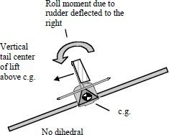
Absentdihedraleffectandunaccompaniedbyaileron,rudderdeflectionaloneinsomeaerobaticaircraftwillproducea roll opposite the expected direction. Forexample, right rudder, instead of rolling theaircraftrightbydihedraleffect(androlldueto yaw rate), slowly rolls it to the left, as inFigure 4.18. Roll due to rudder is caused bythe vertical tail’s centre of lift being abovetheaircraft’scentreofgravity.
Fig.4.18.RollduetoRudder,𝑪𝒍𝜹𝒓.
A moment arm results. The effect could be particularly evident in a zero-dihedral,low-wingaircraft,whenasideslipgeneratedbyrudderdeflectionalsoproducesanaccompanying, destabilizing roll due to cross flow. (Check back to Figure 4.10, top. Lowwingisdestabilizing.)Thefirsttimeyoutrytounfoldamapwhileusingyourfeettokeepthewingslevelinanaircraftthatbehaveslikethis,you’reinforasurprise.
If you actually lost your ailerons you might regain some positive dihedral effect androll due to yaw rate by slowing down and increasing the coefficient of lift. Also, slowingdown will raise the nose, and so place the tail lower and decrease the vertical distancebetween its centre of lift and the C.G., reducing the moment arm. Perhaps the aircraft wouldthenrespondinthenormalway.Itmaybepossible(asintheGilesG-200,forexample)tocontrol an aircraft by using roll due to rudder, but it’s not the sort of thing that happensintuitively. Aileron failure is typically catastrophic in an aircraft without dihedral effect.That’sonereasonwhypre-flightinspectionofthelateralcontrolsysteminazero-dihedralaerobatic aircraft (for integrity of the linkages, and for items that could cause jams like loosechange, nuts, bolts, screwdrivers, hotel pens—your mechanic has horror stories and probablyacollectionofpreservedexamples)issoimportant.Thesame,ofcourse,goesforelevatorandruddersystems.

Here’s a related phenomenon: Next time you fly the swept-wing MiG-15, notice thatrudder deflection produces a roll in the expected direction until you get past about Mach0.86, but then the response reverses—left rudder causing the right wing to drop, for example.A sideslip, as pointed out in Figures 4.13 and 4.14, reduces the sweep of one wing andincreases the sweep of the other, relative to the free stream. The reduction in the effectivesweep of the right wing, caused by pressing the left rudder, can send the right wing pastcriticalMachnumber,causingshockairflowseparationandawingdrop.Ifyou’repullingg,theeffectcanhappenatalowerspeedbecauseoftheaccelerationoftheairflowoverthewing caused by the higher angle of attack. Response to the rudder returns to normal at aboutMach0.95.

  - RollDuetoYawRate,𝑪_{𝒍}𝒓
When an aircraft yaws, thewingmovingforwardhashigherlocalvelocity than the wing moving back.Thehighertheyawrate,orthelongerthe wingspan, the greater the velocitydifferencebecomes.Yawrateproduces a difference in lift and anaccompanyingrollmoment,whichdisappears once yaw rate returns tozero.Therollmomentvarieswiththesquareofthedifferenceinspeedsacross the span (since the lift producedbyawingvarieswithV²).

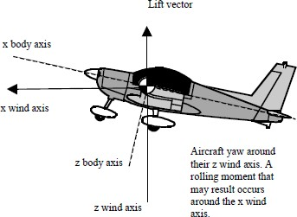
Fig.4.19.AircraftYawAroundZWindAxis.

When you enter a sideslip by pressing the rudder, some percentage of the roll momentgenerated is caused by dihedral effect, and some by roll due to yaw rate. Once a givensideslip angle is reached and held and yaw rate disappears, dihedral effect provides theremaining rolling moment. Like the dihedral effects described above, roll due to yaw rateincreases with coefficient of lift, CL. For rectangular wings, the value for the rolling momentcoefficient per unit of yaw rate, 𝑪_{𝒍}𝒓 , is about 0.25 times CL, on average. Wingtip washout,and/orflapdeployment,reduces𝑪_{𝒍}𝒓.
An aircraft in a banked turn has a yaw rate. The outside wing has to travel faster thanthe inside. This can create a destabilizing, “over-banking” tendency and force the pilot tohold outside aileron during the turn. The situation gets worse as you slow down (or growlonger wings). For a given bank angle, yaw rate varies inversely with airspeed. So as youslow down and increase CL, yaw rate also increases and roll due to yaw becomes moreapparent.That’swhyturninginslow-flightrequiredsomuchoppositeailerontomaintainbankangleandfeltsoweirdbackinprimarytraining—andstilldoestoday.

An aircraft that requires lots ofopposite aileron in response to yaw ratein a turn is likely to be spirally unstableif left to its free response. When a winggoesdownandanaircraftentersasideslip, dihedral effect will tend todecrease bank angle and roll the wingbackup.Butatthesametimetheaircraft’s directional stability tends toyawthenoseintothesideslip,generating ayaw rate and a rollingmoment that increases bank angle. Ifthat moment wins the contest, a spiralbegins.
SrinivasanEngineeringCollege,Perambalur–621212. AUCR2013

  - AdverseYaw,𝑪_{𝒏}𝜹
𝒂

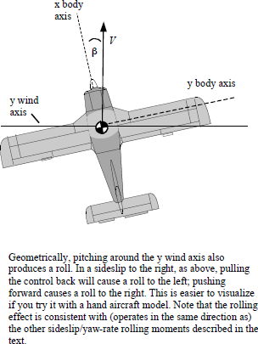

Fig.4.20.AircraftPitchAroundYWindAxis.

Aerodynamic coupling effects keep rolling frombeingaone-degree-of-freedomproposition.Rollingmoments come with yawing moments attached, and thoseyawingmomentsaffectrollbehaviour.
Induceddragincreaseswhenanailerongoesdown,decreaseswhenanailerongoesup.Theresultisusuallyanadverse yawing moment, opposite the direction of roll. In theabsenceofasufficientcounteractingyawmoment—suppliedinpartbytheaircraft’sinherentdirectionalstability, in part by aileron design, and in the remainder bycoordinatedrudder—theaircraftwillbegintosideslip.
The velocity vector will shift from the plane ofsymmetrytowardtherolldirectioniftoolittlecoordinatingrudderisapplied,andshiftoppositetherolldirectioniftheruddergetstooemphaticanin-turnboot.
In a perfectly coordinated, ball-centred roll and turn,with adverse yaw properly countered by rudder deflection,the“instantaneous”velocityvectorremainsontheplaneofsymmetry,asFigure4.21describes.

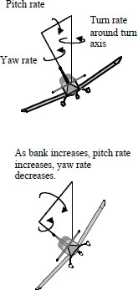

Fig.4.21.RelativeYawandPitchRates.Constant-AltitudeTurn.

Therudderdeflectionnecessarytohandleadverseyawdependsontheratioofyawmomenttorollmomenttheaileronsproduce.Whiletheratioisbasicallyafunctionoftheaileron system design, it increases with coefficient of lift, CL. This means that as airspeedgoesdown,theneed for ruddercoordinationbecomesgreater.Thenatureofinduceddragriseathighanglesofattackisthemajorreason,sinceinduceddragincreasesasthesquareof the coefficient of lift. As the drag curve becomes steeper, a given aileron deflectionproduces a greater difference in induced drag across the span, and the yaw/roll ratioincreases. Differential or Frise ailerons, initially designed to reduce aileron forces, alsoreduce adverse yaw by increasing the drag of the up-going aileron. Another factor is thereductionindirectionalstabilitycausedbythedisruptedfuselagewakeatanglesofattackapproachingstall.Becauseenergyisremovedfromthefreestream,morerudderdeflectionisneededasweathercockstabilitygoesdowninthetired-outair.
Configurationisalsoimportant.Partial-spanflapscauseanaircrafttoflyatamorenose-downangleforagivenoverallcoefficientoflift.Asaresult,theaileronportionofthewing experiences a relative washout and generates a lower local coefficient of lift than whenthe flaps are up. That lower local coefficient translates into less adverse yaw. Flaps alsoreducedihedraleffect,sothesideslipthatdoesoccurhaslesseffectonroll.

AeroelasticAileronReversal
At high speeds, aeroelastic deformation also puts a cap on roll rates. The downaileron produces a twisting moment on the wing, which forces the leading edge to deflectdownward, reducing the angle of attack (Figure 4.22). This reduces lift and consequentlyrolling moment. Roll rate then starts going down and at a certain speed, VR, when thedecrease in lift due to twisting equals the increase in lift due to aileron deflection, the aileronswillnolongercreateanormalrollingmoment.Beyondthisspeed“aileronreversal”occurs.Adown-goingaileronthenproducesadown-goingwing.
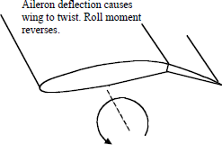

Fig.4.22.AileronReversal.
One of the cures for aileron reversal, not surprisingly, is to increase the torsionalstiffness of the wing (at the expense of added weight). On swept wings it’s necessary toincreasethebendingstiffnessbecausethegeometryofasweptwingcausesittotwistasitbends.MovingtheaileronsinboardorextendingtheirspaninboardalsohelpsraiseVRonasweptwing.Spoilersareanotheroption,asmentioned.

Weathercockeffect
Whenever an airplane, originally flying with zero sideslip, develops a sideslip (β),theverticaltailtendstobringitbacktotheoriginalpositionofzerosideslip.
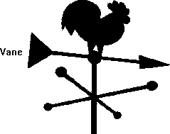
This effect is similar to that ofthe vane attached to the weathercockwhich is used to indicate the direction ofwind and is located on top of buildingsinmeteorologicaldepartmentsandnearairports(Figure4.23).Whenthevaneisat an angle of attack, it produces lift onitselfandconsequentlyamomentaboutits hinge. This moment becomes zeroonlywhenthevaneisalignedwiththe
winddirection.
Fig.4.23.Weathercockorweathervane.
Hence, the vane is always directed in a way that the arrow points in the directionoppositetothatofthewind.Theactionofverticaltailontheairplaneisalsosimilartothatof the vane and helps in aligning the airplane axis with wind direction. Hence, the directionalstabilityisalsocalledweathercockstability.

RudderRequirements

Adverseyaw
Whenanairplaneisbankedtoexecuteaturningmanoeuvretheaileronsmaycreatea yawing moment that opposes the turn (i.e., adverse yaw). The rudder must be able toovercome the adverse yaw so that a coordinated turn can be achieved. The critical conditionforadverseyawoccurswhentheairplaneisflyingslow(i.e.,highCt.)

Crosswindlandings
To maintain alignment with the runway during a crosswind landing requires the pilotto fly the airplane at a sideslip angle. The rudder must be powerful enough to permit the pilotto trim the airplane for the specified crosswinds. For transport airplanes, landing may becarriedoutforcrosswindsupto15.5m/sor51ft/s.

Asymmetricpower
The critical asymmetric power condition occurs for a multiengine airplane conditionwhen one engine fails at low flight speeds. The rudder must be able to overcome the yawingmomentproducedbytheasymmetricthrustarrangement.

Spinrecovery
The primary control for spin recovery in many airplanes is a powerful rudder. Theruddermustbepowerful enoughtoopposethespinrotation.

RudderLockandDorsalFins
Rudder lock occurs at a large angle of sideslip when reversed rudder aerodynamichinge moments peg the rudder to its stop. The airplane will continue to fly side slipped,rudderpedalsfree,untilthepilotforcestherudderbacktocentreorrollsoutofthesideslipwith the ailerons. Aerodynamic hinge moments can peg the rudder against its stops sosecurelyastodefythepilot’seffortsatcentring.Inthatcaserecoverybyrollingorpullinguptoreduceairspeed aretheonlyoptions.
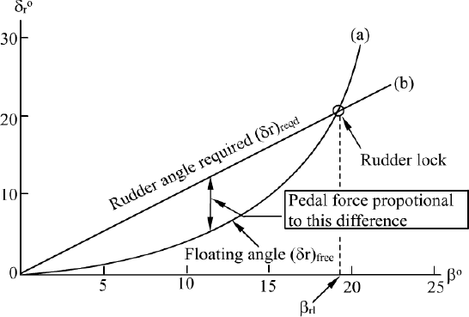
Fig.4.24.RudderLock.
Two things must happen before an airplane is a candidate for rudder lock. Directionalstability must be low at large sideslip angles and rudder control power must be high. Therelative size of the fuselage and vertical tail determines the general level of directionalstability. Directional stability is reduced at large sideslip angles when the fin stalls. Thesideslip angle or fin angle of attack (considering side wash) at which the fin stalls depend onthe fin aspect ratio. Unfortunately, tall, efficient, high-aspect-ratio fins stall at low fin anglesofattack.Asageneralrule,finstalloccursatsideslipanglesofabout15degrees.
Unlike normal wings, whose lift is proportional to angle of attack until near the stall,theliftofverylow-aspect-ratiorectangularwingsisproportionaltothesquareoftheangleofattack(Bollay,1937).Thereisverylittleliftgeneratedinthelowangleofattackrange.However,theangleofattackforstallisincreasedgreatly,reachinganglesashighas45degrees.

The two-part vertical tail is an efficient way to avoid loss in directional stability atlargesideslipanglesandrudderlock.
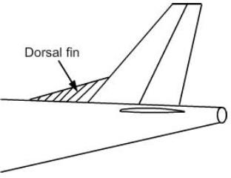
One part is a high-aspect-ratio verticaltail,whichcanprovidedirectionalstiffnessinthenormal flight regime of low side-slip angles andgivegoodDutchrolldampingandsuppressionofaileronadverse yaw.
The other part is a low-aspect-ratio dorsalfin, with a reasonably sharp edge, which will carryvery little lifting load in the normal flight regime.However,atasideslipanglewherethehigh-
aspect-ratiofincomponentstalls,thedorsalfin

canbecomeastrongliftingsurface,maintainingdirectionalstability.
Fig.4.25.DorsalFin.

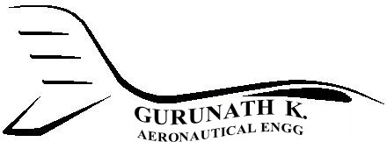UnitV DynamicStability
  - LongitudinalDynamicStability
Stabilityisthegeneraltermforthetendencyofanobjecttoreturntoequilibriumifdisplaced.Staticstabilityisanobject’sinitialtendencyupondisplacement.
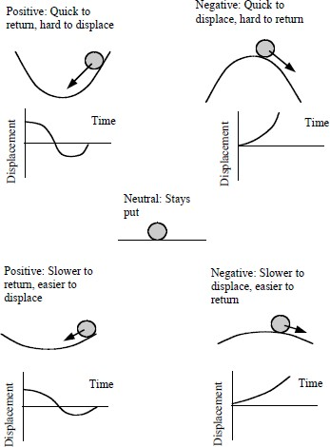
Anobjectwithaninitialtendencytoreturntoequilibriumissaidtohavepositivestaticstability.Forthoseblessedwithaconventionalpilot’seducation,the concept of stability normallyevokes the textbook image of amarblerollingaroundinsomething like a teacup, as showninFigure5.1.
Anairplanecan’tbetrimmed unless it has longitudinal(aroundtheyaxis)staticstability—in other words, unlesspitchingforcestendingtoequilibrium are present. But thegreateranaircraft’sstaticstability(thusthegreatertheforces tending to equilibrium) themore resistant the aircraft is to thedisplacementrequiredinmaneuvering.Foragivenaircraft,themostimportantfactor

indetermininglongitudinalstaticstabilityisc.g.position.
Fig.5.1.StaticStability.

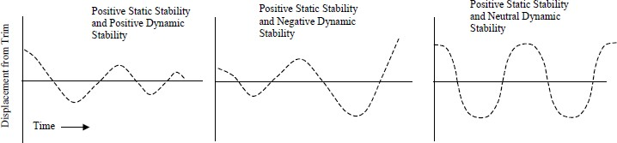

Fig.5.2.DynamicStability.
Movingthec.g.aftreducesstaticstability.Dynamicstability,ourrealsubjecthere,refers to the time history that transpires following displacement from equilibrium, as showninFigures5.1and5.2.Aircraftcaneitherhaveinherentaerodynamicstability(thetypicalcase), or de-facto stability, in which stability requirements are met with the aid of a controlsystemaugmentedwithsensorsandfeedback.

For example, in order to achieve maximum maneuverability, the F-18 lacks inherentstability,andcan’tbeflownwithout someoperationalbrainpoweronboardinadditiontothepilot.TheBoeing777hasrelaxedinherentlongitudinalstaticstability,whichproducesefficienciesincruisefromamorerearwardc.g.andaphysicallylightertailstructurethanotherwisepossible.
Boeing transport aircraft have conventional downward lifting tails that, like all suchtails, in effect add weight to the aircraft by virtue of the “down-lift” they generate (and alsodrag,theby-productofthatlift).Themainwinghastoproduceadditionalliftincompensation,and consequentlyproducesmoredragitself,whichcostsmoneyatthe gastruck. Moving the c.g. aft reduces the necessary down-force. The 777’s digital flightcomputersmakeupfortheresultinglongitudinalstabilitydeficit—buttheaircraftstillhasto have sufficient inherent stability to be flown safely and landed should the digitalaugmentation go bust. The monster Airbus A380 employs an aft center of gravity for thesamereason.Itcanpump fuelafttoshiftthec.g.

DynamicStability:ShortPeriodandPhugoid
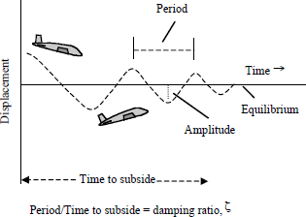
Figure5.3illustratespositivelongitudinal dynamic stability: a series ofdamped oscillations of constant period,orfrequency,anddiminishingamplitudethat bring the aircraft back to the trimmedconditionafteradisplacement.
Periodistimepercycle.Frequency,whichisinverselyproportional to period, is cycles per unitoftime.Amplitudeisthedifferencebetweenthecrestorthetroughandthe
originalequilibriumcondition. Fig.5.3.PositiveDynamicStability.
Damping is the force that decreases the amplitude of the oscillation with each cycle.The damping ratio, ζ, is the time for one cycle divided by the total time it takes for theoscillation to subside. The higher the damping ratio, the more quickly the motion disappears.Damping defines much about the character of an aircraft. If damping is too high, an aircraftmay seem sluggish in response to control inputs. If damping is too low, turbulence or controlinputscanexcitetheaircrafttooreadily;itsbehaviorappearsskittish.
There are two modes of pitch oscillation: the heavily damped short period mode(damping ratio about 0.3 or greater), followed by the lightly damped, and more familiar,longperiod,phugoidmode.Whenyoumaneuveranairplaneinpitchbymovingthestickforward or back, you initially excite—and essentially just ride through—the short periodmode.Ifyouwerethentoletgoortoreturnthestickbacktothetrimposition,theaircraftwould enter the phugoid mode. Instead, you normally hold the pressures necessary topreventaphugoidfromoccurring.

ShortPeriod
SrinivasanEngineeringCollege,Perambalur–621212. AUCR2013
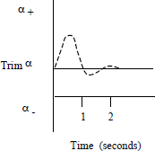
The short period mode is excited by a change in angleofattack.Thechangecouldbecausedbyasuddengustorbyalongitudinaldisplacementofthestick.Figure5.4showsthevariationinangleofattack,α,overtime.Theaircraftquicklyovershootsandrecoversitsoriginalangleofattack,oritsnewangle of attack in the case of an intentional pilot input and anew stick position. The motion of the tail causes most of thedamping,althoughotherpartsoftheaircraftcancontributetodamping (or to oscillation). There’s negligible change inaltitudeorairspeedbythetimethemodesubsides.Duringthe
shortperiodoscillationtheaircraftpitchesarounditsc.g. Fig.5.4.ShortPeriod.
Positivedampingoftheshortperiodisimportantbecausecatastrophicflightloadscouldquicklybuildfromadivergentoscillation—suddenlytheairplanehasoscillatedintoparts. The short period mode is also an area in which pilot induced-oscillations, PIO, canoccur,becausethetypicallagtimeinpilotresponseisaboutthesameasthemode’speriod(approximately1-2seconds).Asaresult,bythetimeapilotrespondstoanoscillationhiscontrol input is out of phase, and he ends up reinforcing rather than counteracting the motionhe’stryingtocorrect.
Atsomepointduringourflights,wecanperformafrequencysweepwiththesticktotrytoisolatetheaircraft’sshortperiodnaturalfrequency,ωn.(Asachildyoupumpedaswing in rhythm with its natural frequency to make it go higher and terrify your mother.)We’ll do this by moving the stick back and forth over a constant deflection range of perhapsthree or four inches, but faster and faster until we find the input frequency that places us 90degreesoutofphase—meaningthatthestickiseitherforwardorbackwhenthenoseisonthehorizon(althoughitcanbehardtotell).
We’re then at the undamped short period natural frequency—undamped becausewe’re driving it with the stick. Then we’ll abruptly return the stick to neutral when theaircraft is at its trim attitude, and observe the damping of the short period oscillation. Itsubsidesveryquickly,asin Figure5.4.
The frequency sweep is not occupant friendly, but it’s a good way to assess anaircraft’s pitch acceleration, or “quickness.” The high pitch acceleration—the ability toquicklychangeangleofattack—isoneofthefirstthingsyou’llnoticewhentransitioningtohigh-performanceaerobaticaircraft.Youcanthinkofanaircraft’snaturalfrequencyintermsofitsabilityto“followorders”—howrapidlyyoucantellittodoonething,thentellit the opposite, and still have it respond. The higher the natural frequency, the more responsecyclesyoucancoaxfrom itperunitoftime.
As we do our sweep, you’ll notice that past a certain point you can’t coax any more.Thenthefasteryoumovethecontrolsbackandforththelesstheaircraftresponds.It’sasiftheaircraftfiguresthatyoucan’tmakeupyourmind,andthatyouneedtobeignored.

An aircraft with a low natural frequency may seem initially unresponsive to controlinput.Apilotmaythenovercontrol,usingalargeinitialinputtogetthingsgoing,onlytofind that the aircraft’s final response is excessive. If the natural frequency is too high, theaircraftwillfeeltoosensitiveinmaneuveringandtooresponsivetoturbulence.
Aircraft with low short period damping ratios tend to be easily excited by controlinputsandturbulence,andtheresultingoscillationstakelongertodisappear.Aircraftwithhigh short period damping can be slow to respond—they’re sluggish, and the control forcesseemhigh.(We’llalsolookatourtrainer’squicknessinroll.
Thenotionofanaturalrollfrequencydoesn’treallyapply,becauseanaircraftisn’tsupposed to oscillate in roll. Oscillatory response is characteristic of “second-order”systems. First order systems, like a rolling aircraft, are exponential and non-oscillatory.We’lldosome“rollsweeps,”anyway.You’lldiscoverasimilarfall-offinresponse.)

LongPeriod—Phugoid
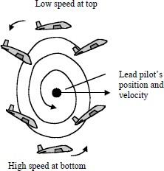
The lightly damped, long period, or phugoid,oscillation can take minutes to play out. But it doesn’tget to very often. Unlike the short mode, the phugoidperiod is long enough that the pilot can interveneeasily and return the aircraft toequilibrium. Wetypically demonstrate the phugoid by pitching thenose up (thus exciting the short period mode) andallowingtheaircrafttodecelerateandstabilizesome15-20 knots below trim. Then we positively return thestick to its original trimmed position. The positivereturnovercomesanyfrictionintheelevatorsystem,andthiskeepsusfromimposinganoveralldescentor
aclimbontothephugoid. Fig.5.5.PhugoidWingman.
Usuallyitdoesn’tmatterifyouthenholdthestickorletitgo,sincethedifferencebetweenstick-fixedandstick-freeisminorinthelongperiodmode.Butforconsistencyinresponse we want to keep the wings level. By using rudder for that job, we can avoidinadvertent pitch inputs. (On our flights we’ll often enter a phugoid more theatrically,perhapsastherecoveryfromaspiral dive.)
Fromthenose-highattitude,thenosewillbegintodropthroughthehorizonintoadescent, then pitch up and climb back up as speed increases. It then repeats the cycle,overshooting its original, trimmed airspeed/altitude point by less and less each time. Duringthephugoidtheaircraftmaintainsessentiallyaconstantangleofattack,α,whilecyclicallytrading altitude and airspeed (potential and kinetic energy) until it again regains equilibriumasin(Figure5.3).

Thepitchrateandthevariationinmaximumpitchattitudewilldiminishwitheachoscillation.Pitchattitudeattheverytopandbottomwillbeapproximatelythesameastheoriginal pitch attitude at trim. Minimum airspeed will occur at the point of maximumaltitude,andmaximumairspeedwilloccuratthepointofminimumaltitude.Thephugoidoscillation is typically damped and convergent, but it can be neutral, or even divergent, andtheaircraftwillstillbeflyable,becauseoftheeasewithwhichthepilotcanbringthelongperiod under control (you’re controlling the phugoid whenever you hold altitude). But poordamping does increase the workload and complexity of the scan for instrument pilots whenflying by hand, because the effort needed to hold altitude increases. Poor damping alsomakesithardertotrimanaircraft.
SrinivasanEngineeringCollege,Perambalur–621212. AUCR2013
TheundulatinglinesbackinFigure5.3suggesthowthephugoidwouldappeartoastationary observer. Figure 5.5 shows the same from the point of view of another pilot flyinglevel in formation, watching a “phugoidal” (“phugoiding?”) wingman. Theaircraft appearsto rise and fall as airspeed changes produce lift changes. Excess airspeed at the bottomproducesliftgreaterthanweightandaresultingupwardforce.Diminishedairspeedatthetopproducesliftlessthanweightandaresultingdownwardforce.Remember,αstaysthesame. As a result of the airspeed changes an aircraft in the phugoid would also appear tomove back and forth, falling behind at the top of the cycle and scooting forward at thebottom,butlessand less eachtimeasthemotiondampsout.Drageffects,ratherthantailmovement, damp the phugoid. Raising parasite drag increases damping. With both the shortperiod and the phugoid mode, an aft shift in c.g., close to the neutral point, will begin toproduceanincreaseinperiodandadecreaseindamping.
Propellers add a damping factor absent with jets. If brake horsepower is constant,propellerthrustincreasesasairspeeddecreases,andviceversa.Thisaddsaforwardforceat the low-speed top of the phugoid and a restraining force at the highspeed bottom. Thischanging thrust/airspeed relationship helps reduce the speed variation from trim and thushelpsdampthemotion.Thephugoidissensitive tocoefficientoflift,𝐶_{𝐿}.At slowspeeds,thusathigh𝐶_{𝐿},boththeperiodandthedampingdecrease.Athighspeeds,thusatlow𝐶_{𝐿},bothperiodanddampingincrease.

DutchRoll
Directional stability, dihedral effect, and roll due to yaw rate all do battle in thedynamic phenomenon called Dutch roll. Dutch roll tendency appears in aircraft with highlateralstabilityascomparedtodirectionalstability.It’sparticularlyaproblemwithswept-wing aircraft, in which lateral stability increases with angle of attack (i.e. coefficient of lift),asalreadydescribed.Althoughnotnearlyasbad,ourstraight-wingZlinhasenoughDutchroll in turbulence to make the ride memorable. In the Dutch roll, a disturbance in roll or yaw,whether pilot-induced or caused by turbulence, creates a sideslip. A sideslip shifting thevelocity vector (relative wind) to the right, as in Figure 5.6, for example, leads to an oppositerolling moment to the left (through dihedral effect and roll due to yaw rate). But the aircraft’sdirectionalstabilityworkstoeliminatethesideslipbycausingthenosetoyawtotheright,backintothewind.

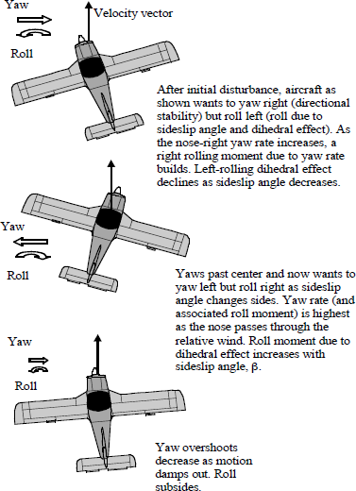
However, momentum causes the nose to yaw past centre (past zero β), andthissetsupasideslipintheoppositedirection,whichinturnsetsupanoppositeroll. The resulting out-of-phase yawing and rolling motions would damp out morequickly if they occurred independently. Instead, each motion drives the other.NotethatDutchrollistheresultofthefundamentaltendencyofastableaircraftto roll away from but yaw toward the velocity vector whenever that vector leavestheaircraft’splaneofsymmetry.
SrinivasanEngineeringCollege,Perambalur–621212. AUCR2013
Withoutayawdampertodoitforthem,it’sdifficultforpilotstocontrola Dutch roll because its period is short. It’s hard to “jump in” with the requireddampinginputattherighttime.
Pilotsofswept-wingarefrequentlytrainedtokeepofftherudders,checktherollwithtemporary,quick,on-offapplicationsofaileron,andthenrecovertowings level. Another strategy is to use the rudder—not to combat yaw but to keepthe wings level. The tendency to Dutch roll increases at higher CL, becauseincreasingthecoefficientofliftincreasesbothdihedraleffect(especiallysweptwing)androllduetoyawrate.Dutchrolltendencyalsoincreasesathigheraltitudes, where aerodynamic damping effects diminish. Since aircraft must fly athigh CLat high altitudes, the problem compounds. Normally aspirated pistonengine aircraft upgraded with turbochargers for high-altitude flight sometimesendupneedinglargerverticaltailsforbetterdamping.
Reducing dihedral effect will ease the Dutch roll problem, but at theexpenseofreducedlateralstability.Aircraftwithgreaterdirectionalthanlateralstability tend to Dutch roll less, but also tend to be spirally unstable. Traditionally,thedesigncompromisebetweenDutchrolltendencyandspiralinstabilityhas
beentosuppresstheformerandallowthelatter,becausespiraldives—while
potentiallydeadly—beginslowlyandareeasiertocontrolthanDutchroll. Fig.5.6.DutchRoll.

98
GurunathK.–AE6501FlightDynamics|

Autorotation
Spinsfeedonautorotation,whichcanfollowastallifforsomereason (sideslip,yaw rate, wind gust,inherent asymmetry in response, pilotinput)thewingsbegintooperateatdifferentanglesofattack.Figure5.7shows what happens. During our practicespins, for example, if we keep the ballcentredasweslowdownandsimultaneously increase α, both wingsshouldarriveattheirmaximumcoefficient of lift, CLmax, more or lesstogether.
If we then press hard left rudder,the right wing will begin to move fasterthantheleft.Theairplanewillrolltotheleft in response (roll due to yaw rate, plusdihedraleffect).Becausethewing’srollingmotionaddsavectortotherelative wind (Figure 5.8), the left wingwill see an increase in α as it descends,but a decrease in lift, since the wing ispast CLmax. Because of the increase in αtherewillalsobeanincreasein drag(asyou’llnoteinFigure5.10).
Therightwingwillseeadecreaseinαasitrises,butstillmoreliftthantheleftwing.Becauseofthedecrease inα therewillalsobeadecrease

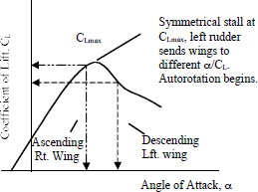

Fig.5.7.Autorotation.

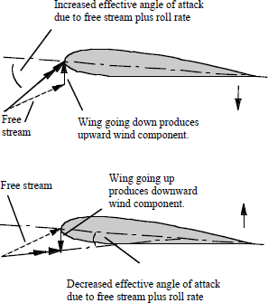

intherightwing’sdrag. Fig.5.8.Roll-inducedAngleofAttack.
As a result, the coefficients of lift and drag will vary inversely in relation to oneanotheralongthespan.Theoutcomeisaself-sustainingautorotation.
Althoughyawtypicallyleadstoroll andthustoautorotation,sometimesdeparturehappens in roll initially, even if the aircraft is in coordinated flight with zero yaw rate orsideslip. One wing might be rigged differently than the other, and stall first. Because of theirsensitivity to any asymmetry along the span, wings that produce sudden leading edge stalls—or that generate sudden trailing-to-leading-edge stalls—tend to roll off. The down-goingwingreceivesanincreaseinα,whichleadstoanincreaseindrag.
The up-going wing gets the opposite. The asymmetry in drag sets the airplane off inyaw,whichinturnreinforcesroll.

Autorotation is roll damping reversed(Figure5.9).
SrinivasanEngineeringCollege,Perambalur–621212. AUCR2013
Considerawingoperatingnormally on the left side of the CL/αcurve,beforethestallregion.Ifthewinggoesdown,perhapsbecauseofagustoran aileron deflection that the pilot thenremoves, it doesn’t continue to roll, butstops.Thedownwardrollingmotionaddsavectortotherelativewind,whichproduces a geometrical increase in α.TheresultingincreaseinCLopposestheroll.This damping, rolling moment due to rollrate,Clp,subsidesastherollratereturnstozero.
If a wing operates on the rightsideoftheCL/αcurve,paststall,adownwardrollstillproducesanincreasein α, but now accompanied by a decreaseinCL,aswe’veseen.There’snodampingeffect.Justthereverse—thewingcontinuestofall.Rolldampingturns unstable when the slope of the CL/αcurve turns negative past CLmax. A rollingmotion kicks off a self-sustaining rollingmoment.
Again consider a wing operatingontheleftsideoftheCL/αcurve,belowthestallregion,butnowrollingupward.An upward rolling motion will induce adecrease in α (Figure 5.9) and a loss oflift—therefore generating roll damping.If that wing were operating on the post-stall, right side of the CL/α curve, anupward roll would still induce a decreaseinα,butanincreaseinCL.
Thewingwouldcontinuetorise—againnodamping.Forautorotation to occur, at least one winghas to operate on the right side of thecurve, past the maximum coefficient oflift.

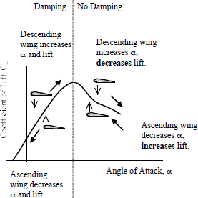

Fig.5.9.RollDamping,=Clp.
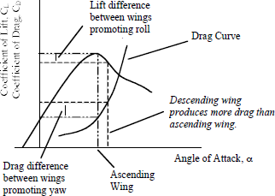

Fig.5.10.Straight-WingLift&Drag.
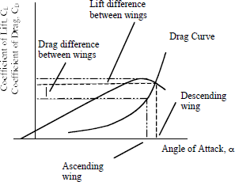

Fig.5.11.Swept-WingLift&Drag.

Watchingwingtuftsinadeparture,you’lltypicallyseecompleteairflowseparationon the inside wing (indicating low lift and high drag), while the outboard tufts on the outsidewingremainattached(morelift,lessdrag).Onceautorotationgetsgoing,inertialdynamicscan take both wings to post-stall angles of attack, as they drive the nose up and the spinattitude flattens. Spin recovery involves getting both wings back into the roll-damping regionontheleftsideoftheCL/αcurve.
Figures5.10and5.11showhowtheyawcomponentofautorotationisgeneratedbythe rise in the coefficient of drag, CD, as α increases. As wings get shorter (smaller aspectratio), or wing sweep increases, the slope of the lift curve decreases. This reduces thedivergence in lift coefficient when the left and right wings operate at different α. In suchcases, CL might not vary much over wide values of α, but CD will. Asymmetric drag thendominatesautorotation.Thatmeansmoreyaw.Oneconsequenceisthatspinattitudehasatendencytogoflat(noseup),especiallyinafuselage-loadedaircraftwithflat-spininertialcharacteristics.

SpinPhases
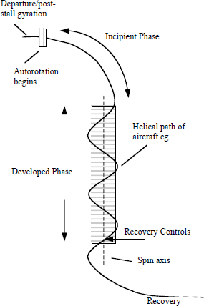
Spinsaretypicallydescribedaspassing through phases: departure, post-stallgyration, incipient spin, developed spin, andrecovery. The developed spin may achievesteadyratesofrotationandaconsistentnoseangle against the horizon, or the rates mayoscillate—often with the nose bobbing up anddown accompanied by fluctuations in roll andyaw.Thenotionthatspinspassthroughidentifiablephasesismoreastudiedanalytical observation than a fact immediatelygladdeningtopilots.Untilthedevelopedstate, spin phases themselves are transitionalin nature, with un-commanded changes inroll,pitch,yaw,andsideslip—oftengoingonall at once and difficult to sort into separatecomponents. This is especially so during theincipient phase, which ends quite differentlythan it begins. Some aircraft will pass throughthephasesquickly,particularlyduringintentionalspinsifcontroldeflections
generatestrongaerodynamicpro-spinforces Fig.5.12.SpinPhases.
andthere’snotmuchinertiatoovercome(strong aerodynamicsandweakinertiasarealsothe formula for good recovery characteristics). Others take longer to get going and finallystabilize,ifindeedtheydostabilize.

SpinAttitudes
SrinivasanEngineeringCollege,Perambalur–621212. AUCR2013
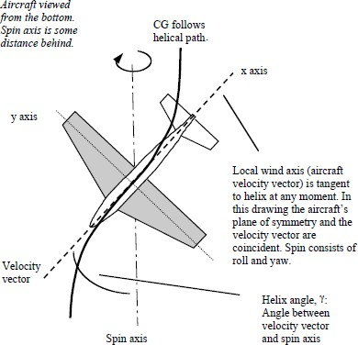
Spinsconsistprimarilyofrollandyaw,withtheairplanecentreofgravityfollowingahelicalpatharound,anddisplacedfrom,thespinaxis, as shown in Figures 5.12,5.13, and 5.14. If the wings aretilted, relative to the helical path(Figure 5.13, bottom) the wingtiltangleintroducesacomponentofpitch.
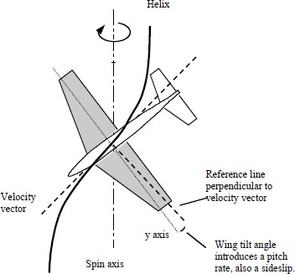
Flatspinsaremostlyyaw,whilesteepspinsaremostlyroll. Spins at45-degrees nose down are equalpartsrolland yaw.Youcanseewhythisissobyholdingamodel aircraft wings-level at a45-degreenosedownangleandyawingitarounditsz-bodyaxis.Thenoseis45-degreesabove the horizon after half aturn. You need to roll as youyaw in order to keep the nosedown. If you play with otherangles, you’ll see how roll andyaw interact. If you can figureouthowtomovethemodelonahelical path and tilt the wing asillustrated, you’ll discover theneedforapitchrate,aswell.
From the cockpit, spinsoftenappearasmostlyyaw,evenpastthe45-degreenose-downangle,whenrollrate
isactuallytakingover. Fig.5.13.SpinHelix.
Asthepitchattitudebecomessteeper,rollrateincreasesandrollperceptionstartstodominate.Withthenosedownitcanbedifficultforthepilottorecognizethathe’sactuallyenteredaspinandnotaverticalroll,orthathe’sstillinaspinwithayawratethathasyettobestopped.

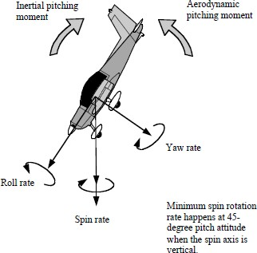
Figure 5.14 shows some ofthecharacteristicsofflatversussteepspins.Intheexampleshown,forsimplificationthespinconsistsofrolland yaw only—no pitch rate. In anequilibriumstate,theaerodynamicpitchingmoments,whicharenosedown, are opposite to and equal thenoseupinertiamoments(moreaboutthislater).
Astheangleofattack,α,increases and the spin becomes flatter,thecoefficientofdrag,CD,increases.Because of the drag rise, the descentratedecreases.
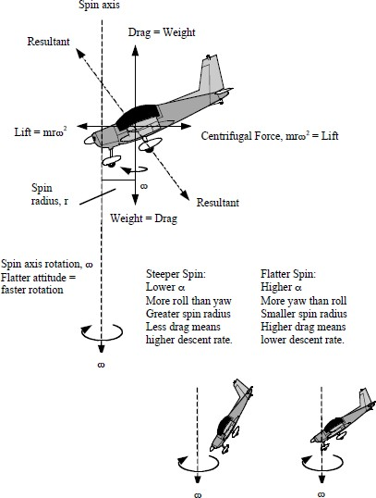
Liftgoesdown.Thedistance, r, from the aircraftcenterofgravity—ridingthehelix—to the spin axis alsodecreases.
Thefigureshowsthe balances of forces in asteadyspin.Theresultantaerodynamicforce(vectorsumofliftanddrag)balancestheresultantofweight(theaccelerationofamassbygravity)andcentrifugalforce.Asaircraftangle of attack increases, andlift consequently decreases,theaerodynamicresultanttilts more toward the vertical,orclockwiseintheillustration. The resultant ofweight and centrifugal forcetiltsclockwiseaswell.Sinceweight stays the same, thismeanscentrifugalforcedecreases.Asitdoes,theradiusofthehelix,r,around
thespinaxisdecreases. Fig.5.14.SpinAttitudes,SteadySpinBalanceofForces.

GurunathK.–AE6501FlightDynamics|

As the aircraft c.g. moves closer to the spin axis, spin rate, ω, increases. In an aircraftwiththec.g.behindthecockpit,theaxiscanpassbehindthepilot;thespinacceleratingandbecoming“eyeballsout.”Notfun,saysthosewhohavebeenthere.
SrinivasanEngineeringCollege,Perambalur–621212. AUCR2013
Whetherthespinissteeporflatwilldependontheattitudenecessarytobalancethemoments—aerodynamic versus inertial—around the aircraft’s axes. As we’ll see, an aircraftwithitsmasspredominatelyinitsfuselagewilltendtospinmorenose-up.Anaircraftwithitsmasspredominatelyinitswingswillspinmorenosedown.

SpiralDivergence
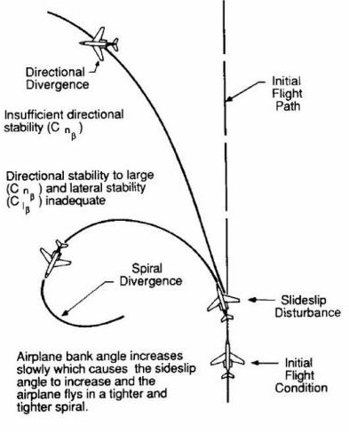
An aircraft may or maynot have inherent static stabilityin roll. Most aircraft are slightlyunstable inroll,bothstaticallyand dynamically. Such instabilityisknownasspiraldivergence.
The vertical stabilizer ona conventional aircraft gives itinherentstaticstabilityinyaw.Iftheaircraftisgivenaslightchangeinyawsoastoproduceasideslipangle,theverticalstabilizerwillprovidearestoringmoment that will swing the nosebacktowarditsequilibriumposition.
Whenanaircraftisdisturbed to yaw so that one wingdrops,suchasto theright,thereis
norestoringmoment. Fig.5.15.Spiraldivergence.
Ifthepilotorautopilotdoesnotapplyleftailerontolevelthewings,therightwingwill slowly continue to drop and a yawing moment will be generated, causing the aircraft tostartaturntotheright.Theverticalcomponentoftheliftwillnolongerbelargeenoughtobalance the weight and the aircraft will lose altitude. The aircraft will start an ever-tighteningspiral, losing altitude, and will eventually crash. In very early aircraft, this spiral divergencemodewassufficientlyfasttobecalled“thedeathspiral”.Inmodernaircraftthewingdropissoslowthatapilotorautopilothasnotroubleincontrollingit.Infact,theaveragepilotisnotevenawareofthisinstability.

